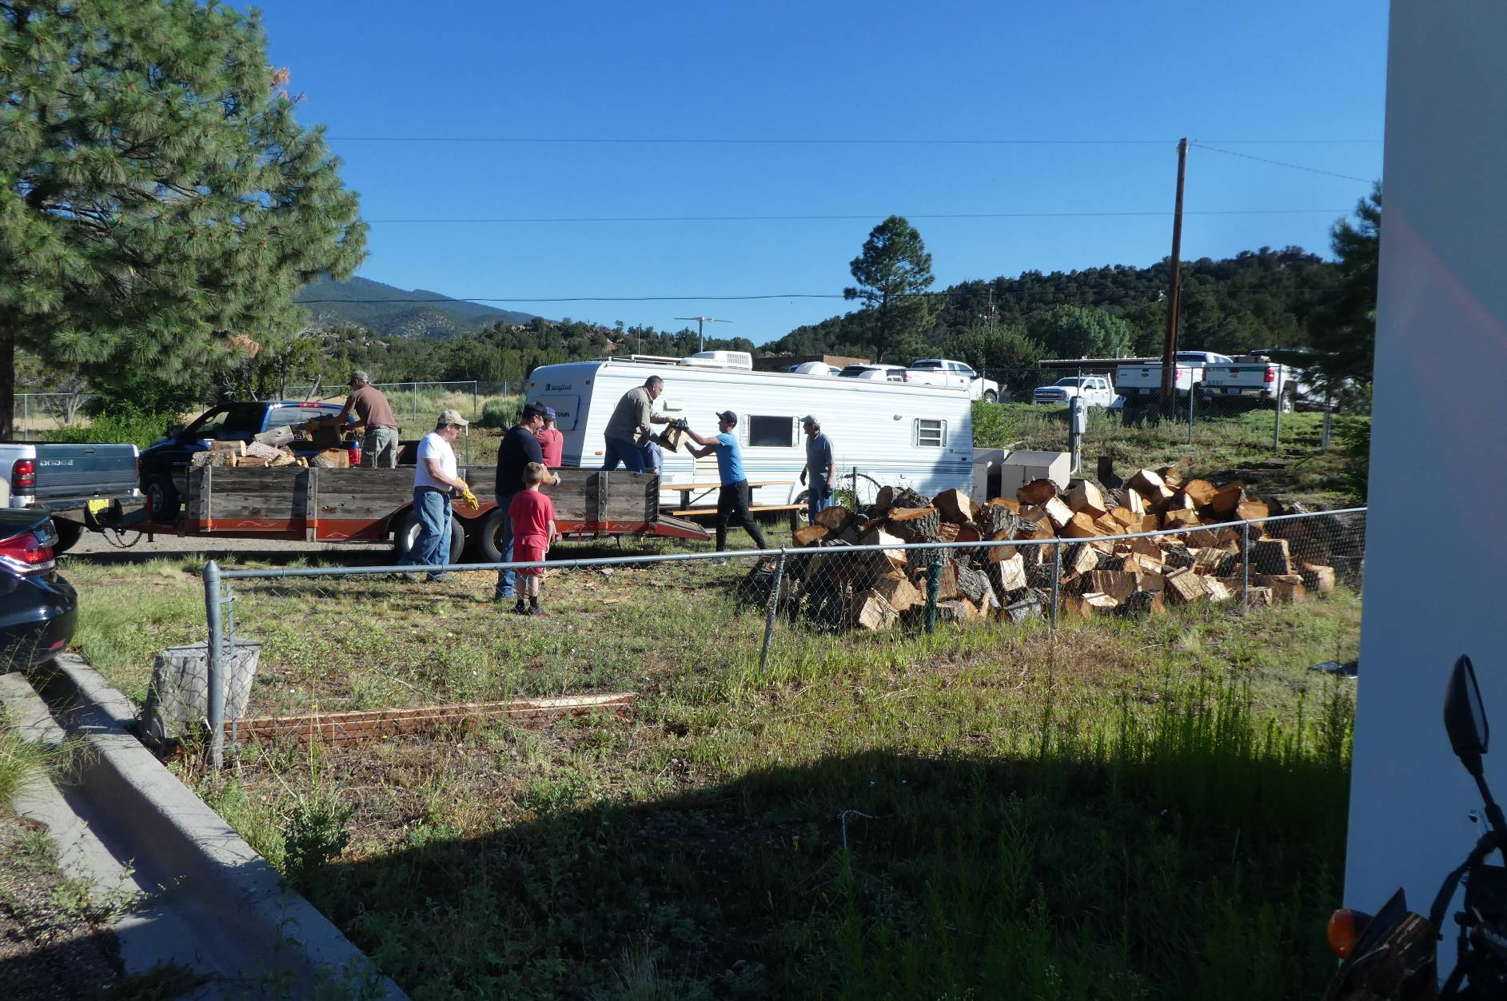
Volunteers with the Mountain Christian Church Wood Ministry loading wood on a large trailer on Saturday, July 27, 2019.
FOSM volunteers had felled, bucked, and split this wood in picnic areas and hauled it to the hazmat building.
Photos by Sam Beard
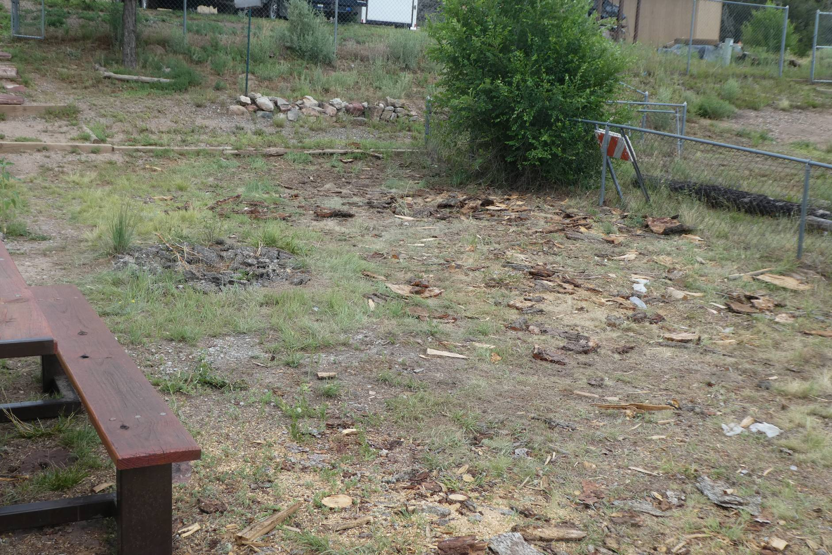
Only pieces of bark remain where the wood had been piled.

