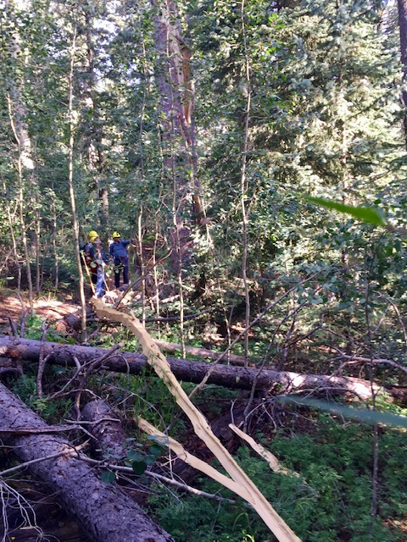

The crew discovered this lightning strike tree (in background) just north of the electronic site fence on Crest Trail 130N.
The long strip of wood in the lower center of the
photo had been blown off the trunk. There were no signs
of burning on the tree.

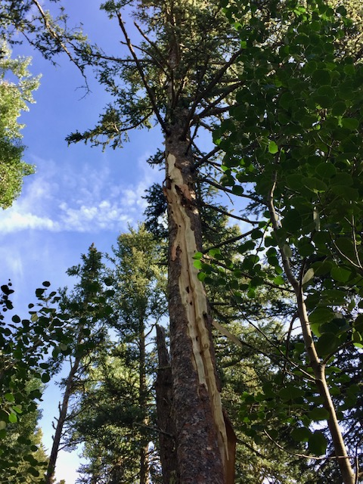
This photo shows the scar that the lightning left
on the trunk of this tall spruce tree. It demonstrates
the power and unpredictability of lightning on the
mountain. It also serves as a reminder of the importance of paying attention to changing weather conditions and the need to retreat from the trails before such storm conditions develop.

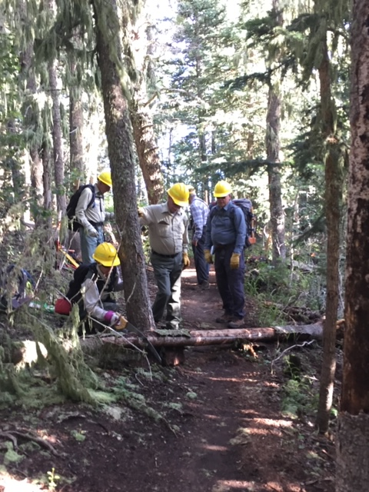
Rav Nicholson cuts the only fallen tree that had been
reported on Crest Trail 130 North.
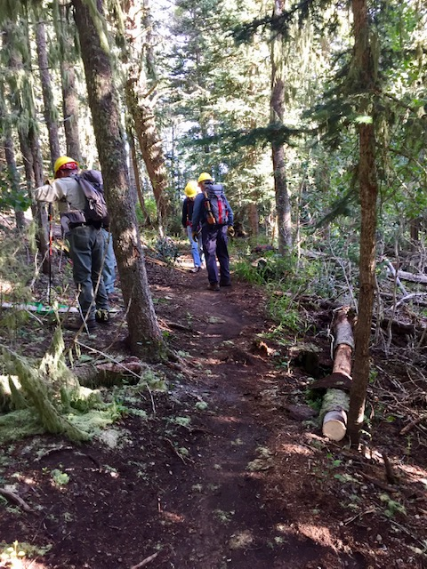
Fallen tree in previous photo has been cut and moved off
to the side of the trail.

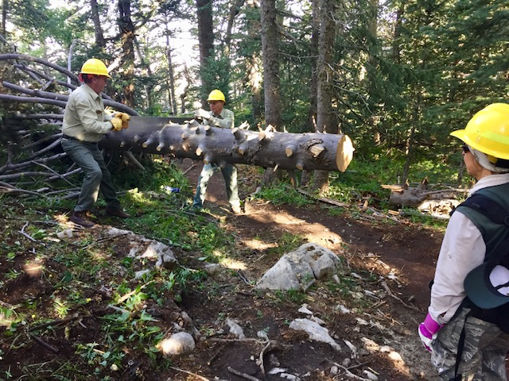
This monster fallen spruce had been part of a major train wreck
which had been removed from this site on a previous workday. ”Upon further review”, the crew decided to cut the tree further
back from the trail. After extensive limbing on the trunk by the crew, Jim and Bob are beginning the cut to remove it.
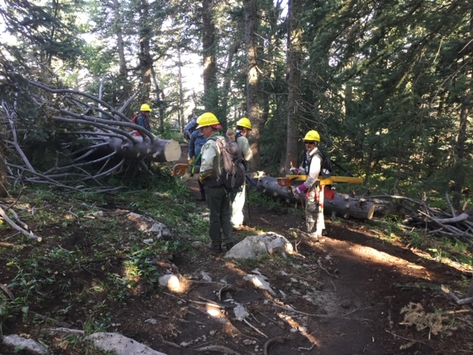
The large tree in the previous photo has been cut well back from
the trail (Where Rav is standing). The cut portion has been moved off to the side of the trail to a secure location that protects the lower trail margin without affecting drainage.

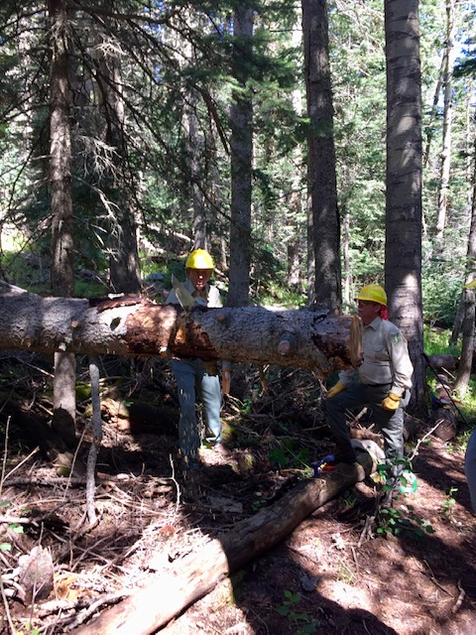
Bob begins the cut on another tree the crew decided
to move further back from the trail tread. Jim awaits
his turn. It is a practice of our crew to give all
members the opportunity to have time using the crosscuts.
Smaller pruning saws get a lot of use in limbing.

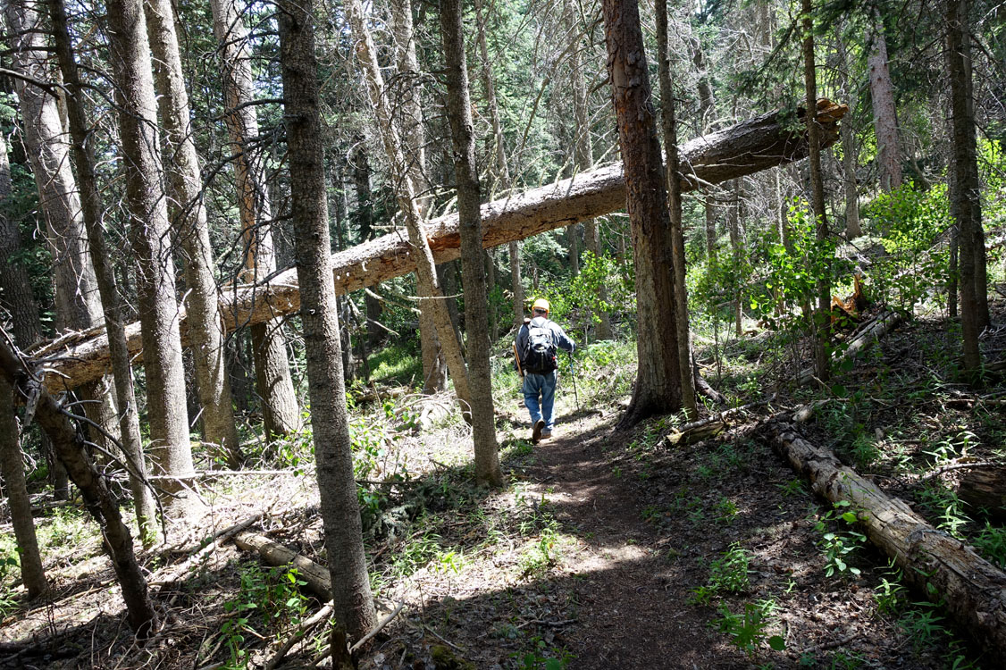
Everyone who has hiked Survey Trail is no doubt familiar with this huge hang-up. Our crew has been past this tree many times. We would often find ourselves looking at it trying to determine if it had moved downward. It was hard to tell. Someone suggested that perhaps if we marked the fallen tree and one of its support trees with small adjacent blazes in the bark, it would serve as a gauge to track downward movement. This was done several years ago. To date, there has been no downward movement at all. This tree is very big and heavy, but it is securely jammed between its supporting trees. No doubt that in time, gravity and other forces of nature, will bring it down, but in the meantime, it is certainly a sight to behold.

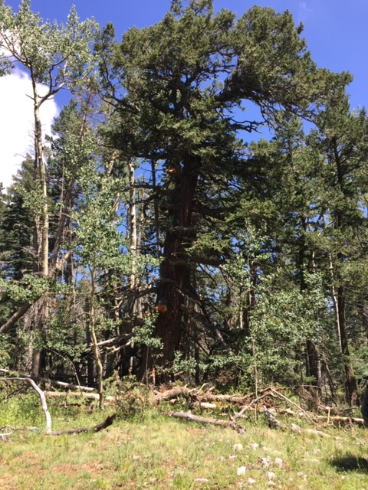
This is a current photo of the well-known “War of Roses Medallion Tree” on Survey Trail. The large aspen tree which had
been leaning against one of its upper branches has fallen
away. This aspen had been a cause of some worry as its
weight was adding downward pressure against an already
leaning tree. The stub of the broken branch of the fir where the aspen had been leaning can be seen in the upper center of the tree. A few branches, mostly dead, came off the fir, but it looks sound. A crew member has an inclinometer app on his iPhone he has used to track the lean on this tree for several years. It has been stable. According to the germination date on the medallion, this tree is 564 years old. It was 37 years old when Columbus sailed from Spain. What stories it could tell!

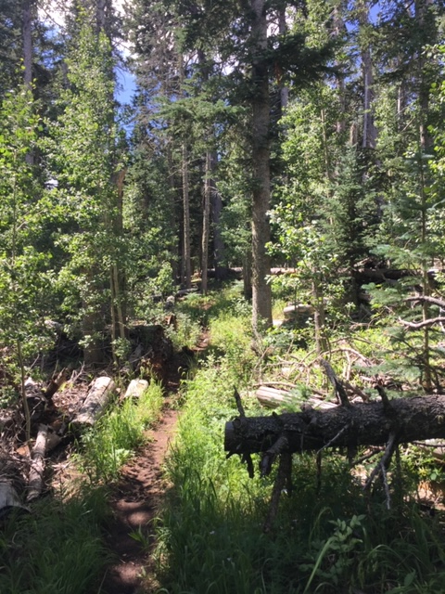
The abundant winter snows and summer rains have resulted
in a park-like appearance along many sections of Survey
trail.

