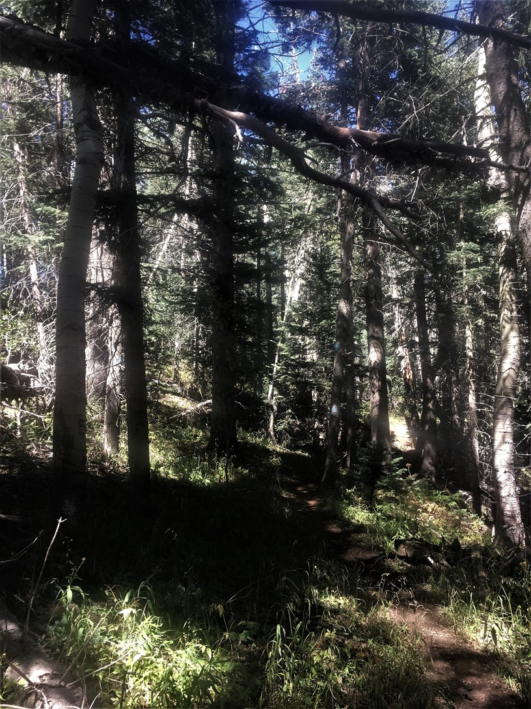
The lowest of the branches seen suspended above Gravel Pit
Trail is actually a “widow maker” that is balanced
on the two well supported leaners seen above it in this
view. A long rope was used to pull this hazard off its
supports onto the ground. It was then moved off the trail.

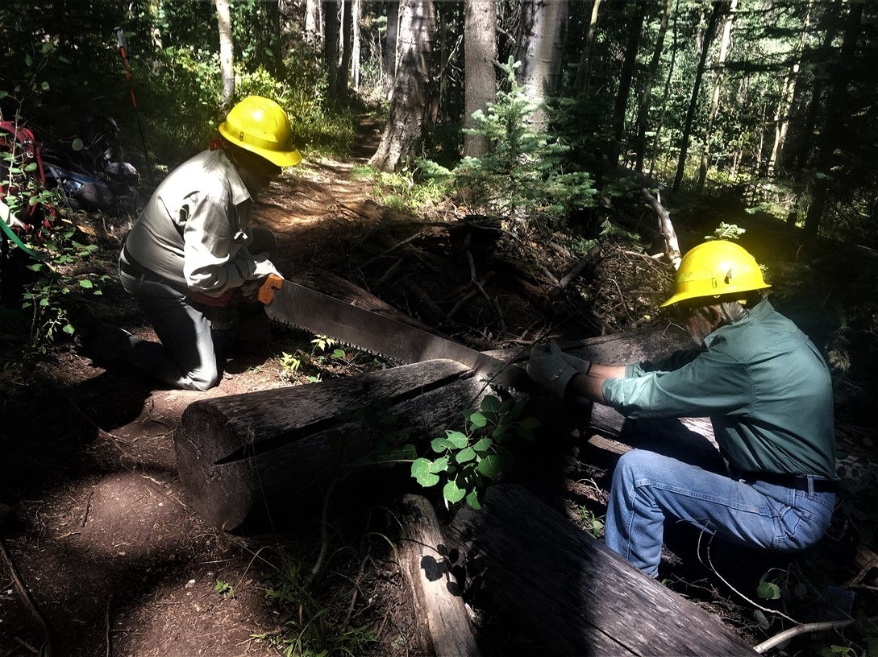
Jim and Byron use Jim’s large crosscut saw to cut back the end this 13-inch diameter fallen tree trunk which was protruding into Rocky Point trail. It appeared from the condition of the exposed wood at the end of the log that it has been cut quite some time ago.
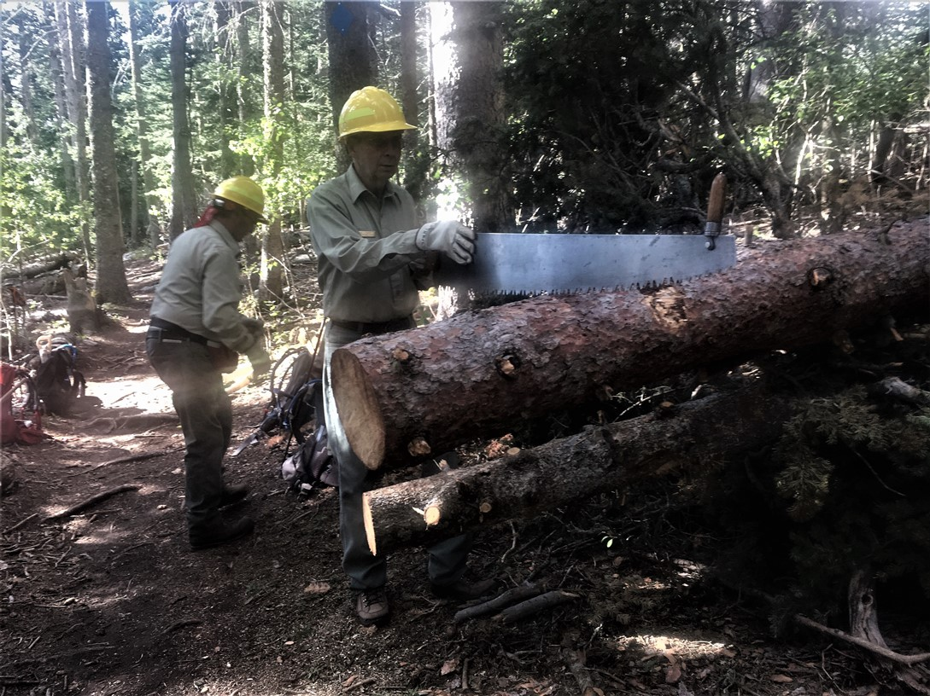
Bob is positioning the crosscut saw prior to beginning work on the first of two fallen trees cut back from Switchback trail. An additional handle is in place toward the end of the saw for use by the second sawyer when the cut is started.

