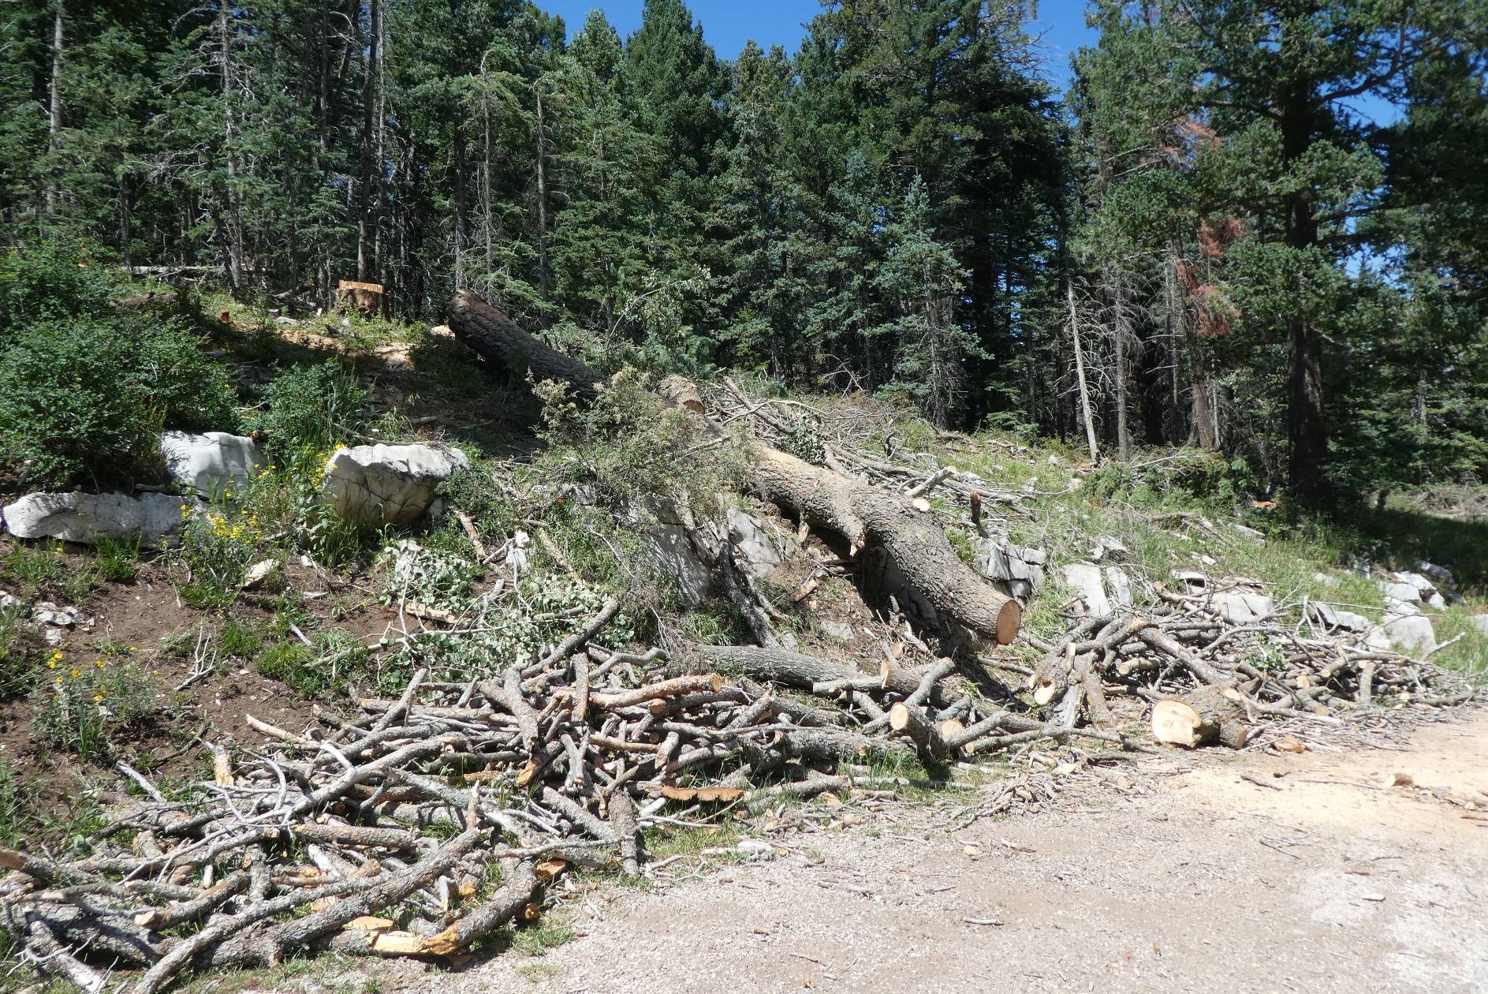
Trunk of large tree that was felled earlier at Dan’s Loop. This trunk was eventually moved down to the pavement.
All photos by Sam Beard

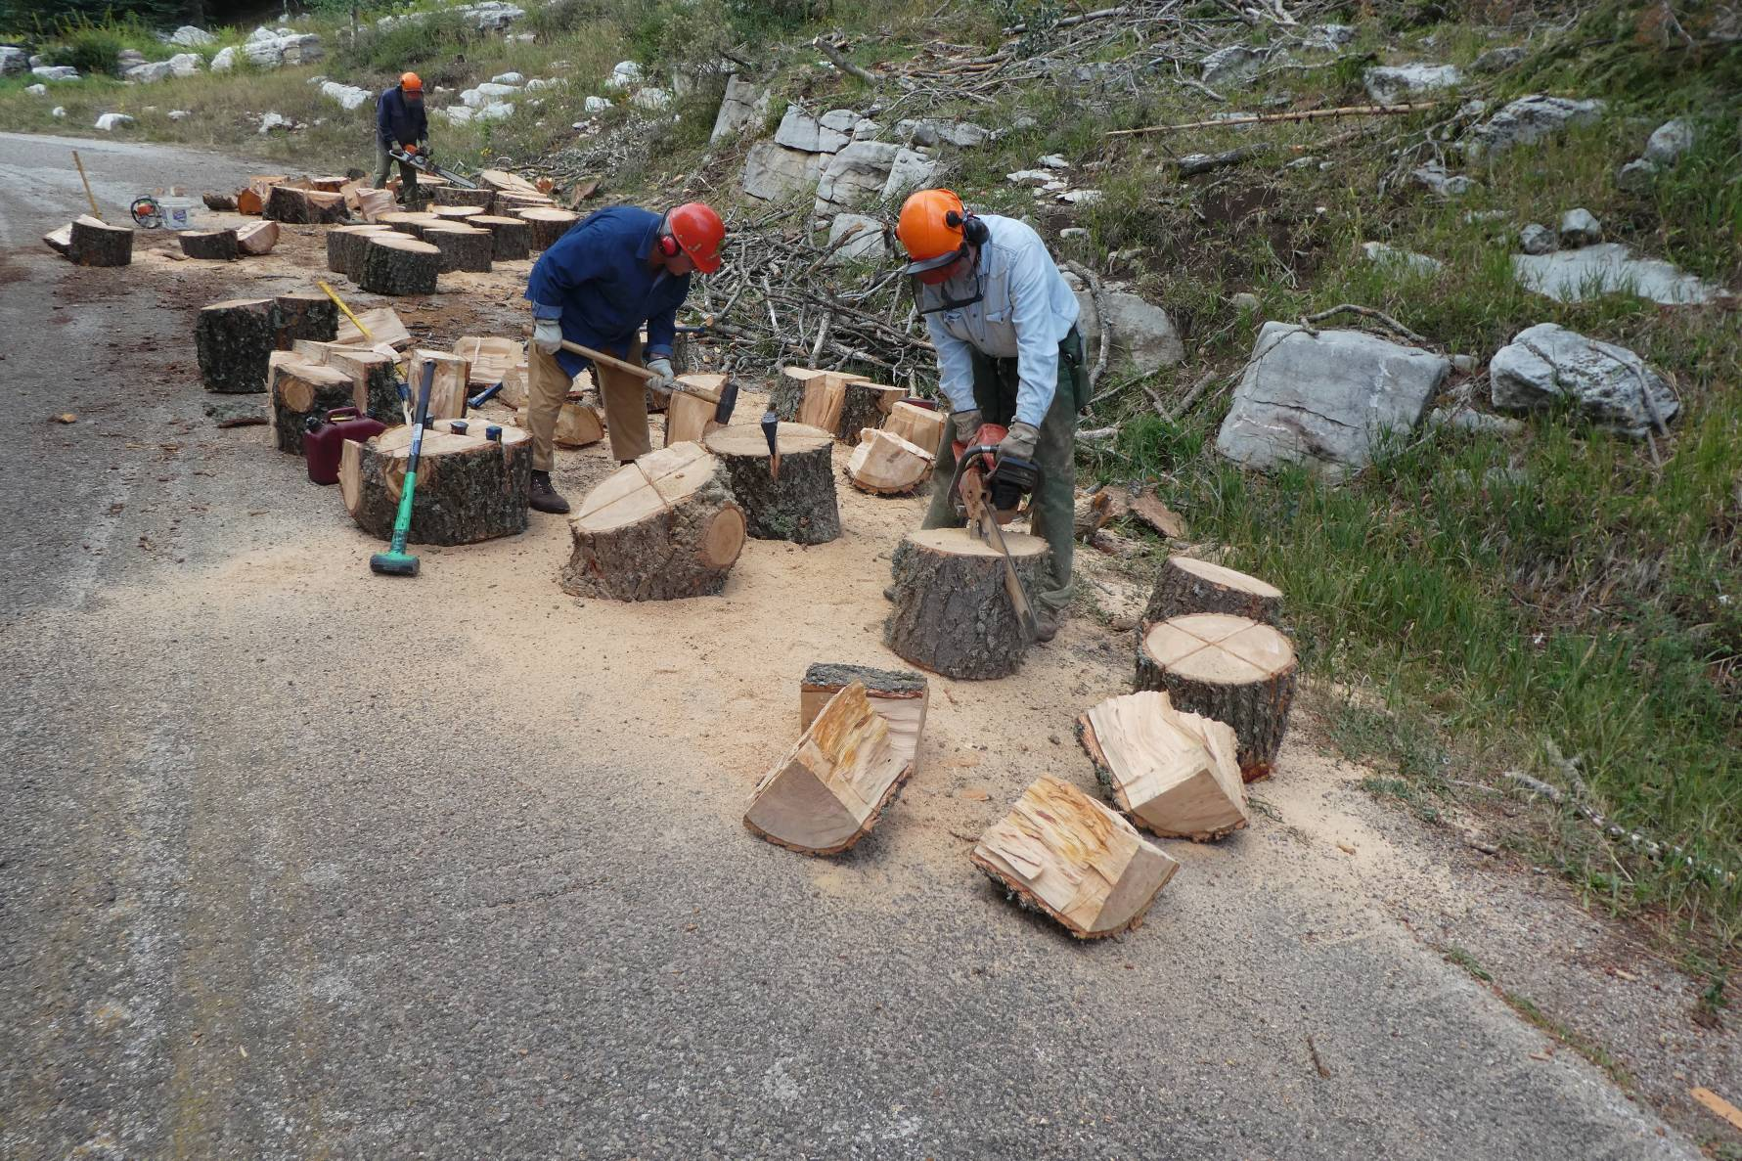
Lou Romero is splitting a large round, and Jerry Carroll and Eric Russell are scoring the rounds deeply to make splitting easier.

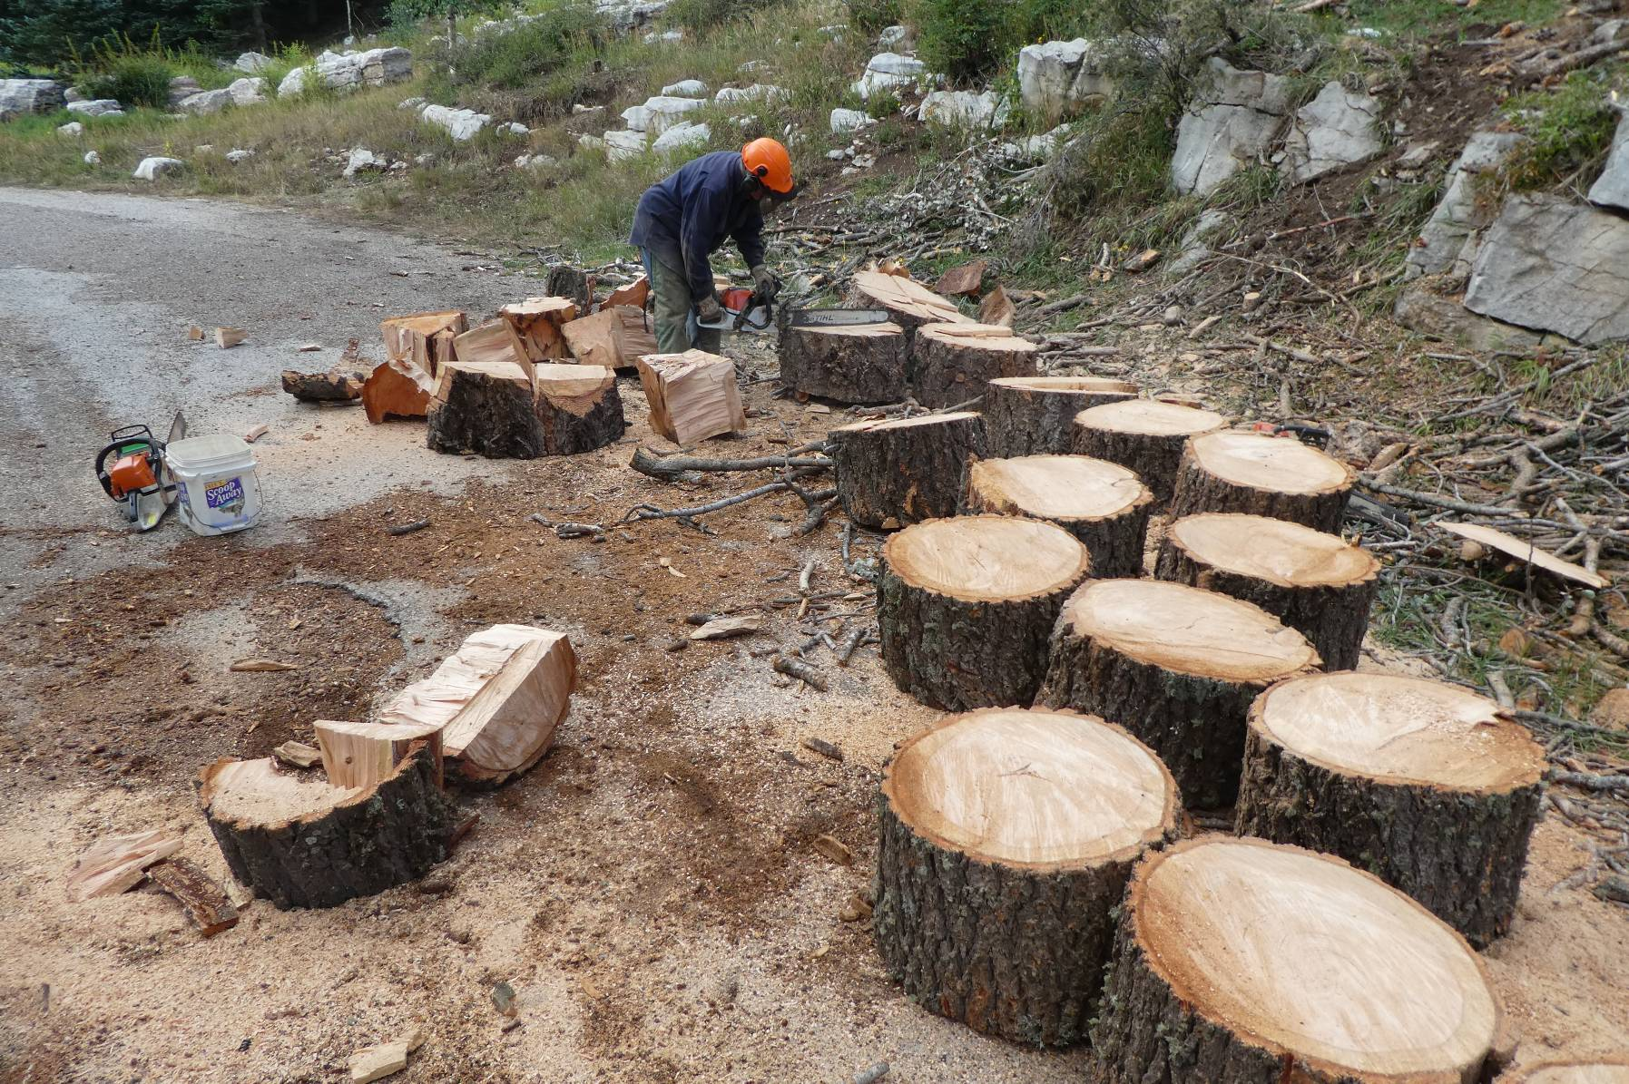
Jerry Carroll scoring another large round. These rounds were especially difficult to split due to twists in the grain.

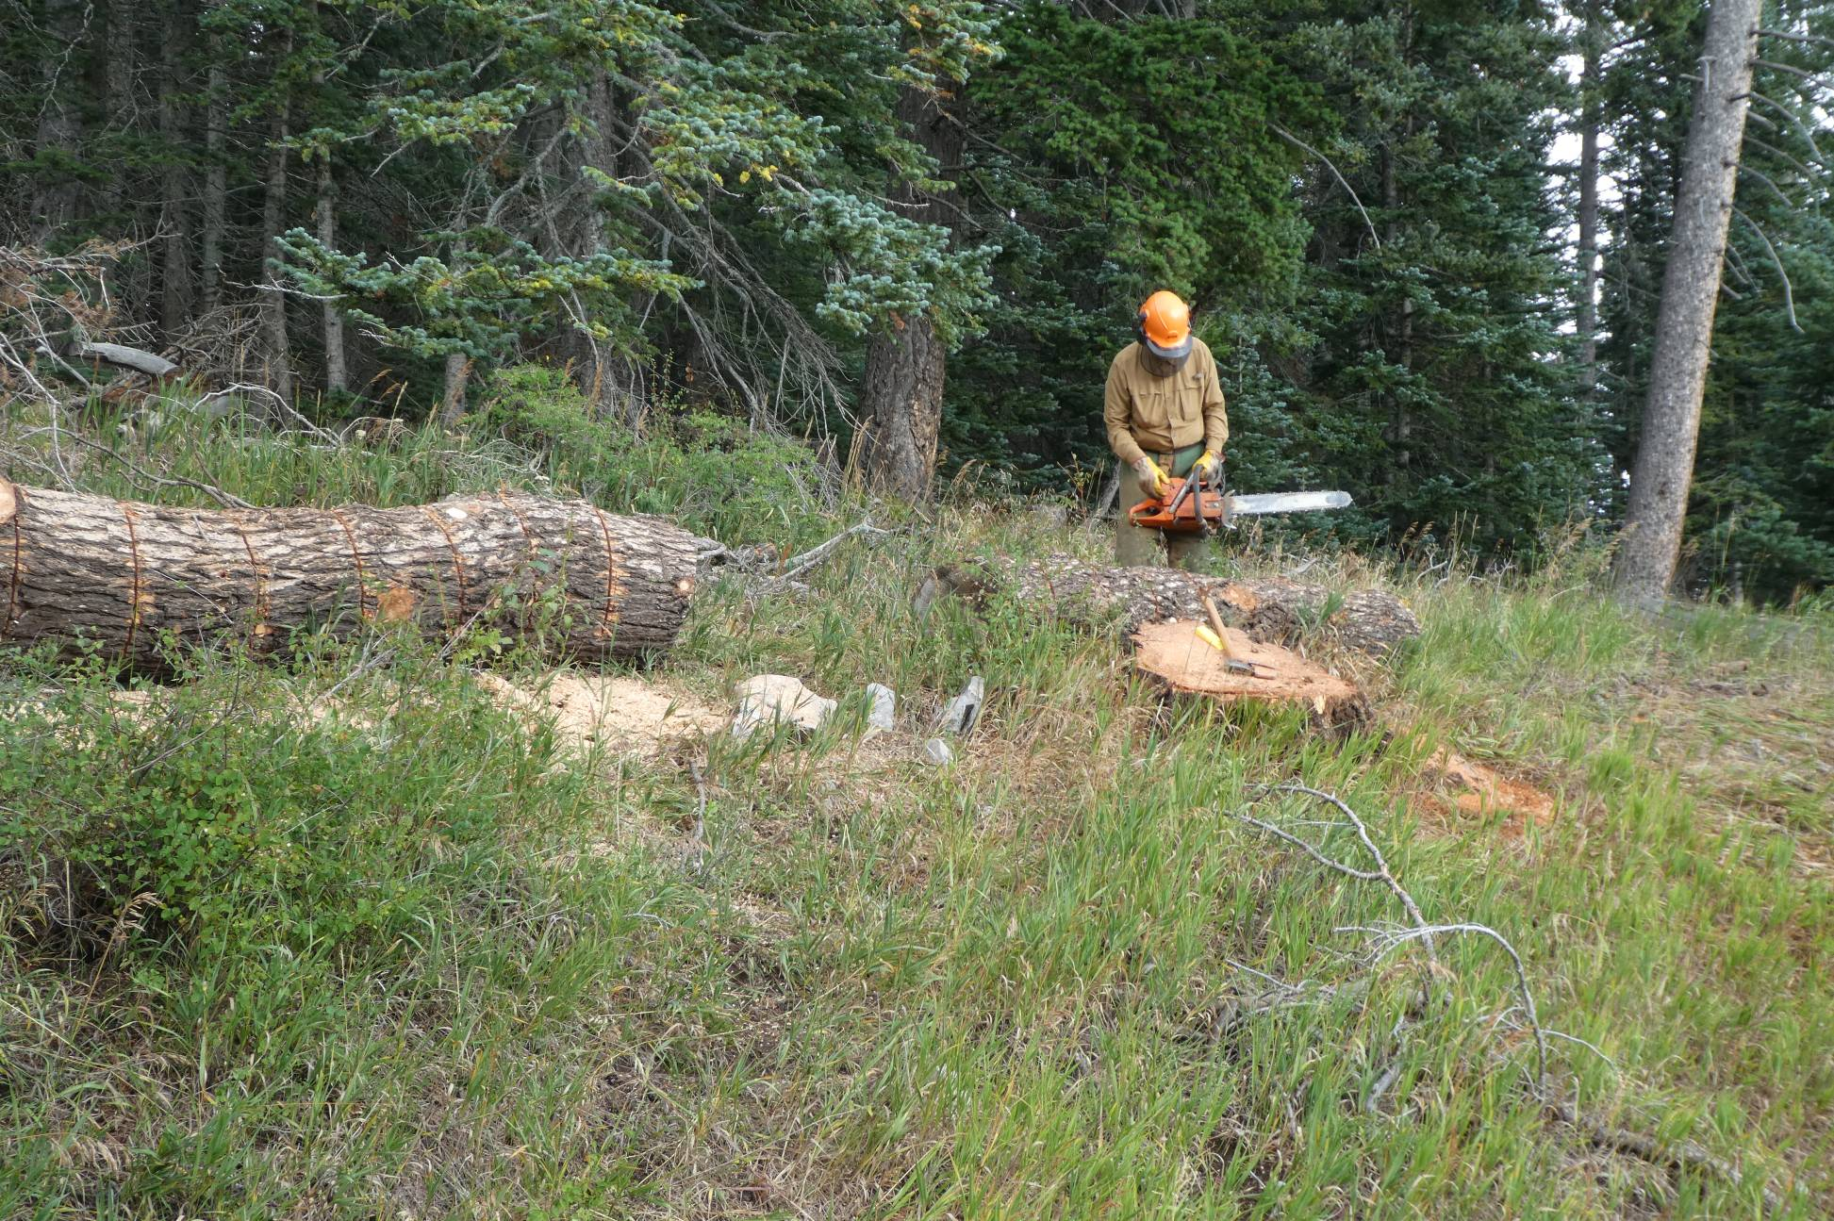
Dan Benton is bucking two logs that were felled a few years ago.

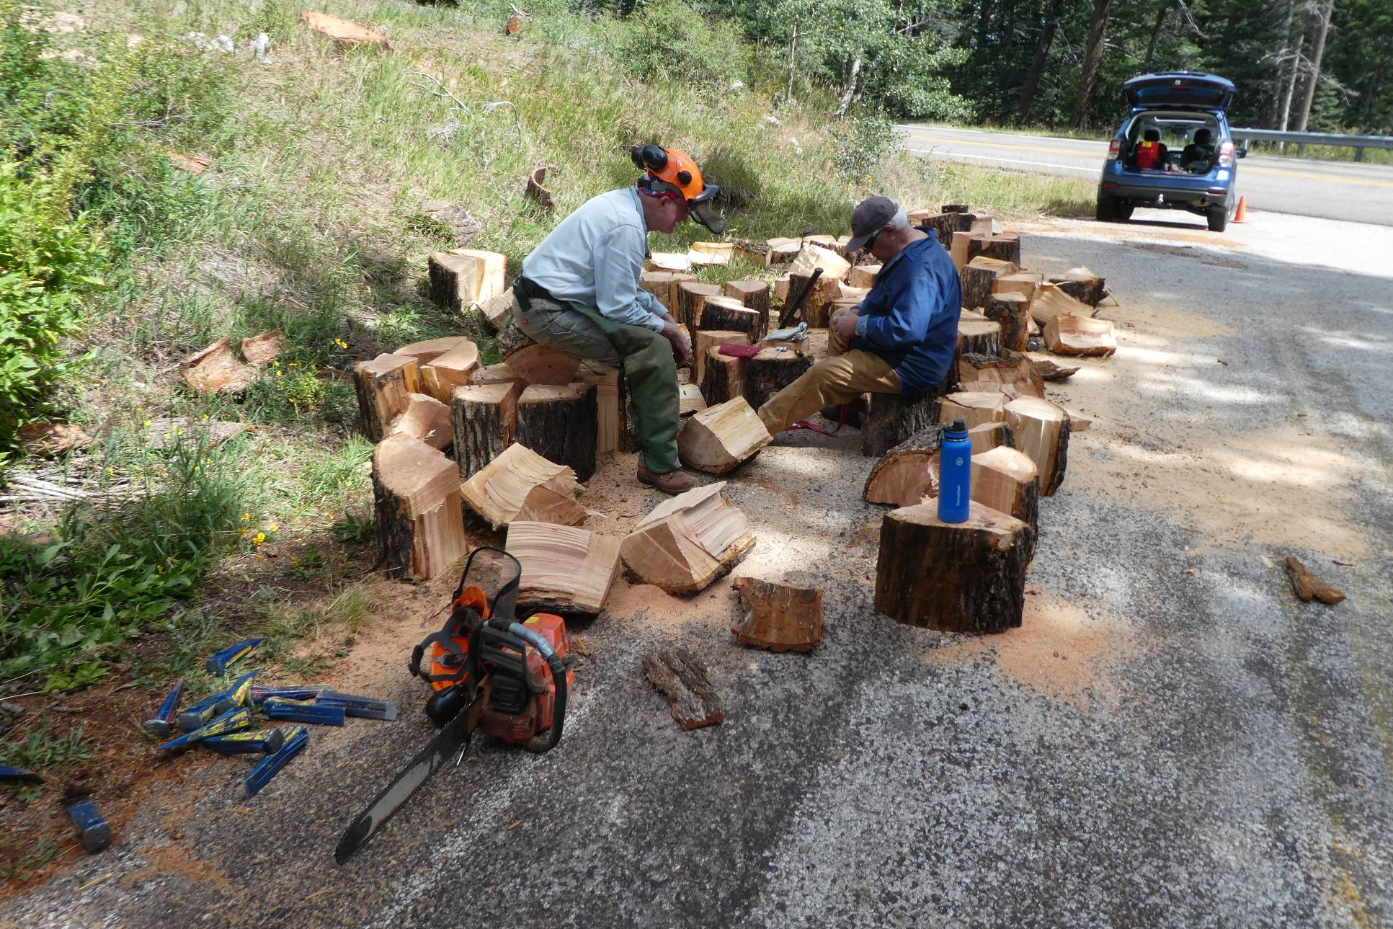
These rounds were bucked by Dan and moved down to the pavement.
They were much easier to split than the rounds from the larger tree.

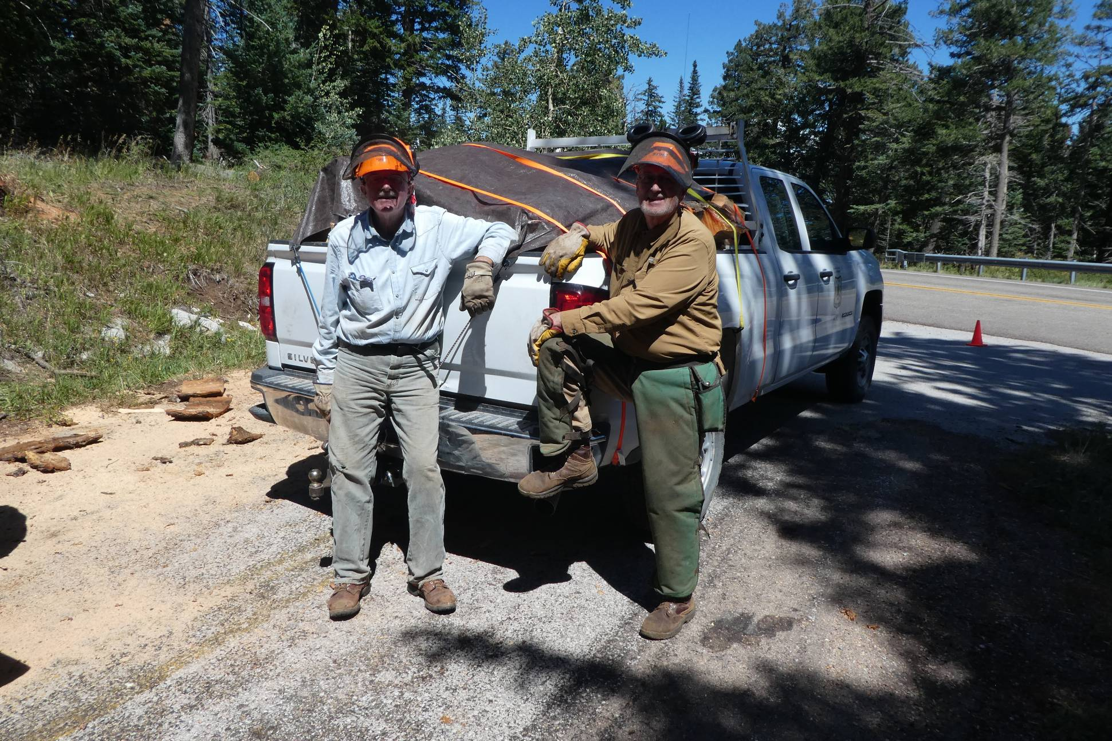
L to R: Eric Russell and Dan Benton ready to haul the second load to the hazmat building. Kerry Wood, SRD Trails and Wilderness Program Manager, had told them that covering the load with a tarp was safer than just using tie downs.
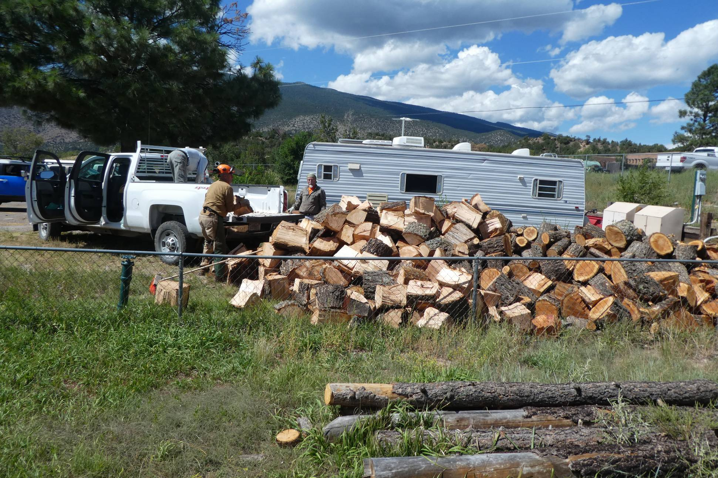
Unloading the wood at the hazmat building. L to R: Eric Russell, Dan Benton, and Bill White.
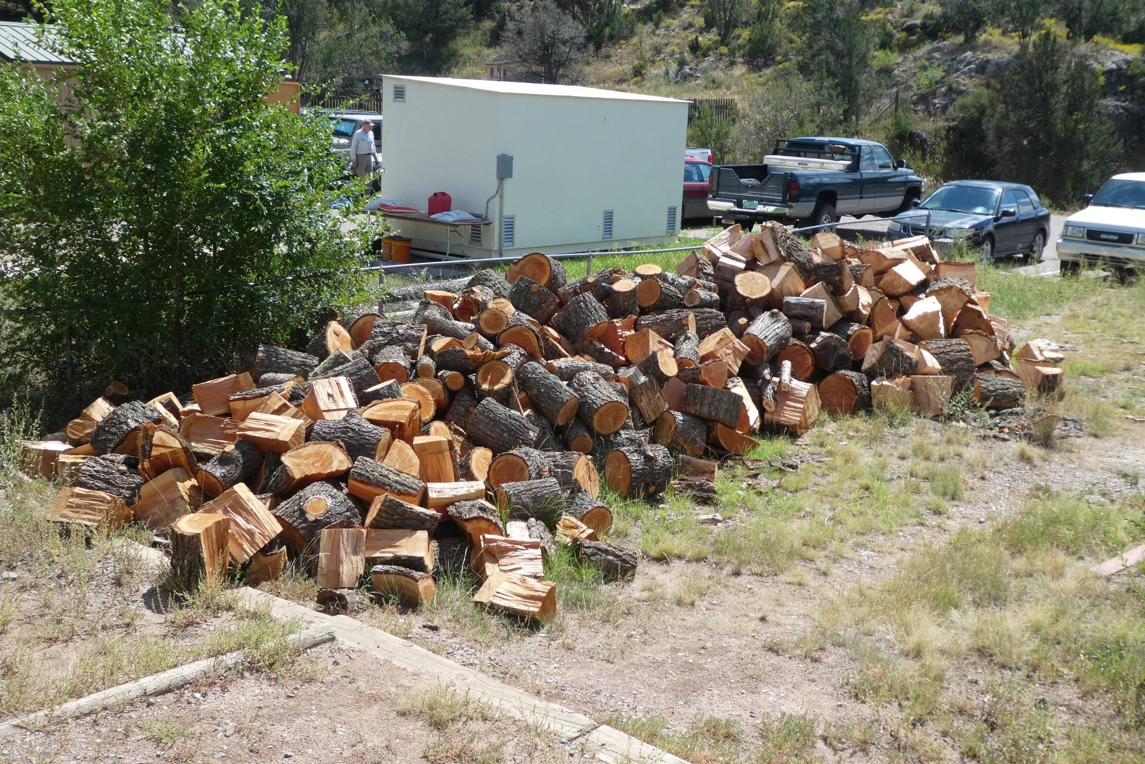
The large pile of bucked and split wood ready for the Mountain Christian Church Wood Ministry to collect.

