Friends of the Sandia Mountains
Annual Newsletter, September 2019
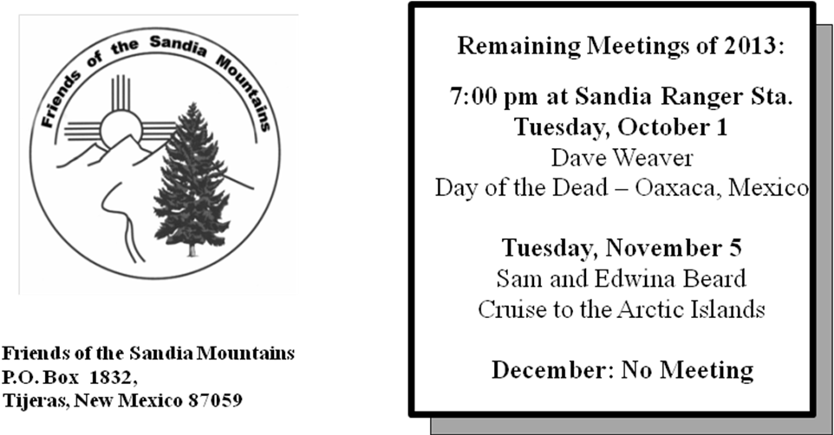
October Monthly Meeting

7:00 pm at Sandia Ranger Station
Tuesday, October 1

Evolution of Cross Country
Skiing in the Sandia Mountains

Scott Dietrich, Steve Roholt,
and Sam Beard

Nov. through March, No Meetings

From the President

It would be hard to say that the past year in the Sandias could be called average in any way. Outstanding would probably be a better word to describe the near record snowfall that provided many opportunities for winter related activities and provided perfect conditions for our Annual Sandia Snowshoe Race. The biggest problem this year was trying to get enough snow cleared from the highway and Crest parking lot just to have the race at all!

The massive winter snow melt-off and higher than normal spring rains ushered in beautiful green conditions going into summer resulting in an outstanding display of flowers in amounts not seen in many years. The annual monsoon seemed a bit below average, but it still was a very quiet fire season. As this is written and autumn is at last starting to make its appearance, the first fall colors are beginning to show on the mountain

As is usual, our Sandia volunteers dedicated thousands of hours to various maintenance and improvement activities. Our Paint Crew kept the signs, various structures, parking lot stripes and whatever else needed a coat of new paint all looking fine. The Trails Construction Crew built or improved miles of District trails providing an enhanced experience for trail users. A combination of the usual supply of dead trees and a couple of violent windstorms resulted in a record number of fallen trees which were removed from the trails by our Trail Maintenance Crew and other volunteers.

There is so much more work that was done by our volunteers over the past year than can not be described in this brief space but will be described in the pages below.

Please take the time to read the activity reports that follow which document the varied projects and activities undertaken by our FOSM volunteers over the past year.

As always, my sincere thanks go to all our dedicated volunteers for their hard work and for all they do on behalf of our organization and the greater public good. Thanks also to the FOSM Officers and Board for their guidance and direction and to the staff of the United States Forest Service Sandia Ranger District whose support and encouragement are vital to our mission.

See you on the mountain,

Bob Lowder, President Friends of the Sandia Mountains

Meadow Restoration in the Cedro CFRP

The Cedro CFRP (Collaborative Forest Restoration Project) is a multi-year multi-organization project on a few hundred acres of the Sandia Ranger District located along Forest Road 242 (Juan Tomas Road) between NM-337 and the village of Juan Tomas. Working with FOSM are two other non-profit organizations, The Nature Conservancy and Talking Talons Youth Leadership. FOSM has committed to thinning 36 acres of forest with scattered trees in three years. The primary objective of the FOSM thinning project is meadow restoration by removing pinon and juniper trees. Tree trunks and large branches are piled and collected as fuelwood as part of Eagle Scout projects.

Provisions of the thinning prescription are to remove pinon and juniper trees with DRC (diameter at root collar) less than 13 inches, not fell ponderosa pines and Gambel oaks, pile felled trunks for fuelwood, place slash in drainages to reduce erosion or scatter it, not fell trees within 25 feet of three drainages and not within 50 feet of a large arroyo along the lower edge of the meadow.

Thinning First 12 Acres – Volunteers began thinning the northern and eastern parts of the 32-acre zone on August 29, 2018. Thinning of the first 12 acres was completed on November 7, after seven working days plus a few days of flagging to mark various boundaries of the zone.

Thinning Second 12 Acres in 2019 -- The second 12 acres are located in the western part of the 32-acre zone south of the old fence. Thinning here was done from November 21, 2018, to December 19, 2018 and from June 8, 2019, to June 21, 2019 when the crew stopped working at 1 pm due to the heat. Additional work will be postponed until the fall when the temperatures are lower. Five of the 12 acres to be thinned in 2019 have been thinned.

Flowers -- Work done in the first year is already showing positive results, as wildflowers are abundant in the areas cleared by FOSM and contract masticators. Common species include Santa Fe Phlox, Indian Paintbrush, Scarlet Bugler Penstemon, Wandbloom Penstemon, and Coreopsis. (Sam Beard and Dan Benton)
FOSM Trail Construction Projects

An assortment of FOSM and other volunteers contributed time and effort to a variety of trail projects under the direction of Kerry Wood, SRD Trails and Wilderness Program Manager, and Russell Berman, Cibola National Forest and National Grasslands Resource Assistant – Trails. This kind of work seems to appeal to a variety of outdoor enthusiasts: hikers, mountain bikers, equestrians, rock climbers, runners, and skiers who keep coming back for more.

Over 30 trail sessions were coordinated in fiscal year 2019 with SRD, except for a few breaks to accommodate winter weather in December through February and a couple of monsoon weather cancellations. In addition to building new trails, the crews obliterated bypassed sections of user trail, erected a trailhead kiosk, assembled rock retaining walls, cut trail corridor, removed deadfall, and installed new trail signs. The volunteers have received positive feedback from trail users on the improvements.

Cienega/Armijo Trails Improvement Project -- The primary focus for the year was the Cienega/Armijo Trails Improvement Project (CATIP) which was first launched in 2017. The new trail system is now 73% complete and will add over six miles of new sustainable trails to the SRD trail network. The work last year included major reroutes of Armijo Trail #222, a trail popular with hikers, equestrians, runners, and mountain bikers. Other tasks included clearing trail corridor, building designated reroutes of user trails, and obliterating extensive sections of unsustainable trail.

Coyote Trailhead Accessible Trail -- When the ice, snow, mud, and cold of winter finally shut down trail construction higher up on the mountain, the FOSM trail crew was looking for any viable projects. Kerry Wood requested support to build an accessible trail at the Coyote Trailhead just off NM 337, so four work sessions in January, February, and March were devoted to building the trail loops. Volunteers cleared corridor, cut a four-foot wide trail tread, built a rock retaining wall, groomed sections where the SRD skidsteer was able to rough out the tread, installed signs, and then spread a thick layer of crusher fines over the finished trail.

Ranger Rock Climbing Area Improvements -- The FOSM membership includes several active rock climbers and a number of former rock climbers. So when Kerry Wood defined a number of improvements needed on the popular Ranger Rock climbing area near the Sandia Ranger Station, FOSM volunteers teamed with local climbing organizations to make the upgrades. The tasks completed included rerouting and improving access trails, opening trail corridor, clearing loose rubble from the cliff top anchor points, building stone steps to access a belay platform, and constructing a rock retaining wall to widen a belay platform.
Juan Tabo Picnic Area Trailhead Access Trail -- Last October, Kerry Wood requested FOSM support to build a trail enabling access to the La Luz Trailhead during a major expansion of the parking area. The new trail helped maintain public access to this very popular trailhead during construction. Experienced FOSM volunteers pitched in to build a trail winding through the oak, juniper, cactus, and boulders to the La Luz Trailhead.
Horse Bypass Parking Lot Trailhead Kiosk and Trail Signs -- In 2018, FOSM received a grant of $5,000.00 from REI, which procured an informational kiosk for the Horse Bypass Trailhead parking lot and signs for SRD trails. FOSM volunteers provided the labor to install the kiosk and the trail signs. FOSM was awarded another $5,000.00 grant from REI in 2019 which is procuring a number of trailhead kiosks to be installed in 2020. REI’s generous support is enabling upgrades to the SRD trail network to encourage and enable public use of our natural resources.
Sandia Trails Improvement Project -- The FOSM trail crew also contributed to the initial phases of the Sandia Trails Improvement Project (STIP), which focuses on improving the SRD trail network higher up on the mountain. Most of the trail construction is scheduled for fiscal year 2020, but work on a couple of high priority areas was started. The SRD seasonal trail crew completed a major reroute of unsustainable trail sections of the very popular 10K North Trail #200. FOSM volunteers in three trail sessions worked to completely obliterate the bypassed length of trail, ensure trail drainage, level tread, build a rock retaining wall, and widen some narrow sections. (Bob Galloway)
Snowshoe Race
The 16th annual Sandia Snowshoe Race was held on January 26, 2019. It serves as FOSM’s only fundraiser. What a difference a year makes! We were forced to cancel the 2018 race due to a lack of snow. In 2019, we had an abundance of snow, but we had other challenges. Due to a shutdown of the federal government, the agency was not able to plow any of the parking lots in the Sandias. As a result, we had several feet of heavy, consolidated snow in the Crest Parking Lot. Fortunately we were able to hire a private contractor to plow this lot and others on the upper part of the mountain. FOSM stepped up, and paid the contractor. We had cooperation from the Ranger District to the extent they were able.
On race day, we had beautiful weather and course conditions, along with a fully cleared parking lot. The before and after results spoke for the incredible effort that was put forth. Many people assisted in this team effort. Thanks to all who helped in any way.
Michelle Hummel won the overall race. She also won the 2017 race. The results are posted on the Sandia Snowshoe Web site, if you would like to see them. Thanks to Mike Coltrin for handling the Web site.
This was our first year to hold the event on the "new" course. Several of our top finishers, along with some of our volunteers, noted that the course must be short, and indeed it was, by 0.2 mile. Serious racers seem to be able to tell as their times were too fast for the full 5 K. We will remedy this in 2020 with some minor course modifications.
I had much positive feedback about the race and also some suggestions as to how to improve it.
Once again, big thanks to everyone who helped. This would not happen without you. (Steve Roholt)

FOSM Trail Maintenance Crew

By using the FOSM Cibola Trail Rangers email group, volunteers hiking on the District are able to report fallen trees and other problems found on the trail system. The fallen trees are recorded and tracked on the Trail Tree Report that is maintained and distributed by FOSM Board member Sally Lowder. Based upon this report, volunteers are able to identify where problems exist on the trails and to plan for ways to address these problems. It has become practice for our trail maintenance crew to schedule trail work hikes on Mondays. Other days may be used if circumstances such as emergency or other high priority work require it.

This crew consists of individuals who have expressed a desire to do this type of work. Their names are included on an email list, and they are contacted as trail work hikes are scheduled. Depending on the location of the work, a chainsaw or crosscut saws are used to remove the fallen trees. Hand tools such as a cant hook, Pulaski, loppers, hedge trimmers or other hand tools are also used.

During the period October 2018 through August 2019 the crew removed a total of 359 fallen trees from Sandia District trails. (Bob Lowder, Crew Leader)

Hazard Tree Removal

During the early spring, SRD personnel flagged dead hazard tree in Pine Flat PA, Oak Flat PA, Doc Long PA, Cienega PA, Tree Spring Trailhead, Balsam Glade PA, and Las Huertas PA. FOSM volunteers felled 30 hazard trees at these sites in April and May. At the request of Kerry Wood, SRD Trails and Wilderness Program Manager, FOSM sawyers identified and felled 13 dead trees at the Ski Area Overflow Parking Lot. These trees were left there to block a user road leading to the north into the forest. In July and August FOSM sawyers identified and felled ten dead trees at Dan’s Loop and the Kiwanis Cabin parking lot. Approximately ten cords of wood from all these sites were hauled to the hazmat building where it was stored until the Mountain Christian Church Wood Ministry collected it. This wood will be donated to East Mountain needy families.

Most of the large rounds from the hazard trees and a very large fir that fell in Cienega Picnic Area were split manually with steel wedges and sledgehammers. Volunteers split these very heavy 12-inch long rounds so that they could be handled safely. The number of hazard trees removed from each site, and the dates they were felled are given in the adjacent table. A total of 63 hazard trees were removed. (Sam Beard)

Dates Hazard Trees Removed FY2019
September 15, 2019
Sam Beard, FOSM
Location | Hazard Tree Numbers | Date Removed  2019
Pine Flat PA | 01 | 4/1
Oak Flat GA | 01 | 4/1
Doc Long PA | 01-05 | 4/2
Cienega PA | 01 Hang-up  01 Oak Branches  02-06  07-09  10-12 | 4/5  4/3  5/4  9/4
Tree Spring TH | 01-04 | 4/10
Balsam Glade PA | 01-05  06  7-10 | 4/10  4/16  4/10
Ski Area Overflow Parking | 01-02  03-13 | 4/16  4/19
Capulin PA | 01-02 | 4/16
Dan’s Loop | 01  02  03  04  05 | 7/31  8/7  8/14  8/21  8/28
Kiwanis Cabin Parking Lot | 01-05 | 7/13
Las Huertas PA | 01-05 | 4/27

FOSM Email Notification Groups

Communication to and between members is important for most organizations and ours is no exception. FOSM established its email notification system in 2002 using the Yahoo Groups system. Due to the unreliability of the Yahoo groups system, FOSM changed the carrier to Southwest Cyber Port, an Albuquerque company, in 2019.

Sandia Volunteers/ FOSM – This group of about 180 email addresses is made up of all FOSM members, authorized USFS/SRD volunteers and others who have expressed an interest in receiving the information it provides. This system publishes announcements of FOSM projects, monthly FOSM meetings, information from our partners at the USFS Sandia Ranger District, etc. Messages to this group require approval by a moderator.

Cibola Trail Rangers – This group of 128 email addresses provides a forum for anyone to report trail conditions on our Sandia trails. Many of our trail maintenance projects have resulted from messages submitted on this system. Messages posted on this system do not require moderator approval. (Bob Lowder, System Administrator)

Albuquerque Mayor Tim Keller Honors Sam Beard

On September 4, 2019, our own FOSM Projects Chair, Sam Beard, was the inaugural recipient of the ONE ALBUQUERQUE Volunteer of the Month award. The tribute occurred in the Mayor’s personal office at City Hall with family and friends present. Television crews from Channels 7, 13 and Gov TV recorded honoring remarks by First Lady, Elizabeth Keller, and the Mayor. Sam was recognized for a wide variety of on-the-ground services he provides to support the US Forest Services and the Greater Albuquerque communities so that the public can enjoy safe experiences in the Sandia Mountains. Every week he is on the mountain scouting, organizing and arranging for teams of FOSM volunteers to maintain forest trails, picnic sites and facilities year-round. He also personally manages the care and maintenance of a wide variety of tools used.

Sam’s exemplary volunteerism spans 50 plus years in New Mexico and the Cibola National Forest. He pioneered much of the development of Cross-Country ski trails we enjoy today. In 1988 he authored the second edition of Ski Touring in Northern New Mexico which ski enthusiasts still appreciate.

We, the FOSM membership, are happy and proud and congratulate Sam. We are grateful for his leadership and the credit he brings to the Friends of the Sandia Mountains. (Lou Romero)

FOSM Publications

Recreation Guide to the Sandia and Manzanita Mountains - This year we continued to distribute this free visitors guide that includes information about sport activities, picnic areas, camping, volunteer work, parking fees and passes, wilderness restrictions, temperatures and precipitation, maps, trail lengths and difficulty, and Leave No Trace. The guide is available at the Ranger Station, Crest Visitor Center, REI, and Tinkertown. In addition, they are frequently distributed at all FOSM outreach activities and handed out by FOSM Volunteers to visitors at the Tram.
Early in 2019, it became apparent that our supply of Recreation Guides was running extremely low and would not cover the upcoming summer season. A preliminary examination to look into reprinting the Guide revealed the prior printer and graphic designer were both out of business plus the format “Page Maker” was totally obsolete and not used by anybody in the business any longer. Fortunately our graphic designer discovered an old PDF file which she shipped to Starline Printing here in Albuquerque, and they agreed to do a reprint if we could limit the updating changes required to a bare minimum. Otherwise a complete redo in a new modern format would be required.
A group of FOSM members, along with the Sandia Ranger District Staff , came up with the changes and Starline Printing masterfully incorporated them and printed 3000 copies. Unfortunately, next time around, we will be looking at a complete redo in a new format. (Don Carnicom)
Field Guide to the Sandia Mountains - UNM Press reports that the sales to date are approximately 13,000 copies. They are currently selling about 200 copies per year. (Tim Brown)

Sandia Crest Area Trails Map
About a year and a half ago, Kerry Wood, the SRD Trails and Wilderness Program Manager, designed an excellent map of the trails in the Crest/Tram Area which our volunteers hand out to visitors at the Tram and the Crest. After printing 2000 in 2018, we were starting to run out in early 2019. We initiated a new order for 2000 more which were delivered in July. (Don Carnicom)
Sandia Ranger District Signage Program
The FOSM Signage Committee continued to keep an updated inventory of the interpretative education signs on the District. Many of the signs are concentrated in the Crest, Tram and Kiwanis Meadow areas. Others are scattered throughout the picnic areas and trail heads around the District. Maintenance, such as graffiti removal and complete sign replacement was performed as required throughout the year. (Don Carnicom)
FOSM Records Retention
Throughout the year we continued to get our corporate records collected and filed. Now all electronic files and hard copy records are stored in a locked cabinet in the FOSM office at the Ranger Station. The electronic files are stored on a flash drive that is updated about twice a year. A duplicate set of files are kept on another flash drive and on a hard drive. Any director issuing a document they wish to have retained can copy it to the email address, fosmrecords@friendsofthesandias.org, and it will end up on the flash drive. (Don Carnicom)
Restoration of CCC Restrooms in La Cueva Picnic Area

Two pairs of CCC (Civilian Conservation Corps) stone restrooms are located in La Cueva Picnic Area. The upper men’s and women’s restrooms are just west of the modern restrooms at the fee pay station. The lower pair is well hidden in boulders and trees west of the middle parking lot.

These restrooms are pit toilets that are not approved by the EPA. In order to prevent the use of these CCC buildings, but still preserve them for the public to visit, Joelle Hertel, volunteer restoration project leader, helped design a steel frame with bars that is secured with a USFS lock. Bars were installed in the four restroom door frames in the spring of 2019.

Upper Restrooms – In the fall of 2018, the door frame header was replaced. The door frame and door were primed and painted with USFS brown paint. The door hinge of the women’s restroom had come off the pintle that was attached to the door frame. The pintle bolt installation was repaired, and the door was re-hung. This door frame and door were also painted.

Lower Restrooms – After bars had been installed in these restrooms, the door frames and doors were painted. (Sam Beard and Michael Arndt)

Modification of Three Modern Picnic Tables in La Cueva Picnic Area
At the request of Sandra Arazi-Coambs, SRD Archaeologist, and Joelle Hertel, volunteer project leader for this picnic area restoration, one long bench on each of three modern picnic tables was removed earlier by FOSM volunteers so that the tables were wheelchair accessible. In FY2019, short wooden benches were fabricated for the table side that was accessible. Dan Benton and Sam Beard installed the two short benches on each of the three modified tables with stainless steel hex bolts screwed into rusty steel inserts in the concrete bases. It was necessary to chase the insert threads with a tap in order to screw in the new bolts.

In order for the design of the short benches and the long benches to be similar, the old long benches were replaced with 2x8 long benches fabricated by Jim Lunn. After the new long benches were installed, two coats of Penofin redwood stain/waterproofing were put on all the new benches. (Sam Beard)
Other Projects in Juan Tabo Basin

FOSM volunteer Joelle Hertel, Project Leader for Restoration of the Juan Tabo and La Cueva Picnic Areas, contributed to the following projects:

La Luz Area Gate – A solar operated gate was purchased and installed at the entry to the La Luz area and Juan Tabo Picnic Area.

Repair of La Cueva Tables and Benches – She organized and oversaw the repair of concrete tables and benches by the carpenter union members in the La Cueva Picnic Area. (Joelle Hertel)

Medical and Saw Certifications

Every year there are classes to be taken by our Chainsaw/Crosscut Sawyers in order to maintain their current certifications for saw work on the Sandia Ranger District. We currently have 30 certified sawyers: 10 chainsaw, 25 crosscut and 5 with dual certifications. There are 6 members in chainsaw trainee status. This allows them to receive field practice with a certified B sawyer. They will receive final certification with a C Sawyer from the Sandia Ranger District at a later time. These members are Byron Garner, Scott Dietrich, Mark Grazier, Michael Arndt, Ben Meisner and Phil Cromer. Four of these individuals already are B certified for crosscut saw work.

The following medical parts of the certification process must be completed: every year (Bloodborne Pathogens), every 2 years (CPR/AED) and every 3 years (First Aid). All our sawyers and trainees are current with their medical certifications.

FOSM had 8 members recertified for crosscut saw work; 4 members were recertified for chainsaw and 1 member received her first chainsaw certification. Congratulation to Lorna Morrow for her accomplishment!

Included here are the names of the certified sawyers (crosscut-cc) (chainsaw-cs):
Sam Beard cc cs, Bob Lowder cc cs, Dan Benton cs, Bill Savage cc cs, Betsy Galloway cc, Bob Galloway cc cs, Jim Levesque cc, Eric Russell cc cs, Rav Nicholson cc, Steve Roholt cc, Roger Wrolstad, cc, Byron Garner cc, Jerry Pekarek cc, Dave Gabel cc, Pete Rhyins cc, Bill White cs, Dennis Crowther, cs, David McCreery cc, Chris Fritzsche cc, Jerry Carroll cs, Bet Gendron cc, Sim Cook cc, Cliff Giles, cc, Cleve Sharp cc; Scott Dietrich cc, Jenny Blackmore cc, Mark Grazier cc, Lorna Morrow cs, Michael Arndt cc. David Harding, a non-FOSM member is also cc certified.

A huge thank you should go out to these folks that put in hours of training and work to keep our District safe. Thanks to Kerry Wood, Trails & Wilderness Program Manager, who provides training, certifications and support. Thank you also to Crystal Powell, District Ranger, who supports our FOSM organization in our efforts to provide the care our Sandia Mountain so deserves. (Sally Lowder)

Adopt-A-Trail Program
For the most part, the Sandia Ranger District does not now use an adopt-a-trail model for trails on the District. Instead, interested groups are asked to take part in one of the scheduled trail workdays during the summer season (typically April - October).
Since October 1, 2018, seven legacy Adopt-A-Trail groups have performed 666.5 hours of trail work as of September 10, 2019. Groups reporting hours were the New Mexico Cross Country Ski Club (numerous cross country ski trails in the Sandia Crest area), Southwest Forest Service Amigos (North Crest and Oso Corredor trails), Friends of Piedra Lisa South (Piedra Lisa South trail), New Mexico Volunteers for the Outdoors (Pino trail), Friends of the Sandia Mountains (Tecolote Trail and Cienega Nature Trail), Rav and Ken Nicholson (10K South trail), and the Happy Hoofers (South Crest trail from the Crest House to the upper Tram Terminal).
Absence of a summer fire closure was probably responsible for an increase of 237.5 hours from the prior year. Another 20 days remain in the fiscal reporting year and good weather may provide opportunities for additional hours that will be reported in next year's totals. Again this year the Southwest Forest Service Amigos had the most site visits (8), followed closely by Rav and Ken Nicholson and the Cross Country Ski Club (7 apiece). The Amigos also had the most hours (254).
During the course of the year two groups reporting hours have since dropped out of the AAT program -New Mexico Volunteers for the Outdoors (Pino trail) and Friends of Piedra Lisa South (Piedra Lisa South trail). However, at the very end of the reporting period, the Sandia Nordic Ski Club (Nordic ski trails) was added to the program. Welcome aboard! (Dan Benton)
Paint Crew Report

The paint crew's objective for FY2019 was to beautify the picnic areas in the Sandia Mountains by painting restroom doors the new FS cinnamon and trash receptacles FS brown. Starting at Doc Long PA, we worked our way through Cienega PA and Sulphur Canyon refreshing a total of 32 receptacles. Six doors have been painted. Benches along the Cienega Nature Trail were scraped and painted as were the Braille information pedestals.

The large restroom at the end of Cienega Canyon road was in need of a complete refurbishment which took three of our work sessions. FS brown went on the building and a new FS cream on the privacy panels and trim. Sam Beard researched the federal standards paint samples, and FOSM purchased the new cream paint.

Winter snow, although much needed, is hard on parking lots. The Crest required the most attention with us returning to paint the yellow safety strips on each step from the upper parking lot to the observation deck. All three levels of the parking lot were striped. Other parking lot projects included Balsam Glade, Sulphur Canyon, Sandia Ranger Station's front lot and the area around the maintenance building.

Volunteers worked 17 sessions and an average of 5.5 hours each day. Our painters are Rikki Barrett, Sam Beard, Jane Harrison, Anne Hickman, Diana Helgeson, Ellie & Russ Parker and Nancy Peterson. (Ellie Parker)
Trees Removed from Trails

The Sandia Mountains enjoyed a much-needed snow pack this year. However, the trees that adorn our mountain did not enjoy the weather so much. The warm 2018 year brought drought and bugs. The 2019 year ushered in cold, snow and horrible winds. The trees responded appropriately to each event. The trees died at an alarming rate. Trees broke off in the wind events, and many were uprooted. It did not matter whether the trees were alive or dead when uprooted. Of course, you know what that means, the crews were all very busy working to clear the mess of the weather events.

Thanks to all the many volunteers that stepped up to the plate and not only reported the trees down on the trails or in the picnic areas, but to the hardy souls that did the work to clear the trees from their unwanted positions. Trees ranged in sizes from 3 inches to 36 inches. Crosscut saws, chainsaws and 21-inch Corona Razor Tooth saws were all used. Added to those tools are the cant hooks, Pulaskis, McLeods, loppers and other tools that were carried along by the crews. It takes a strong, dedicated bunch of folks to get out there and keep the mountain safe for all to use.

This 2019 Fiscal Year brought reports of 359 fallen trees. A huge THANK YOU to all the volunteers who braved the elements to venture out to clear these trees. Whether it be 4 degrees or 98 degrees, the work got done. A total of 725 trees were removed from the official designated USFS Trail System.

Everyone played such a vital role in clearing the trees. However, I must mention a few that stood out: FOSM CREW (321), Beard Team (108), Roholt Team (54), Dave Gabel (40), New Mexico Volunteers for the Outdoors -NMVFO (24), and the Forest Gnome who shows up every year (22). That is a total of 500 trees removed. The remainder of 225 trees were removed by various individuals/groups. The trail with the most trees down was Oso Corredor with some 70+ trees removed; followed closely by 10KN from TH to Ellis of 53 trees. Many others had totals of 25 or more.

I must mention that Pauline Ho, Richard Buss, Dave Gabel, Cliff Giles and Jamey Browning are providing outstanding documentation of problems on the mountain. It makes my job so much easier in keeping track of the work needed to be done. (Sally Lowder)

Sign Shed Roof Replacement

On October 1, 2018, FOSM volunteers completed the new roof on the sign shed in the SRD bone yard (storage yard) near the shop. Kim Round, SRD Recreation Staff Officer, requested that FOSM put a new roof on this building after strong winds blew off the original one-piece aluminum roof.

The original poor quality sheathing was not adequate to support a new roof; therefore, OSB sheathing was screwed to the rafters. Steel roofing panels were then screwed to the OSB. The roof has an eave width of 4 inches and a roofing panel overhang of 1 inch at the drip edge on the eaves. The roof was finished by screwing trim pieces on the gable ends and a ridge cap over the upper ends of the panels. Sim Cook, Michael Arndt, Russell Parker, and Sam Beard completed this project in four work sessions between September 14 and October 1. (Sam Beard)

Pruning Juan Tabo and La Cueva Picnic Area Roads

On February 8 and 13, volunteers pruned brush on both sides of Juan Tabo Picnic Area Road at the request of Kerry Wood, SRD Trails and Wilderness Manager. At the FOSM Guard Station when we were loading the USFS truck and hitching the chipper to the truck, the temperature was 0 F. At the meeting place on FR-333 east of Tramway Road, the temperature was still low enough that Sally Lowder had problems starting the chipper engine.

The crew used chain saws to cut brush, mostly clumps of mountain mahogany, and prune one-seed juniper and pinon trees that were on the shoulders of the road within 5 feet of the pavement edge. The larger brush and tree branches were chipped with the SRD Vermeer chipper. The pruned part of the road was more attractive, and sight distances were improved for vehicle and visitor safety.

On March 27, FOSM volunteers completed extensive pruning with chain saws and loppers along the full length of La Cueva Picnic Area Road (1.2 mile). They pruned or removed and chipped several dozen Apache plume, gray oak, one-seed juniper, and mountain mahogany plants. (Sam Beard)

Cutting Brush in Capulin Snow Play Area Parking Lot

On Oct. 19, 2018, four FOSM volunteers cut brush in the traffic island and around the parking lot at the Capulin Snow Play Area. Prior year projects to reduce the amount of large brush in this area has definitely paid dividends in that most of the brush can be cut with brush cutters instead of chain saws. Ben Meisner and Jerry Carroll used the two FOSM Stihl brush cutters to cut brush in the traffic island. Bob Lowder cut large brush around the edge of the parking lot and some in the traffic island with a chain saw. Sam Beard used the SRD small lawn mower to cut grass along the lower edge of the traffic island and around the edge of the parking lot. Generally, the brush was too large and the ground was too rough to use the lawn mower on the less steep parts of the traffic island. (Sam Beard)

Wildflower Walks

June, July and August Saturday Wildflower Walks, sponsored by the Sandia Ranger District and FOSM, and led by a team of nine volunteers, continued a tradition started by Pearl Burns more than 25 years ago.

Team Members for 2019 were Tom Baumgartel, Mari Draper, Vicki Farrar, Chris Husted, Kathy Lord, Marj Patrick, Frances Robertson, Becky Schnelker , and Jean Payne. Due to a June article in the Albuquerque Journal, more eager participants than in other years met at the Sandia Ranger Station parking lot to start the informative outings. Some of the walks required three leaders, rather than the usual two, to interact with and lead the larger groups.

The Wildflower Walks began the season with many more flowers than the past few years due to heavier than usual snowfall. By the end of August, because of a drier monsoon season, finding easily accessible trails for participants that also had plentiful wildflowers to list on the handout given to all attendants was challenging. Oasis Albuquerque, a unique educational program for older adults, requested two separate Wildflower Walk sessions which were coordinated and organized by Becky Schnelker, Chris Husted, and Frances Robertson led the seniors on those weekday outings. (Jean Payne)
Crest Visitor Center

Summer 2019 at the Crest House Visitor Center was successful due to a group of 11 dedicated returning volunteers including: Fran Lusso, Dave Weaver, Tim Brown, Don Hoke, Chris Kelleher, Ken Nicholson, Sue Keil, Jim Patrick, Robin Bender and Kitsie and Don Smiset. Two new volunteers came on board as alternates, Pete Rhyins and Renee’ Tourville, to substitute when the schedule volunteer for that day could not make it. With no forest closures this year, the team was able to staff the Crest VC daily from Memorial Day through the end of Balloon Fiesta.

To help promote the Crest Gift Shop and encourage visitors to stop by the Visitor Center, signs were placed outside of the building including a plywood cutout of Smokey Bear. We talked to an average of 25 to 30 people per day; handed out free area maps and gave suggestions on hiking trails; monitored trails for hazards; picked up trash around the Crest parking and viewing areas; and talked to a number of children interested in hearing the story of Smoky Bear.

If you or anyone you know would like to join the team for next year, have them contact Don Smiset or the Sandia Ranger Station. All that you need is a love of the mountain and an interest in sharing this with visitors, some of whom are visiting from other countries. (Don Smiset, Project Coordinator)

Four Seasons Visitors Center

The Four Seasons Visitor Center opened Memorial Day weekend. The season runs through Balloon Fiesta; however, we are open only on Friday, Saturday and Sunday, and on Labor Day after August 25. Visitation was up from an average of 119 per day through Labor Day in 2018 to 143 per day through Labor Day in 2019. This was the result of having volunteers every weekend when more people visit.

Our volunteers are: Joe Espinosa, Jay Fielding, George Guerdrum, Kathleen Kackerson, Helene Eckrich, Jim Levesque, Judy Levesque. Fotoni Lujan, Pam McCoy, Khondeh Mirshek, Tim Murphy, Amy Rizzo, Lynn Ruger, Gerhard Salinger, Dennis Vik and Linda Vik.

Our space is in an alcove of the Upper Tram Terminal where we display materials on a coffee table. This year FOSM provided a very good supply of colored maps of trails around the top of the mountain for day hikers. We were able to leave them out for any visitor to take. The map can be viewed at:
https://www.fs.usda.gov/Internet/FSE_DOCUMENTS/fseprd535719.pdf.
Through Labor Day we were open 98 days and have had 13,998 visitor contacts. These include 106 Junior Rangers, a program supported by FOSM. THANK YOU, FOSM! (Lynn Ruger)

Mowing Snow Play Area Slopes

On September 26, 2018, three FOSM volunteers helped mow the sledding areas at the Capulin Snow Play Area. Michael Arndt, Scott Dietrich and Steve Roholt assisted AJ Brown and Bob Gore from the SRD in mowing the snow play area sledding slopes. After AJ and Bob did the safety briefing, each volunteer was assigned to a machine to cut grass and brush. Michael used a brush cutter around the bathrooms at the north end of the parking lot and other areas and assisted Bob in putting up some snow fencing. Scott and Steve used walk-behind USFS power mowers (48-inch mower and 36-inch brush hog) to mow the sledding slopes and the pathways along the side which are used for walking to the tops of the slopes. It was a beautiful day with ideal working conditions. (Steve Roholt and Scott Dietrich)
FOSM/SNSC Work on Groomed Ski Trails

October 11, 2018 - FOSM members Lou Romero, Michael Arndt, Rich Besser and Scott Dietrich worked to remove stumps and deadfall from the Klaus Trail in order to get the trail ready for grooming once the snow falls. The Klaus Trail runs parallel to the Rocky Point Trail and Service Road. The trail, which had not been groomed for the past several years, was prioritized by Sandia Nordic so skiers accessing trails from the tram could use it as an alternate to the Service Road, which was periodically plowed by the Ski Area during construction of the new Ten-3 restaurant.

October 19, 2018 - Using the Sandia Ranger District’s 48-inch mower and 36-inch brush hog, FOSM members Jeff Huser and Scott Dietrich mowed the sections of the groomed trails that traverse the 10K Meadow and the smaller meadow across from the Dan’s Loop parking area. Mowing the small brush, which tends to act as a heat magnet and facilitates snow melting if not attended to, helps prolong the snowpack and extends the length of time that the meadow trails can be groomed.

November 2, 2018 - FOSM members Sam Beard, Michael Arndt, Jeff Huser and Scott Dietrich continued work on the south end of the Klaus Trail, low stumping several stumps and bucking fallen trees. Bucked sections of the trees were moved to the low side of canted trail to catch the snow and help level the trail to facilitate grooming and skiing. This process is called “cribbing”.

December 3, 2018 - FOSM members Sam Beard, Steve Roholt and Scott Dietrich worked to remove fallen trees from the Klaus Trail and also from the small access trail that leads to the Klaus Trail from Sandia Nordic’s grooming equipment storage container. Several stumps were also low cut during the outing. (Scott Dietrich)

Metal Roof on Pine Flat North Restroom
On October 22, 2018, FOSM volunteers began replacing the roof on the Pine Flat picnic area north restroom. The old roof was removed with a sturdy fork and a flat bottom shovel to raise the shingles and remove nails. The roof debris was loaded in the SRD dump trailer and hauled to the Tijeras Transfer Station. Three-quarter inch plywood was used to replace decayed sheathing. Russell Parker used his pneumatic nail gun to quickly nail the new plywood to the rafters and also put nails in the original plywood. 30-pound felt was stapled and nailed to the sheathing with 1-1/4-inch roofing nails. 2-inch long deck screws were added to the fascia on the eaves and gable ends of the roof. Wide dark brown steel drip edging was nailed along both eaves.
On October 29, volunteers completed the installation of a metal roof on the Pine Flat Picnic Area north restroom using materials purchased by Kim Round, SRD Recreation Staff Officer. After nailing a drip edge on each of the eaves so that rain is directed away from the wooden fascia, they screwed steel panels over the felt that was nailed to the plywood. A time-consuming part of the project was cutting semi-circles in the panels at the south end of the roof where the two 12-inch vent pipes are located. The installation of the steel components was completed by attaching the wide trim on each gable end and installing the ridge cap over the upper ends of the panels. The final step was to seal the joint between the pipes and the panels with roofing cement reinforced with a fabric strip. The volunteers working on this project were Dan Benton, Sim Cook, Bob Galloway, Betsy Galloway, Ellie Parker, Russell Parker, and Sam Beard. (Sam Beard)

Treasurer’s Reports

Expenditures in Support of the Sandia Ranger District - Total expenditures were $27,047.15 broken down as follows: Juan Tabo CCC $11,246.13, miscellaneous projects $6,731.65, Cienega/Armijo Trail $5,566.12 and Snowshoe Race $2,444.63. (Tim Brown)

Membership - We now have 106 memberships compared with 100 memberships at this time last year. New memberships are: Ben Meisner, Michael Arndt, Mark Grazier, Charles Karaian, Jenny Blackmore, Peter Marks, Mark Biesel, Jim and Marilyn Mallinson, Lawrence Clayton, Elizabeth Kapiloff, Don Lemke, Debra Stefen, James Houle, Kelly McClendon. Welcome Everyone! (Tim Brown)

Audits - In October 2018 Art Arenholz completed an audit of the FOSM financial records. He reported the records to be accurate and in good shape. Also, in November 2018 Tim Brown completed an audit of the FOSM physical assets. (Tim Brown)

Financial Report - We began FY2019 on October 1, 2018 with a checking account balance of $32,404.62 and on September 1, 2019 the balance was $17,647.48. We also have two CD's which total $41,358.77. The largest expense was $23,530.83 for projects. The largest revenue was $6,308.12 from donations and grants for specific projects and Snowshoe Race $3,715.00. (Tim Brown)

Other Projects

National Trails Day Project -- On Saturday, June 1, eight FOSM volunteers completed a project at the Pino Trailhead in Elena Gallegos Picnic Area in Simms Park. At the request of Kerry Wood, SRD Trails and Wilderness Manager, they built a half-chicane to discourage the passage of bicycles into the Sandia Mountain Wilderness at the Park boundary. The tasks included digging two post holes with the FOSM Stihl power post hole auger, installing 2 posts, and screwing four pieces of 2x4s to the posts. Lunch was provided at the Park's Kiwanis Shelter, and door prizes were passed out to the lucky ticket holders. The prizes were donated by REI and other local businesses. All the volunteers won a prize.
The FOSM volunteers were Dan Benton, Cliff Giles, Jerry Pekarek, Tim Brown, Jim Levesque, Rick Buss, Pauline Ho, and Sam Beard.

Bob and Betsy Galloway worked on another project on the east side of the mountain. Kerry Wood led a NTD project to reroute part of the Challenge Trail near Nine Mile Picnic Area so that it would be more sustainable. (Sam Beard and Dan Benton)

Maintenance of Cienega Picnic Area Nature Trail -- FOSM adopted this trail several years ago; therefore, Don Carnicom repaired a few interpretive signs by placing epoxy putty around the metal plates on top of the large wooden posts where the wood had decayed. Down trees on the paved path and adjacent to the path were removed and hauled to the donation pile at the hazmat building. Don and Sam Beard removed a large Rocky Mountain juniper that had fallen on the path between the middle restroom and the low bridge near the Nature Trail. Don also replaced a 2x8 board in this bridge. (Sam Beard)
Earth Day Event -- SRD demonstrations for Earth Day were on Tuesday, April 23, for the second through fifth grade students from A. Montoya Elementary School in Tijeras. Local wildlife and outdoor organizations presented demonstrations and handed out information about various outdoor topics including Smokey Bear and wildfire. Jim Levesque and Sam Beard were at a table with a display of crosscut saws and pruning saws. One-inch long disks were cut from a 5-inch diameter log with a one-person crosscut saw with Jim or Sam on the D-handle end of the saw and a student on the small end of the saw with the short vertical handle. Many students enjoyed sawing, and some even stayed at the table and made more than one cut. The disks were given to the students. (Jim Levesque and Sam Beard)
Restaining/Waterproofing Capulin Picnic Area Kiosk and Shelter -- When the Capulin Spring Picnic Area was rebuilt several years ago, the wooden kiosk and shelter were finished with a stain/waterproofing product. Due to weather and solar radiation, most of the finish on the east sides of these structures had been removed. At the request of the SRD, the kiosk and lower parts of the shelter eastern end (posts and lower beam) were refinished with Cabot’s Australian Timber Oil stain/waterproofing. The shelter upper beams will be refinished later using scaffolding to reach these structures. (Sam Beard and Russell Parker)

Challenge Trail Rerouting and Maintenance -- During the spring and summer of 2019, three short segments above and one segment below Nine Mile Picnic Area were rerouted by the SRD Trails Crew to reduce the grades and make these segments more sustainable. On three outings this summer, the entire trail was maintained by FOSM/Ski Club volunteers, and blue diamonds were installed along the lowest rerouted segments. Kerry Wood’s Trails Improvement Plan includes the rerouting of a quarter-mile of this trail from the groomed trail area to Kerry’s/Sam’s Trails parallel to the Crest Highway from Dan’s Loop to 10K South Trailhead. (Sam Beard and Jerry Carroll)

Cutting Brush at Cienega Road and Crest Highway – On October 26, Jim Lunn, Ben Meisner, Dennis Crowther, Don Carnicom and Sam Beard cut brush at the intersection of Cienega Picnic Area Road and the Crest Highway. Removing brush increases the sight distance at this intersection. They also cut brush around the entrance to Sulphur Canyon Picnic Area. (Sam Beard)

Filling Potholes – On September 25, 2018, Russell Parker, Michael Arndt, Lou Romero, and Sam Beard worked with SRD employees Steven and Amelia to fill five small holes and one large hole in the Crest parking lot. The cold patch was tamped manually before being compacted with the front wheel of a SRD pickup driven by Steven. At Balsam Glade Picnic Area, this crew filled one large hole and one medium-size hole. (Sam Beard)

Sign on FOSM Guard Station -- Jim Lunn made the sign on the west end of the FOSM Guard Station from a Rocky Mountain juniper, and he and Lou Romero mounted it on the building. (Sam Beard)
Juniper Branches for Ornaments on Capitol Christmas Tree -- At the request of Esther Nelson, SRD Wildlife Biologist, about three dozen juniper branches were collected as part of a project to make ornaments for the Capitol Christmas Tree from the Carson National Forest. The 3 to 5-inch diameter branches will be cut into one-inch long disks with red centers and white rims. (Sam Beard)
FOSM Outreach
Bear Fair - On September 23, 2018, Dan and Pat Benton and Tim Brown staffed a table at the annual Bear Fair located at the Rio Grande Zoo, providing information and answering questions. (Tim Brown)

Celebrate Wildlife Event at Wildlife West Nature Park. – On June 15 the Wildlife West Nature Park celebrated wildlife with their Wildlife Festival. Many wildlife orientated organizations such as FOSM, Sandia Mountain Bear Collaborative, NM Herpetological Society, Sandia Mountain Bear Watch and a number of others participated. On the order of 75 people passed through the Jo White Theater where each organization had a table displaying their handouts, literature, photos, and in some cases live animals. We passed out a number of Recreation Guides, FOSM membership applications, Crest Maps, SRD Trail Maps and other literature plus selling a couple of our books. (Don Carnicom)
Short Decorative Posts on Three Modern Picnic Shelters

In the 1990s, two large picnic shelters were built at Doc Long Picnic Area, and one was built at Balsam Glade PA. The design of these shelters included two short decorative wooden posts at each corner to give the buildings a rustic appearance. The untreated posts were set in the ground, and concrete was poured around them. Over the years the lower part of these posts decayed, and most of the posts were removed. The remaining holes in the concrete were tripping hazards, and at the request of Kim Round, SRD Recreation Staff Officer, FOSM volunteers filled the holes with concrete during the past year.

During 2018, FOSM collected logs from felled trees to make replacements for the removed decorative posts. The 9-inch to 15-inch diameter logs were cut to a length of about 33 inches, and the tops were beveled on four sides. Sandra Arazi-Coambs, SRD Archaeologist, approved this design that matches the decorative posts in the Doc Long CCC picnic shelter. Three 2-inch lag screws were placed in the bottom of each post to elevate it one-half inch from the concrete in an attempt to reduce moisture damage.

Two replacement posts were installed at each large structural post in all three shelters. The posts were secured to the large posts with 8-inch long 3/8-inch lag screws inserted through 1-inch diameter holes in the posts so that 4-inches of the screws penetrated the large posts. The holes in the posts were plugged with 1-inch wooden dowels, and the posts were painted. (Sam Beard)

FOSM 2019 Monthly Meeting Programs
Lou Romero, Vice President
Date | Title | Presenter
April 2 | 2nd Edition of Hiking Guide | Mike Coltrin
May 7 | Juan Tabo Basin; CCC trails and structures | Joelle Hertel
June 4 | Untold Smokey Bear Stories | Larry Allen and Abel Camarena
July 2 | Science Voluntourism: Volcanoes to Bees | Pauline Ho
Aug 6 | 60 Hikes within 60 Miles | David Ryan
Sept 3 | History of La Madera/Sandia Peak Ski Area | Michael Donovan and Jessica Fox
Oct 1 | Cross Country Skiing in NM | Scott Dietrich; Sam Beard, Steve Roholt

Chain Saw Maintenance and Chain Sharpening

Although chain saw maintenance and chain sharpening are done year-round as needed, on Dec. 5 and 12, the Wednesday project was cleaning saws and chain sharpening. Eleven volunteers cleaned 14 saws at the solvent station behind the SRD shop and several chains were sharpened. After a saw was cleaned, the drive sprocket bearing was packed with grease. The parts were then reassembled in the following order: bearing, centrifugal clutch drum, rim sprocket, washer, E-clip, clutch cover, bar, and chain. Volunteers were Carl Smith, Dennis Crowther, Jim Levesque, Jerry Pekarek, Jim Lunn, Sam Beard, Eric Russell, Jerry Carroll, Ben Meisner, Dan Benton, and Phil Cromer. (Sam Beard)

Project Participants in FY2019

A total of 127 volunteers worked on at least one project in FY2018. About two to three dozen members frequently volunteer to work on the weekly projects, and about 20 members typically work each week.

The FOSM officers, Board Members, and the Sandia Ranger District Staff appreciate very much the support of all the FOSM members. The names are roughly in alphabetical order. The volunteers who worked on FOSM projects in FY2018 were Jelke Adema, Michael Arndt, Dean Athow, Robin Bender, Courtnee Bennett, Dan Benton, Claudia Bergsohn, Rikki Barrett, Tom Baumgartel, Garrett Beard, Carly Beard, Kyra Blakeman, Jenny Blackmore, Anna Brown, Tim Brown, Richard Buss, Marilyn Caldwell, Don Carnicom, Anthony Campbell, Jerry Carroll, Chris Casey, Tom Claus, Casey Cook, Sim Cook, Dewayne Coambs, Phil Cromer, Dennis Crowther, Scott Dietrich, Mari Draper, Gordon Eatman, Helene Eckrich, Joe Espinosa, Vicki Farrar, Heather Farrell, Jay Fielding, Dave Gabel, Bob and Betsy Galloway, Byron Garner, Tim Garner, Bet Gendron, Steve Gendron, Cliff Giles, Mark Grazier, James Hann, George Guerdrum, Bruce Hansche, Dave Harding, Jane Harrison, Diana Helgesen, Joelle Hertel, Anne Hickman, Pauline Ho, Don Hoke, Jim Houle, Gay Huffman, Jeff Huser, Chris Hustad, Kathleen Kackerson, Betsy Kapiloff, Sue Keil, Chris Kelleher, Jim and Judy Levesque, Larry Littlefield, Kathy Lord, Bob and Sally Lowder, Fotoni Lujan, Jim Lunn, Fran Lusso, Mike Madden, Pat Madden, Bonnie Mauldin, Pam McCoy, David McCreery, Joe Meade, Ben Meisner, Khondeh Mirshek, Lorna Morrow, Tim Murphy, Rav and Ken Nicholson, Terry Owen, Russ and Ellie Parker, Jim Patrick, Marj Patrick, Jean Payne, Jerry Pekarek, Rosalie Rayburn, Pete Rhyins, Eric Rinehart, Amy Rizzo, Frances Robertson, Steve Roholt, Lou Romero, Lynn Ruger, Eric Russell, Scott Russell, Gerhard Salinger, Dustin Sandquist, Bill Savage, Becky Schnelker, Cleve Sharp, Kitsie and Don Smiset, Carl Smith, Mark Starr, Roland Stumpf, Tim Taylor, Doug Thiesen, Paul Torno, John Torres, Renee’ Tourville, John Vande Castle, Dennis and Linda Vik, Kandi Voss, Dave Weaver, Bill White, Roger Wrolstad, Nan Zou, and Sam Beard. (Sam Beard)

Publication of the FY2019 Newsletter

A huge “Thank You” to the following people who contributed to the publication of
the FY2019 Friends of the Sandia Mountains Annual Newsletter: authors who contributed articles, photographers who made informative and interesting pictures, reviewers who found errors in the early versions, and FOSM volunteers who completed the many projects for us to report. This is our year-end historical review that is available to all members, volunteers, and visitors to our meetings. (Sam Beard, Editor)

FOSM Officers
* President – Bob Lowder
821-9640, rjlowder@msn.com
* Vice-President – Lou Romero
275-1570, lromero705@aol.com
* Treasurer – Tim Brown
296-3360, tgbrown@infionline.net
* Secretary – Rav Nicholson
293-6624, skiglutton@peoplepc.com
Board Members
* Sam Beard, 828-0673
samgbeard@msn.com
* Dan Benton, 797-1941
phineasrtree@comcast.net
* Don Carnicom, 281-3421
d-mcarnicom@msn.com
* Mike Coltrin, 299-2056
mecoltrin@gmail.com
* Sally Lowder, 821-9640
rjlowder@msn.com
* Jim Lunn, 506-7316
jamesalunn@aol.com

Ballot: October 1, 2019 Annual Meeting of the Membership

We appreciate the contributions of those Board Members whose terms are expiring at the end of September: Dan Benton, Don Carnicom, Mike Coltrin and Sally Lowder. Continuing Board members are: Sam Beard. The one-year terms of Officers are also expiring as follows: Bob Lowder, President; Lou Romero, Vice President; Tim Brown, Treasurer and Rav Nicholson, Secretary. The members listed below have been nominated for Officer and Board Member positions. (Officers are also members of the board.)

Only current members of the Friends of the Sandia Mountains are eligible to vote in the annual election.

In accordance with Section 5.4.3 of the Bylaws, the Nominating Committee has put forth the following list of candidates for consideration by the General Membership:

President: Vice President:
1. Bob Lowder ___________ 1. Lou Romero______________
2._____________________ 2.________________________

Treasurer: Secretary:
1.Tim Brown _____________ 1. Rav Nicholson____________
2.______________________ 2._________________________

Board members: (Vote for Four)
- Dan Benton ______ 2. Don Carnicom_______ 3. Mike Coltrin. __________
4. Sally Lowder______ 5. _________ (Write-in)

If you are unable to attend the Annual Meeting of the Membership to cast your vote in person, you may vote by mailing this ballot to:

Friends of the Sandia Mountains
P.O. Box 1832
Tijeras, New Mexico 87059

Mailed ballots must be received by 5:00 pm, October 1, 2019

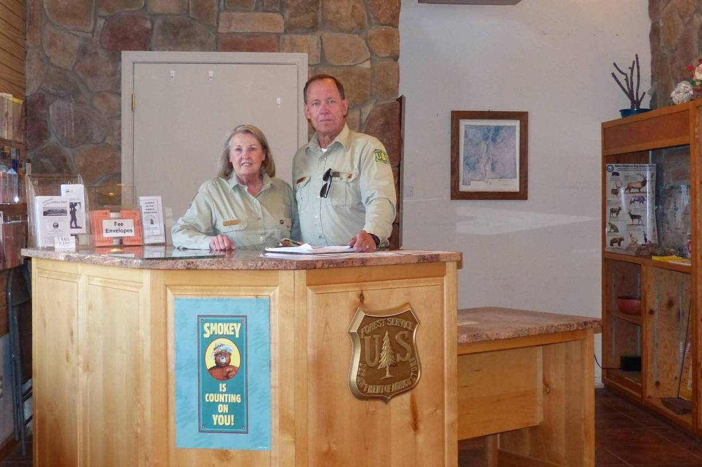
Volunteers Fran Lusso and Dave Weaver at the Crest Visitor Center located in the Crest House.
Photo by Don Smiset

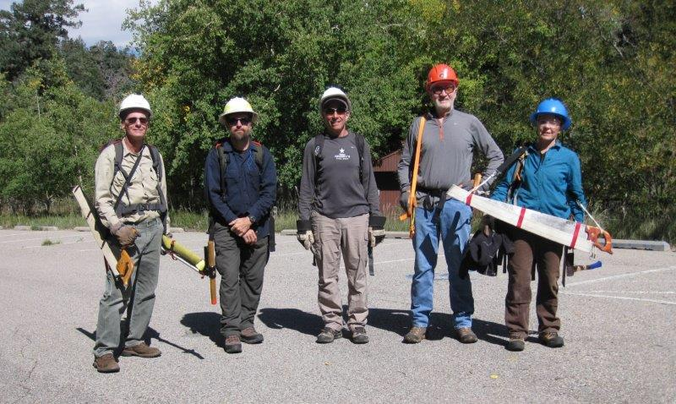
Kerry Wood, Certifier and SRD Trails and Wilderness Program Manager, with a group of
volunteer crosscut sawyers after the volunteers were certified. L to R: Bill Savage,
Kerry Wood, Steve Roholt, Roger Wrolstad, and Bet Gendron. Photo by Carl Smith
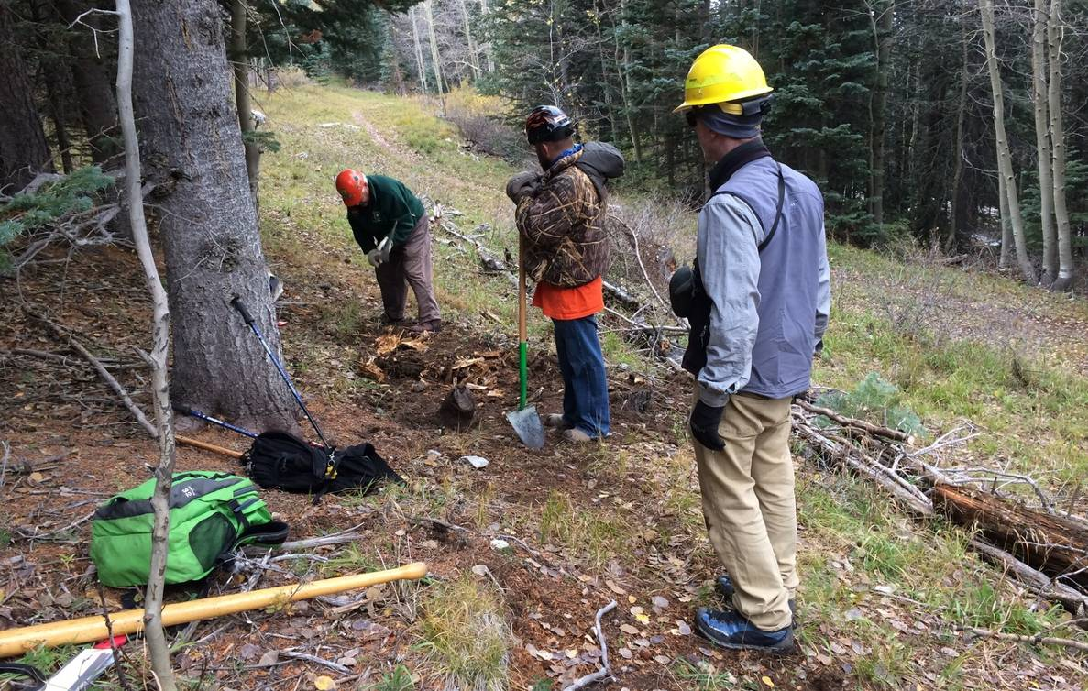
L to R: Lou Romero, Michael Arndt, and Rich Besser. Lou is digging out a stump
so that ski trail grooming equipment will not hit it. Photo by Scott Dietrich.

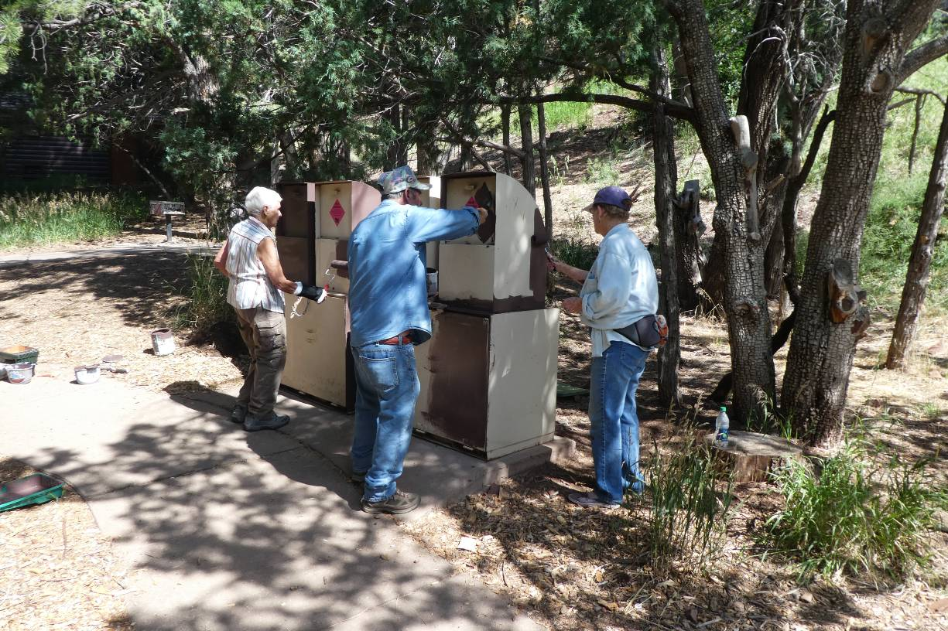
L to R: Jane Harrison, Russell Parker, and Ellie Parker painting trash containers in
Cienega Canyon Picnic Area. Photo by Sam Beard
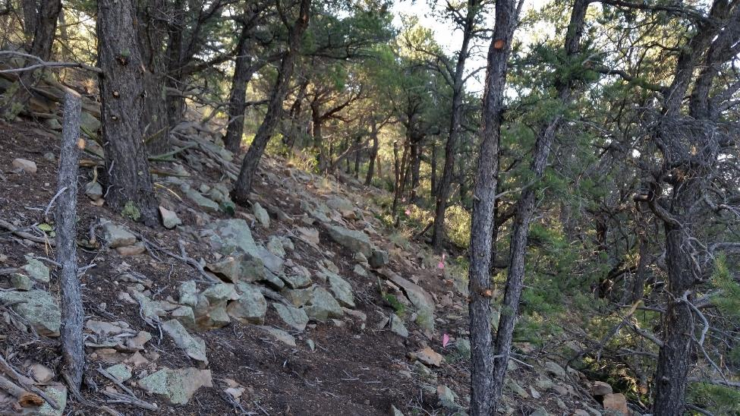

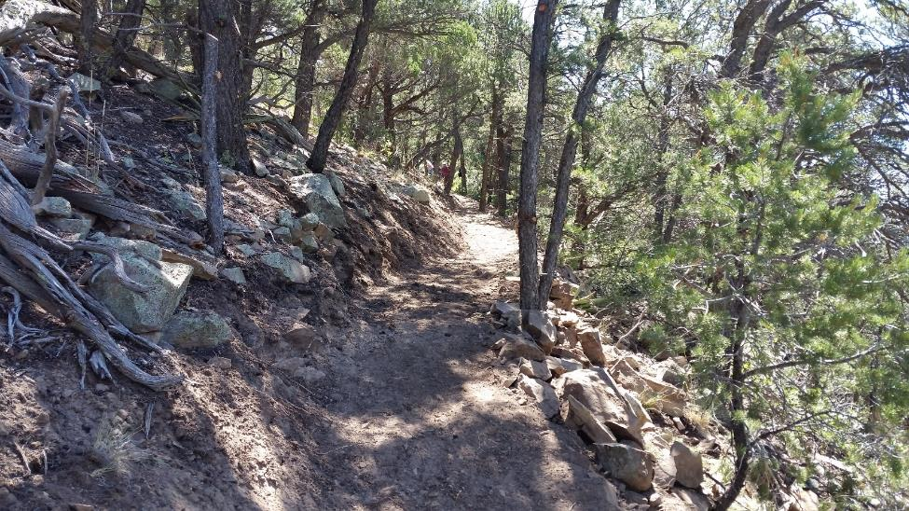
Top: Typical hillside in the Cienega/Armijo Trails Improvement Plan area; and Bottom: After: a nice, sustainable trail section was finished. Photo by Betsy Galloway.

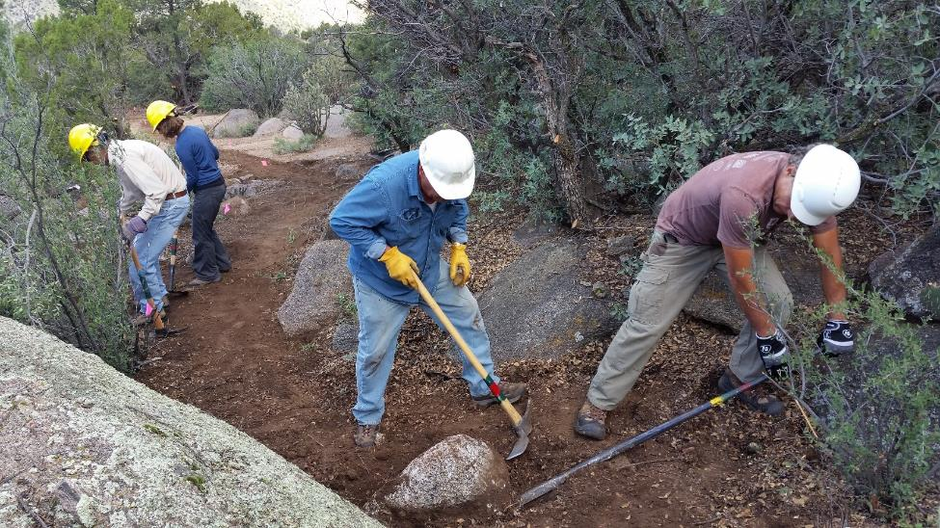
The crew carves the new trail through a boulder field. Photo by Betsy Galloway

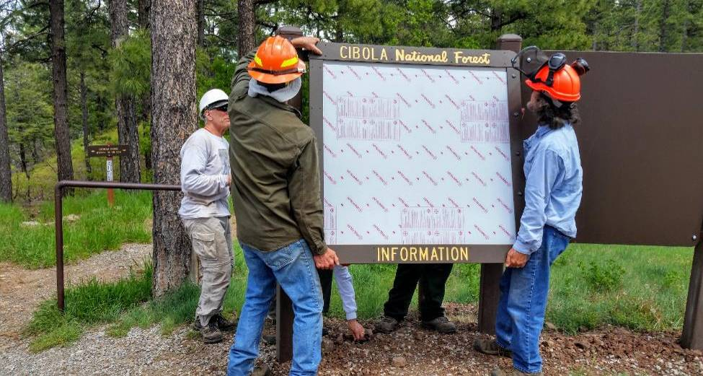
Volunteers install the kiosk information panels at the Cienega Horse Bypass Parking Lot.
Photo by Betsy Galloway.

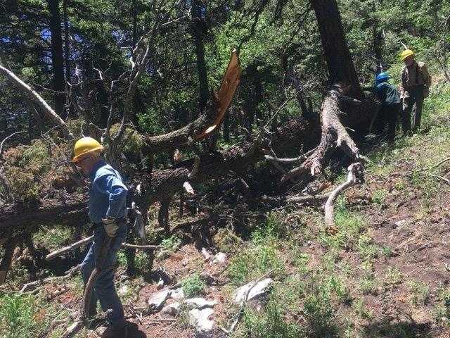

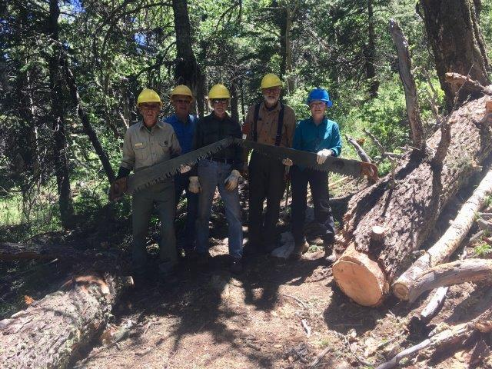
Top: Large tree across the North Crest Trail, and Bottom: The trail after the tree was
removed. L to R: Bob Lowder, Jerry Pekarek, Byron Garner, Sam Beard, and
Bet Gendron. Photos by Cliff Giles
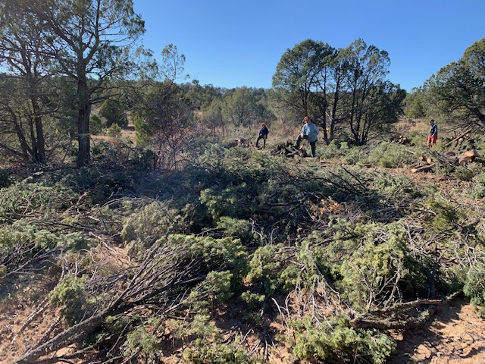
Thinned area in the Cedro CFRP. Note the scattered slash and piles of fuel wood.
Photo by Bob Lowder

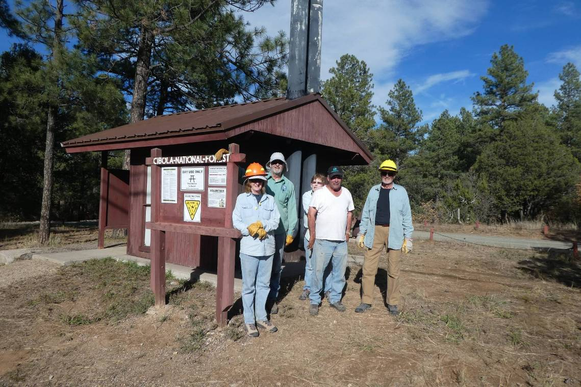
L to R: Betsy and Bob Galloway, Ellie and Russell Parker, and Dan Benton after they
completed the new steel roof on the Pine Flat PA north restroom. Photo by Sam Beard
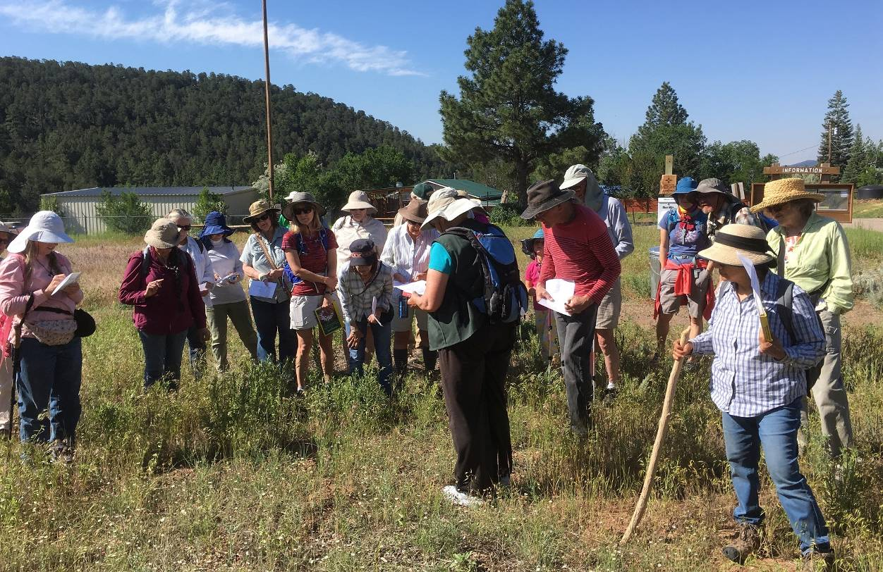
One of the well-attended Saturday wildflower walks.
Photo by Chris Husted

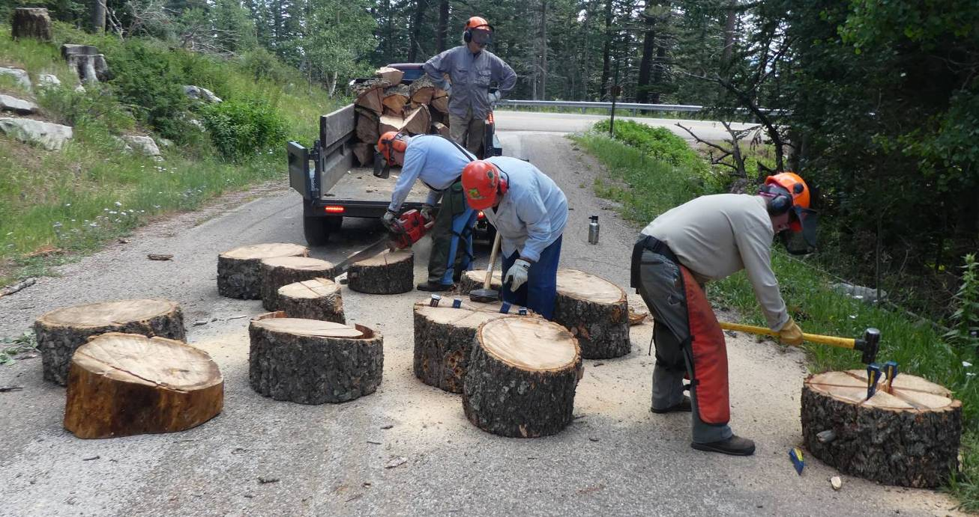
L to R: Dennis Crowther is scoring the Dan’s Loop hazard tree rounds with a chain saw to make
starting the splitting wedges easier. Joe Meade is standing in his trailer waiting for more
wood to stack. Lou Romero and Jim Levesque are splitting rounds. Photo by Sam Beard
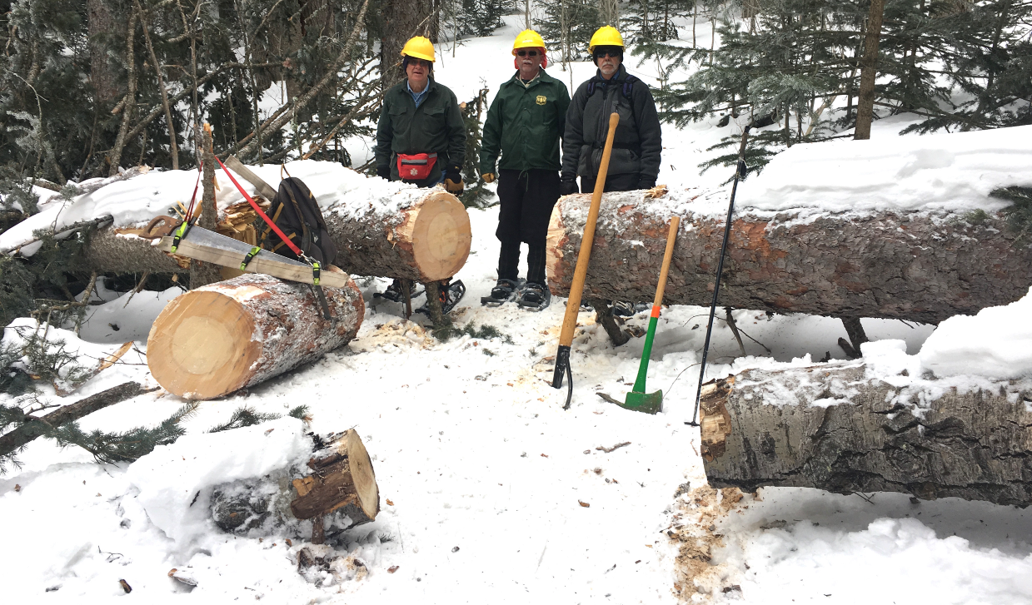
L to R: Jerry Pekarek, Jim Levesque, and Byron Garner after cutting 11-inch
and 21-inch logs across 10K South Trail. Photo by Cliff Giles

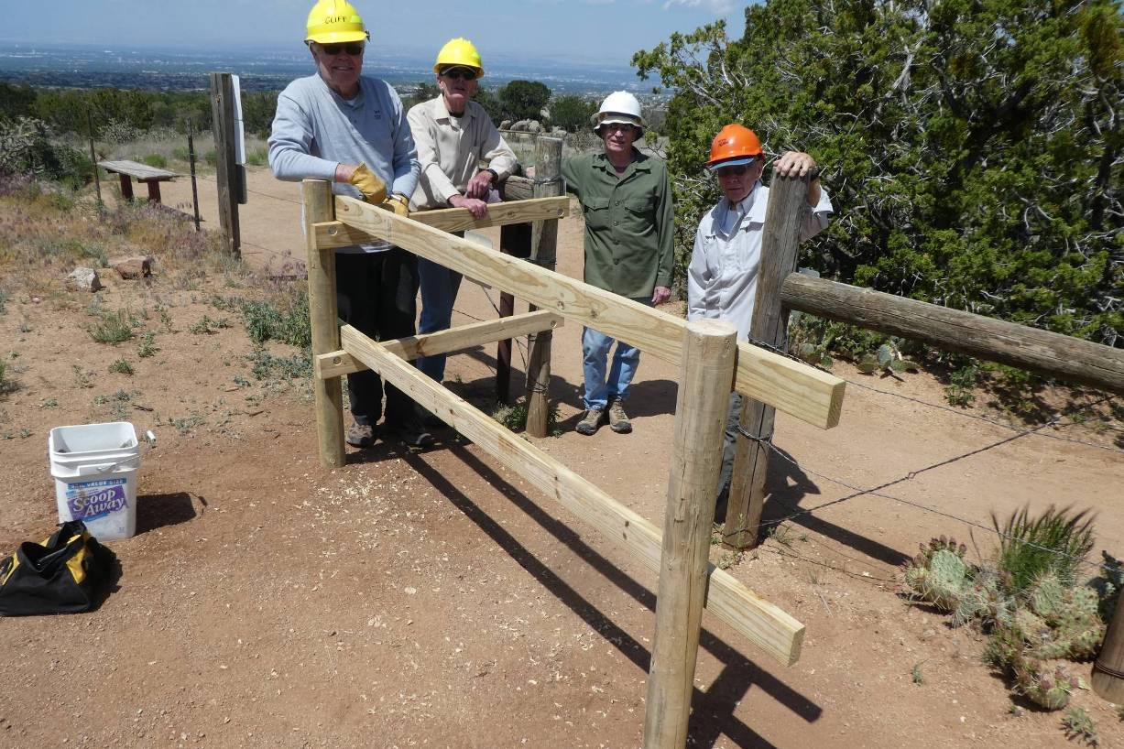
Completed National Trails Day Project at Pino Trailhead. Other half of the chicane was not built, because it would have been on City Open Space land. L to R: Cliff Giles, Sim Cook, Tim Brown, and Don Carnicom. Photo by Sam Beard.

