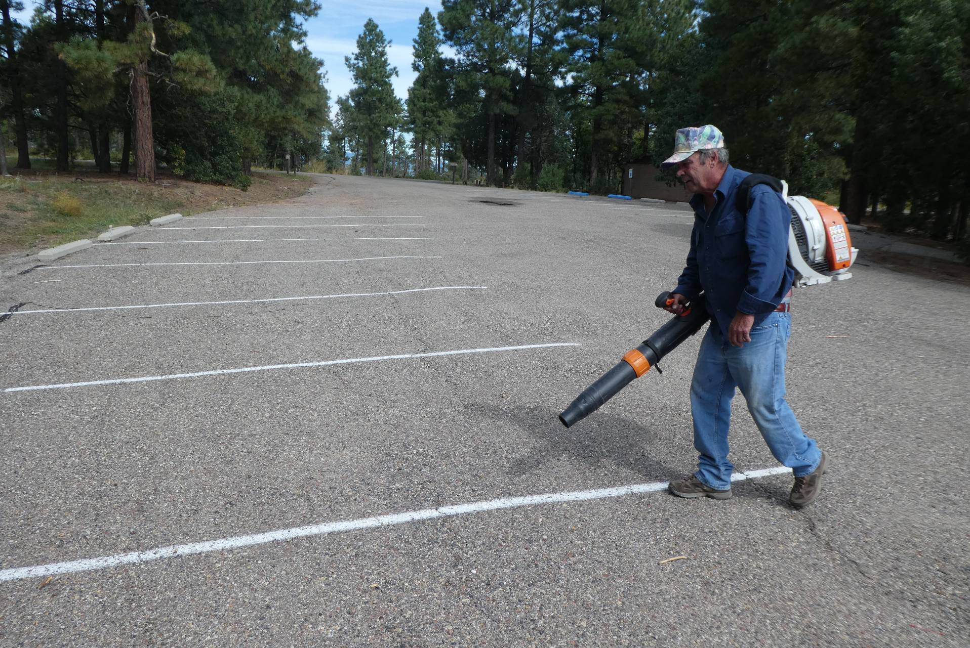
Russell Parker using the SRD Stihl power blower to clean a stripe area by blowing off dirt and gravel.
All photos by Sam Beard

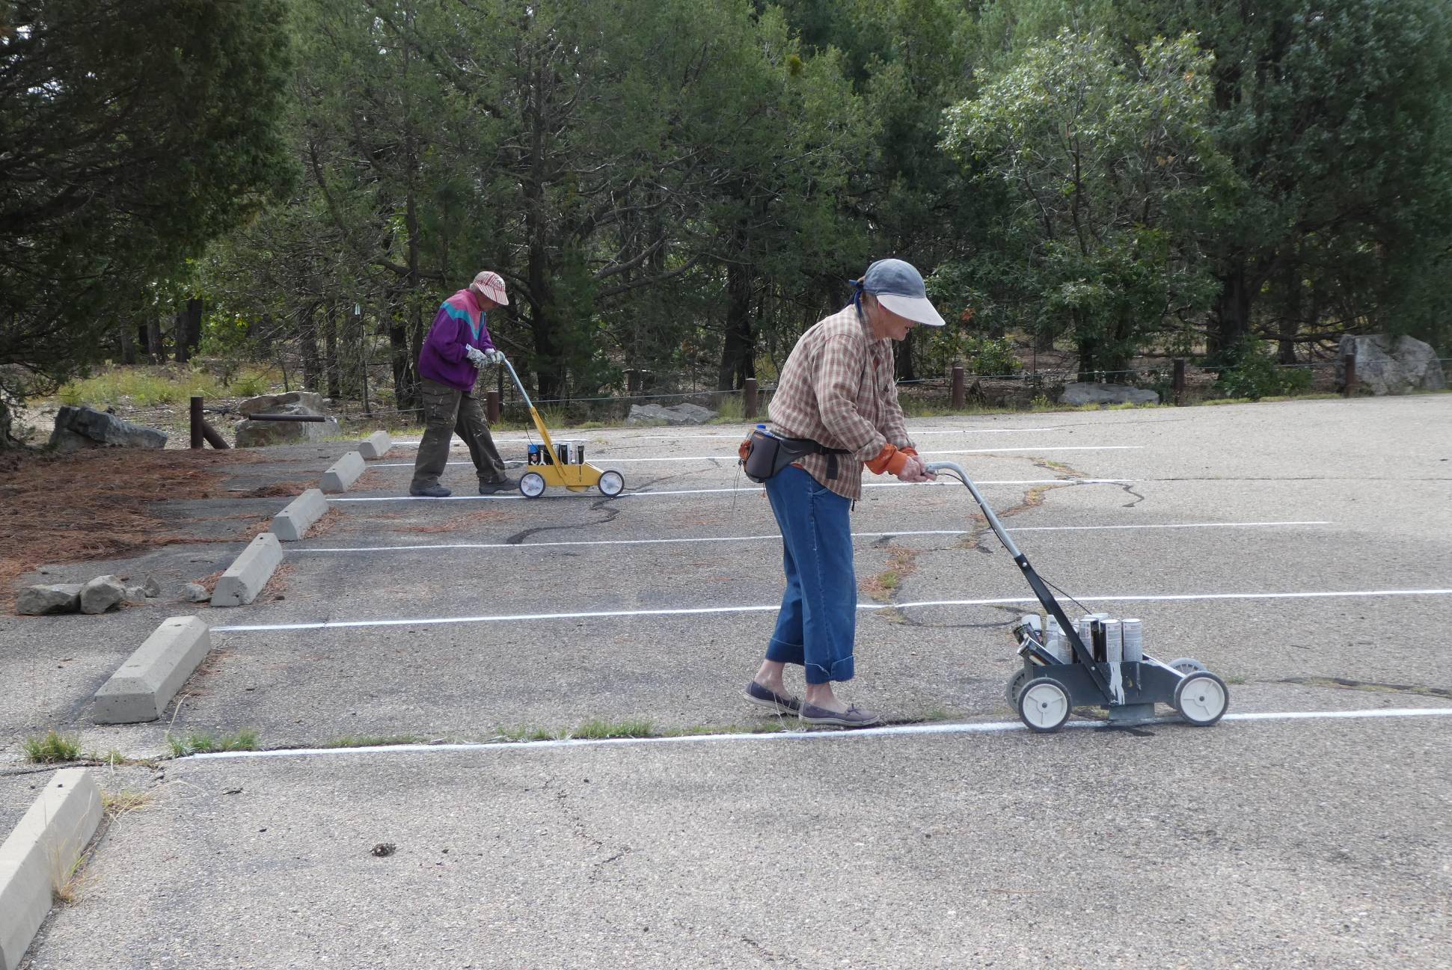
L to R: Jane Harrison and Ellie Parker using the Aervoe Striper 800 Vers-A-Striper to paint stripes in the Oak Flat Group Picnic Area.

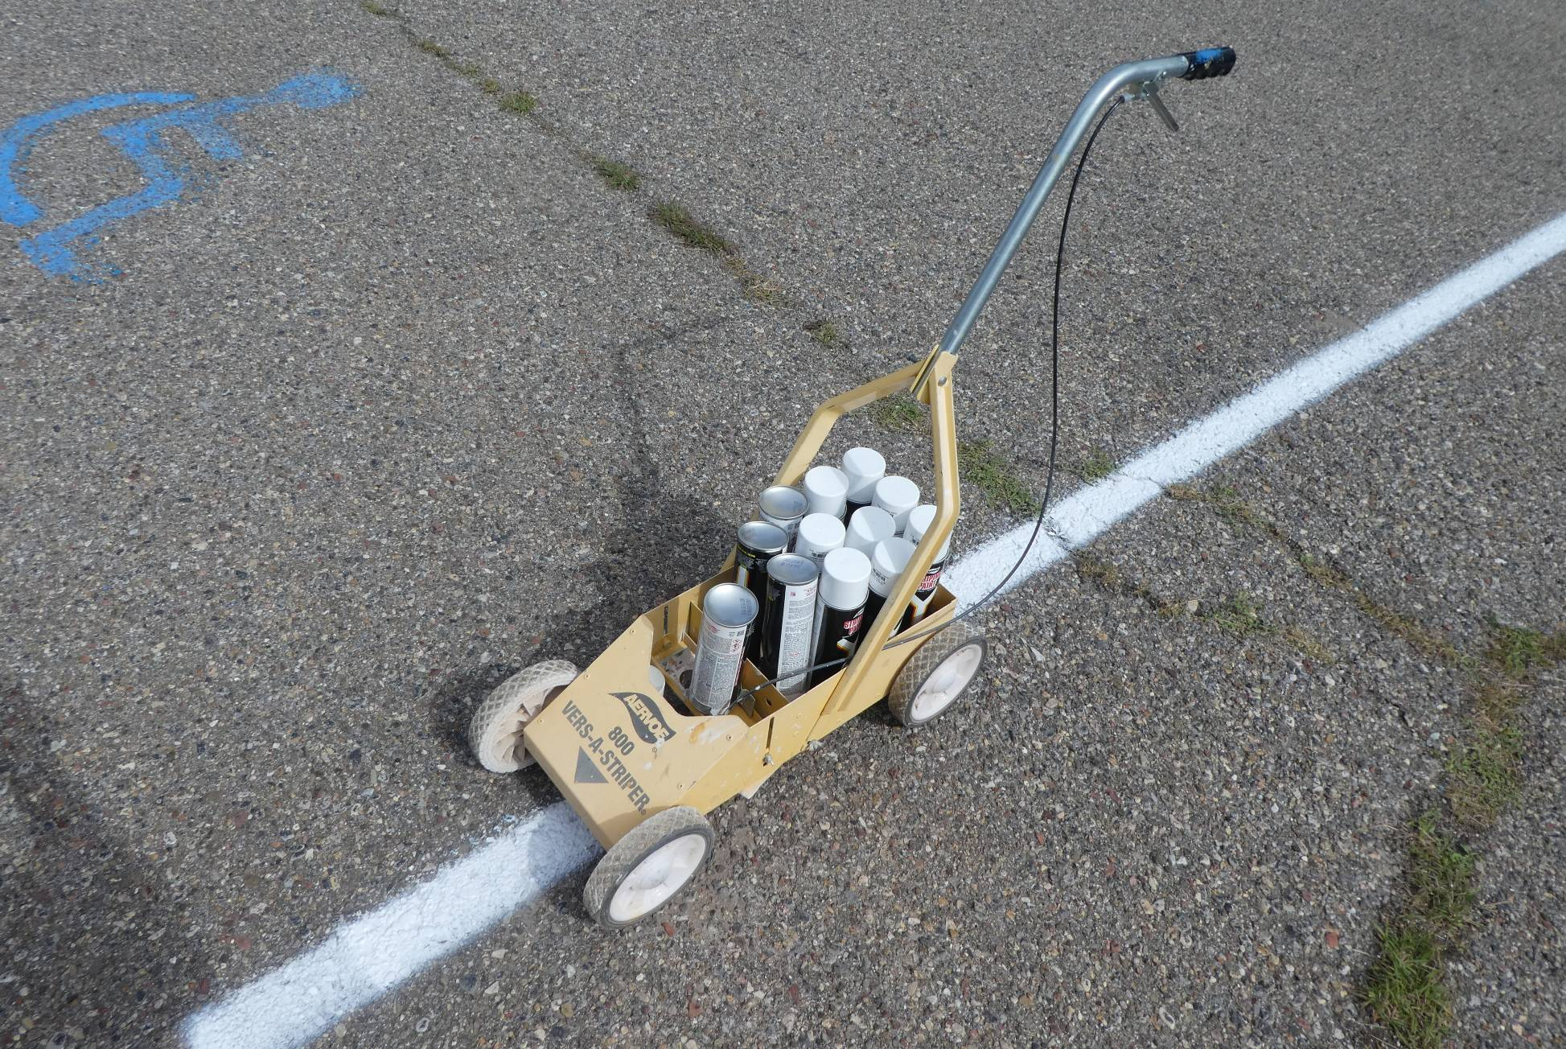
The Aervoe 800 Vers-A-Striper with cans of Aervoe Striping Paint. The inverted front can is held in a fixture so that when the handle
is squeezed, the nozzle is pressed, and a 3-inch wide stripe is painted. Two coats are applied on each stripe,
and one can will paint only three stripes.
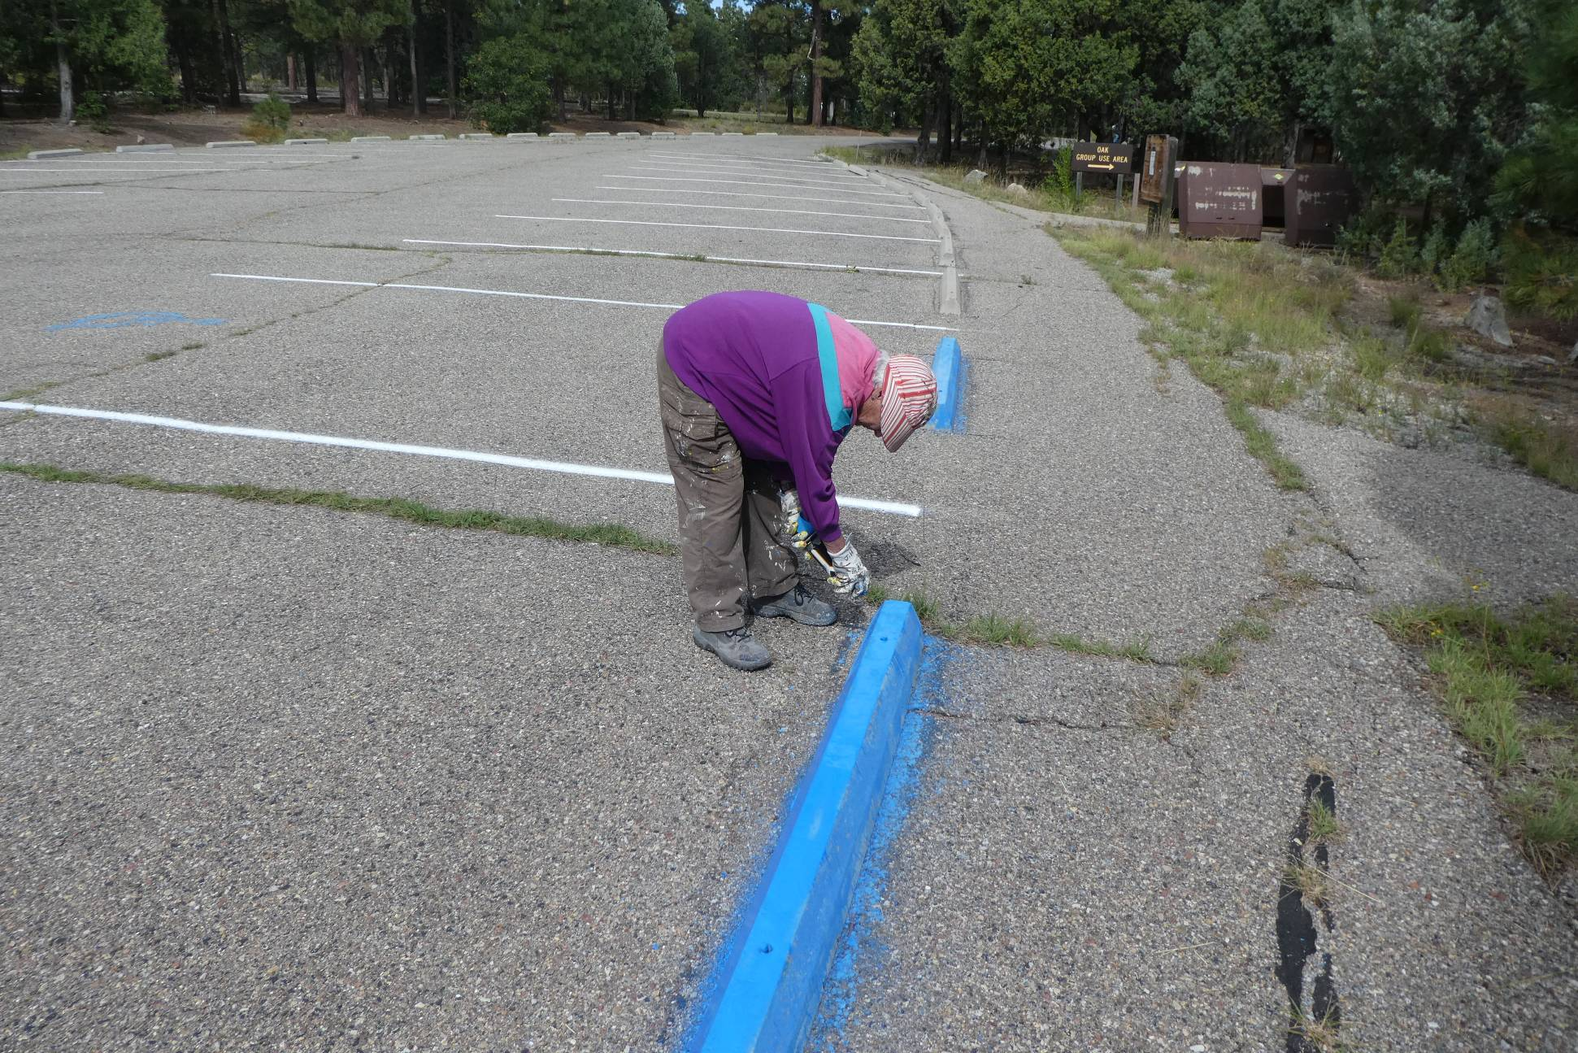
Jane Harrison applying blue paint to a bumper in a handicapped parking space.

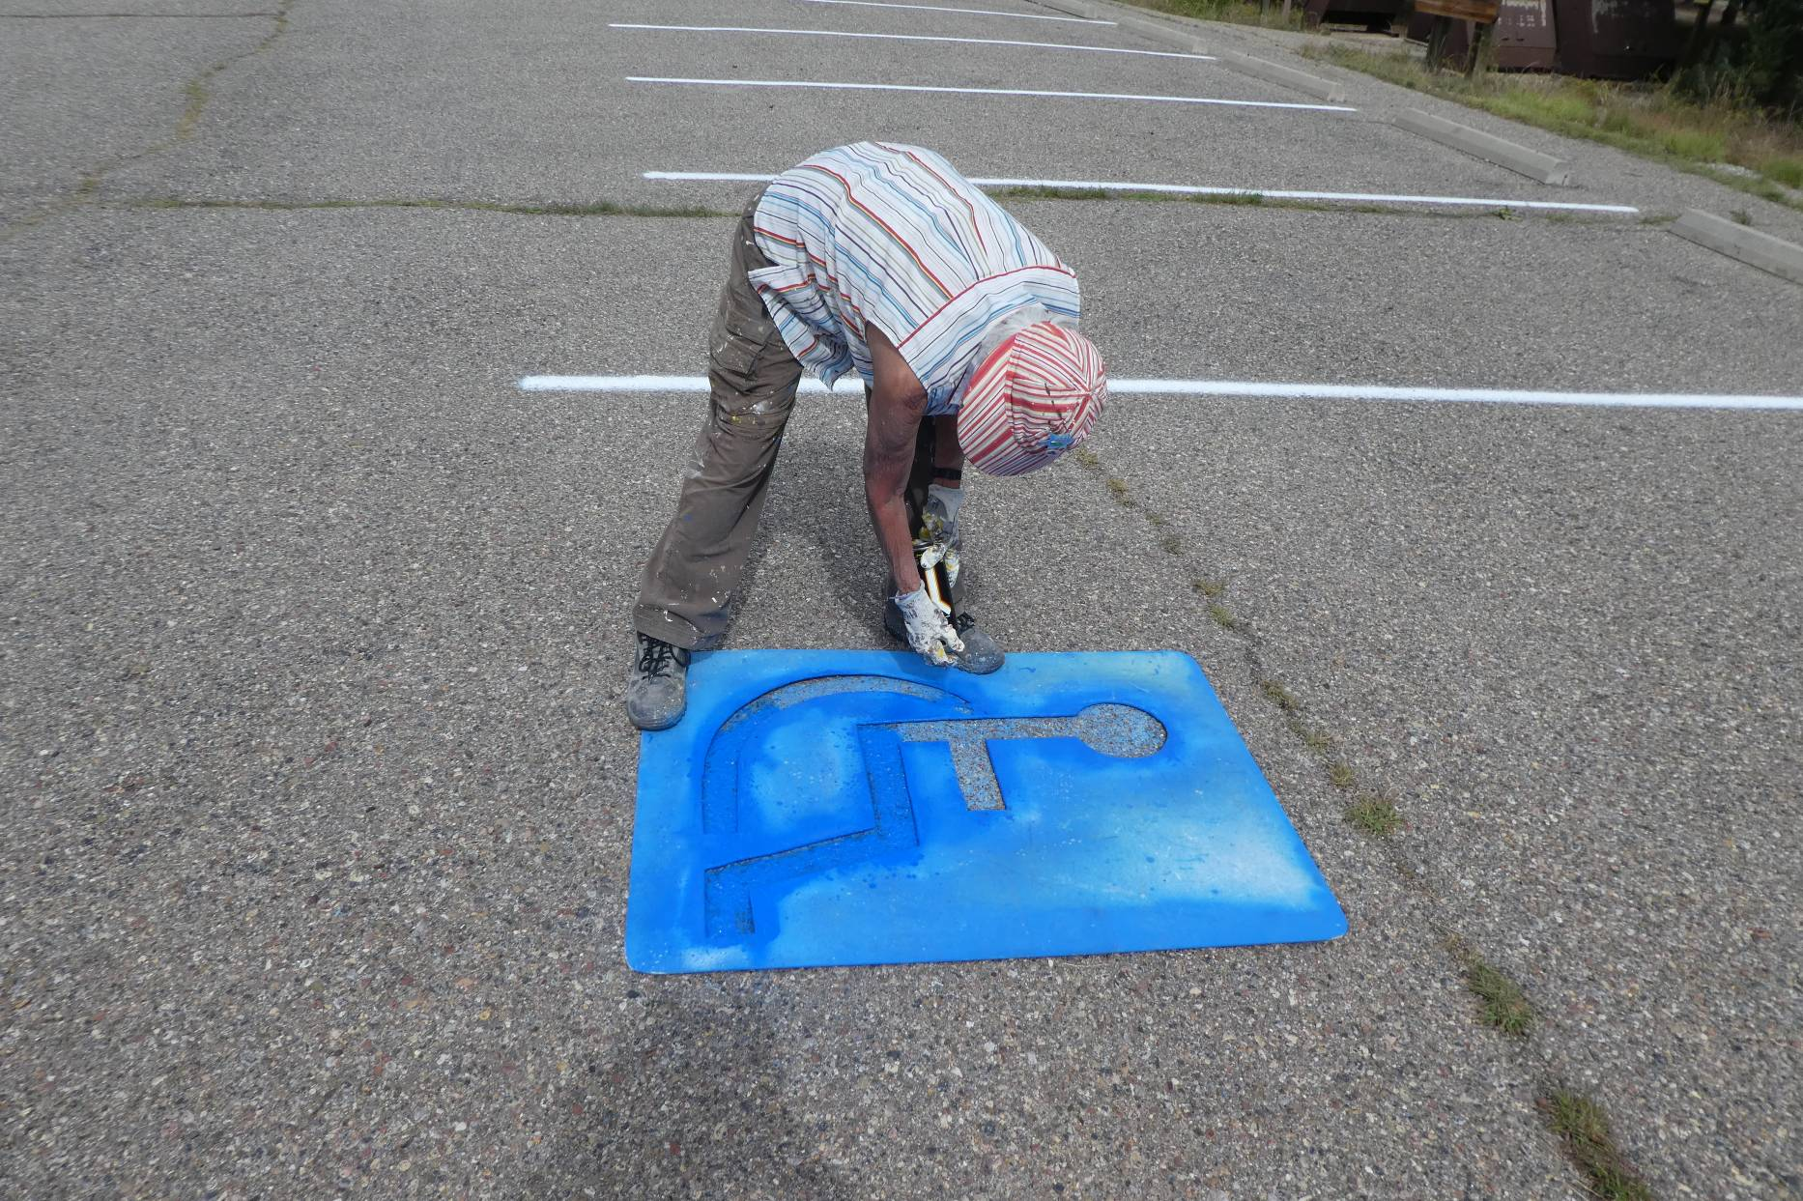
Jane using blue paint and a stencil to mark a handicapped parking space.

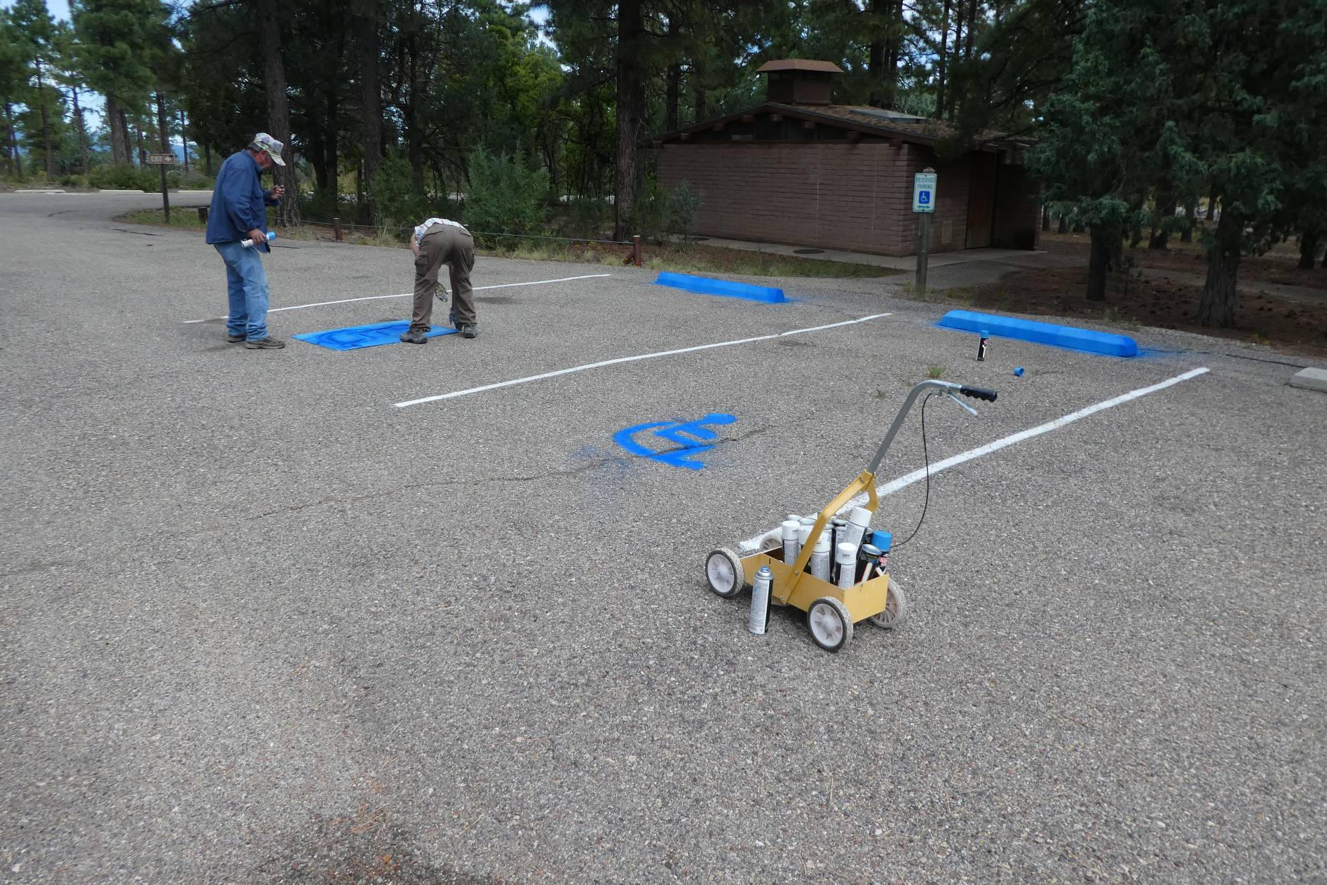
Russell and Jane marking two handicapped parking spaces in the Oak Area in the Oak Flat Group Picnic Area.

