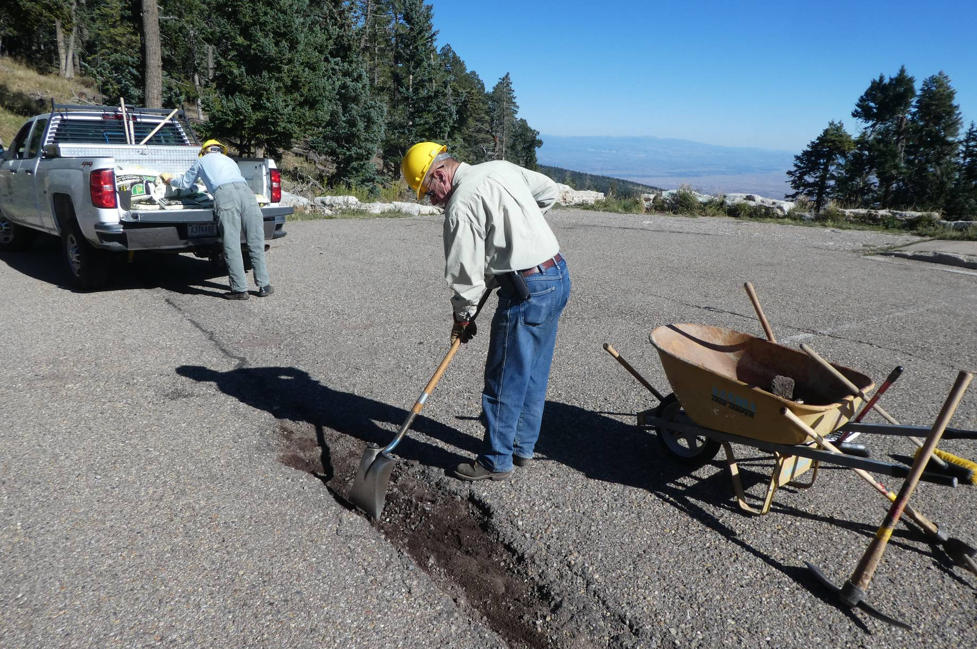
Jerry Carroll removing gravel and dirt from a pothole in the 10K North Trailhead parking lot. In the background, Eric
Russell is getting 50-pound bags of cold patch ready to put the hole.
All photos by Sam Beard

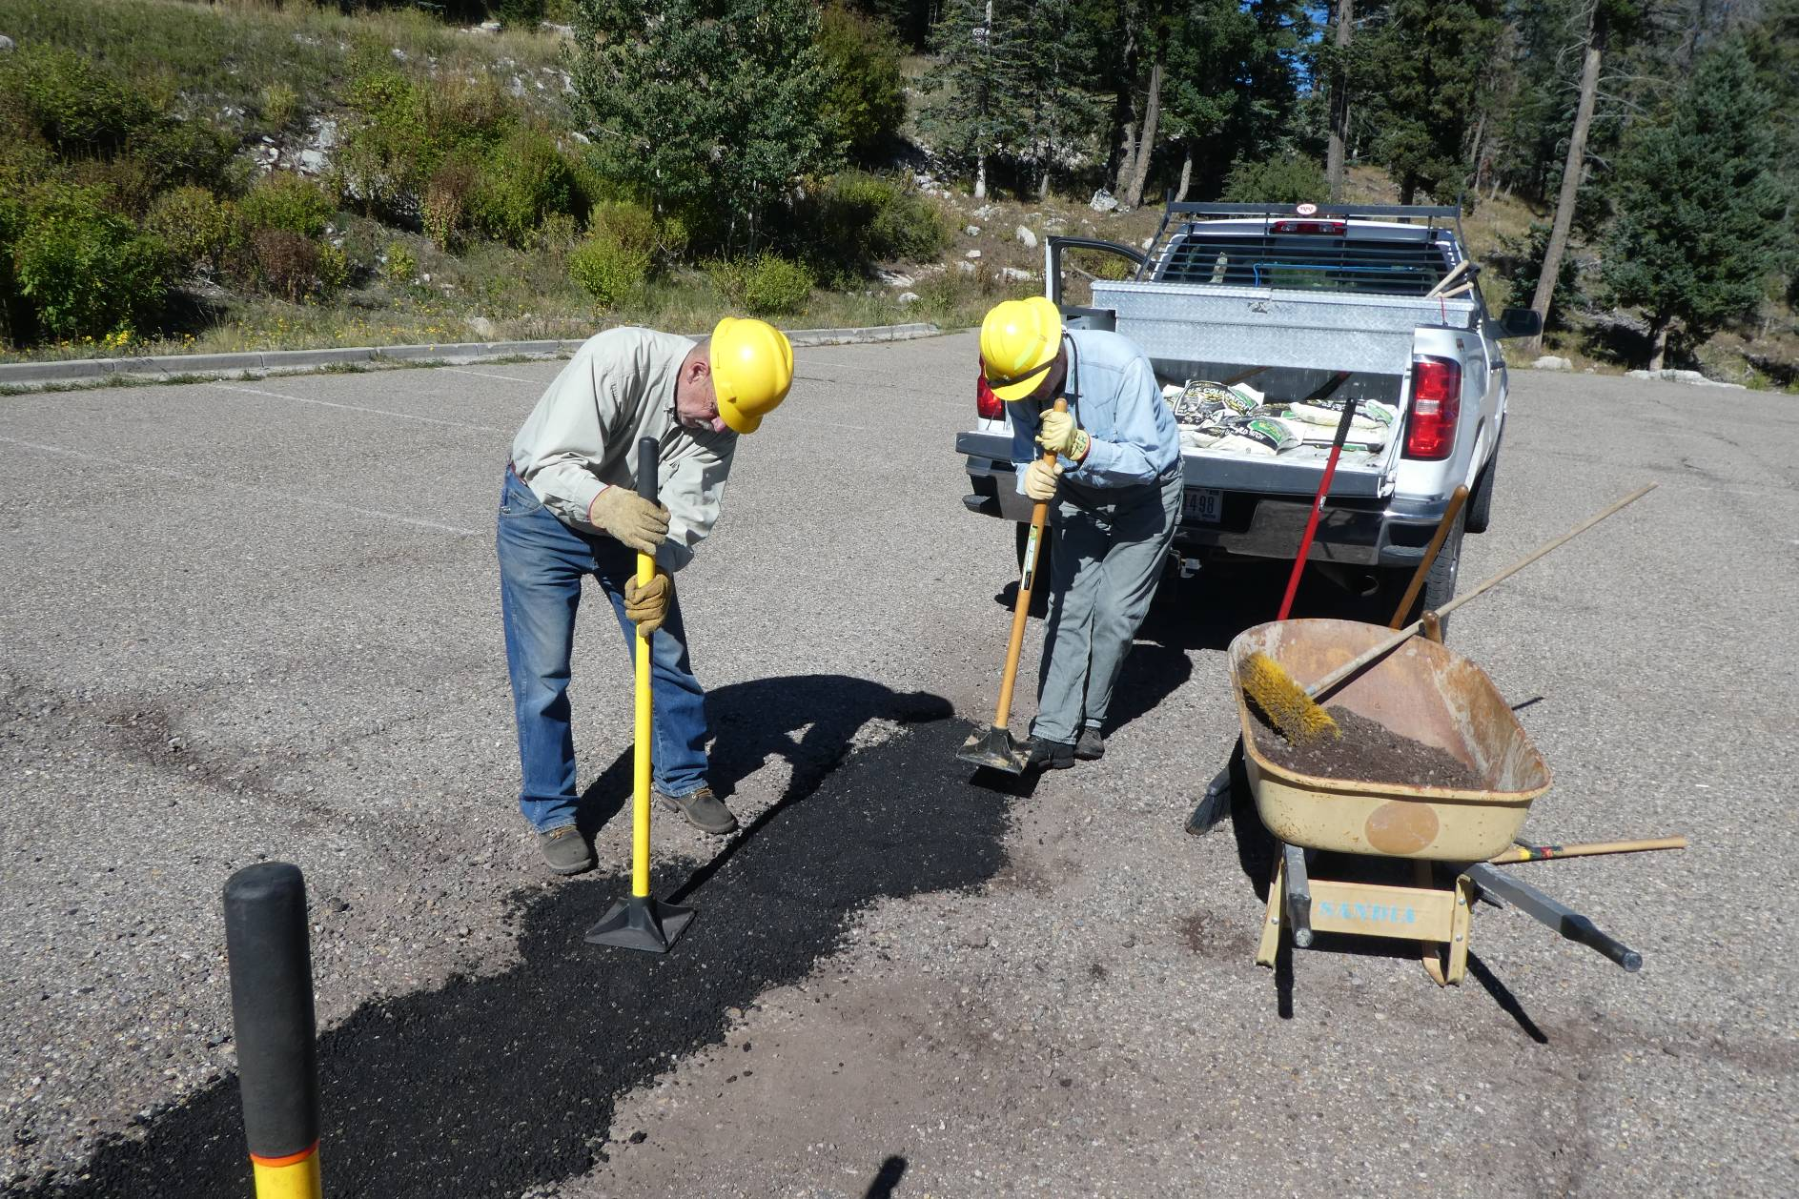
Jerry and Eric manually tamping the cold patch before the pickup is driven over it to complete the patching process.

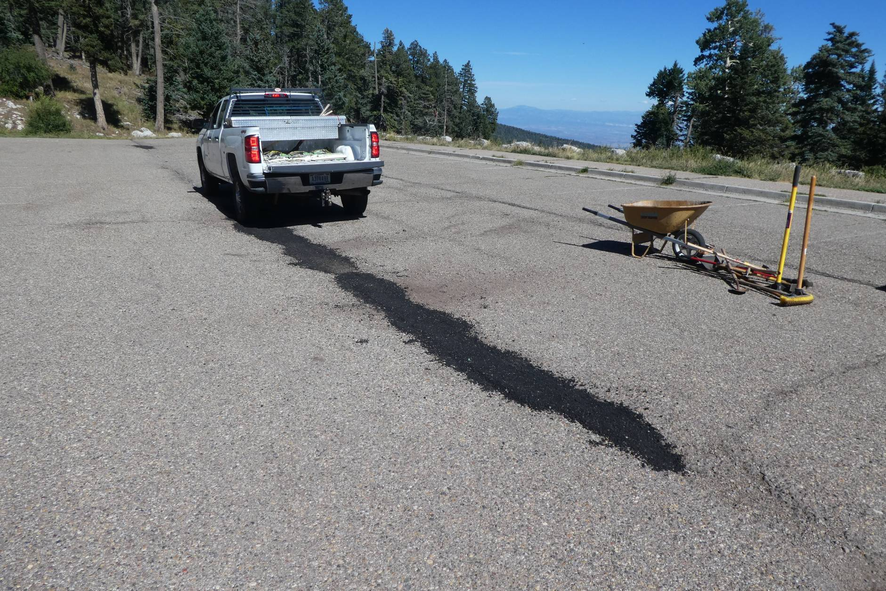
The long narrow pothole has been filled with cold patch and tamped.

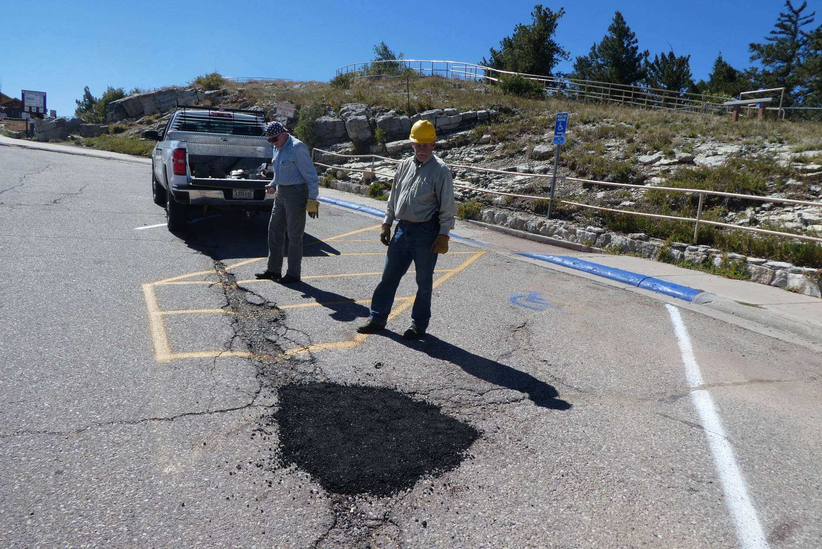
The last four bags of cold patch were used to fill this hole in the upper parking lot at the Crest.

