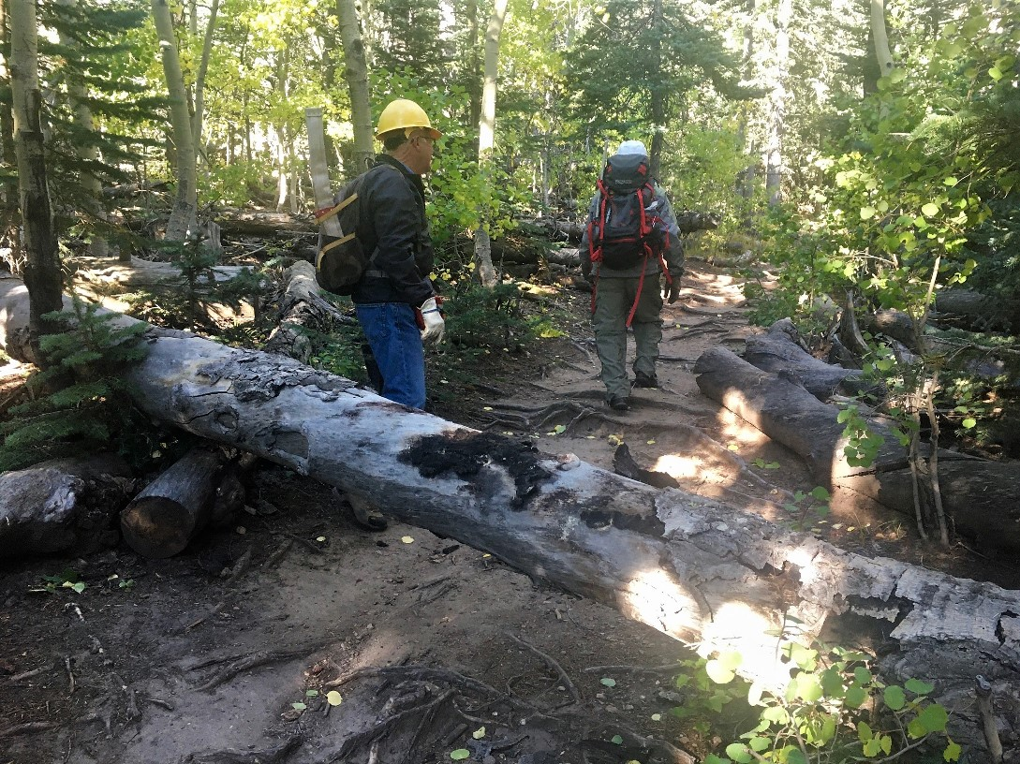
The crew discovered this 14” diameter dead aspen just north of the Lower Switchback/Crest Trail 130 junction. It completely blocked the trail. It appeared to be quite new and there was no walk-around at all.

(Photo by Cliff Giles)

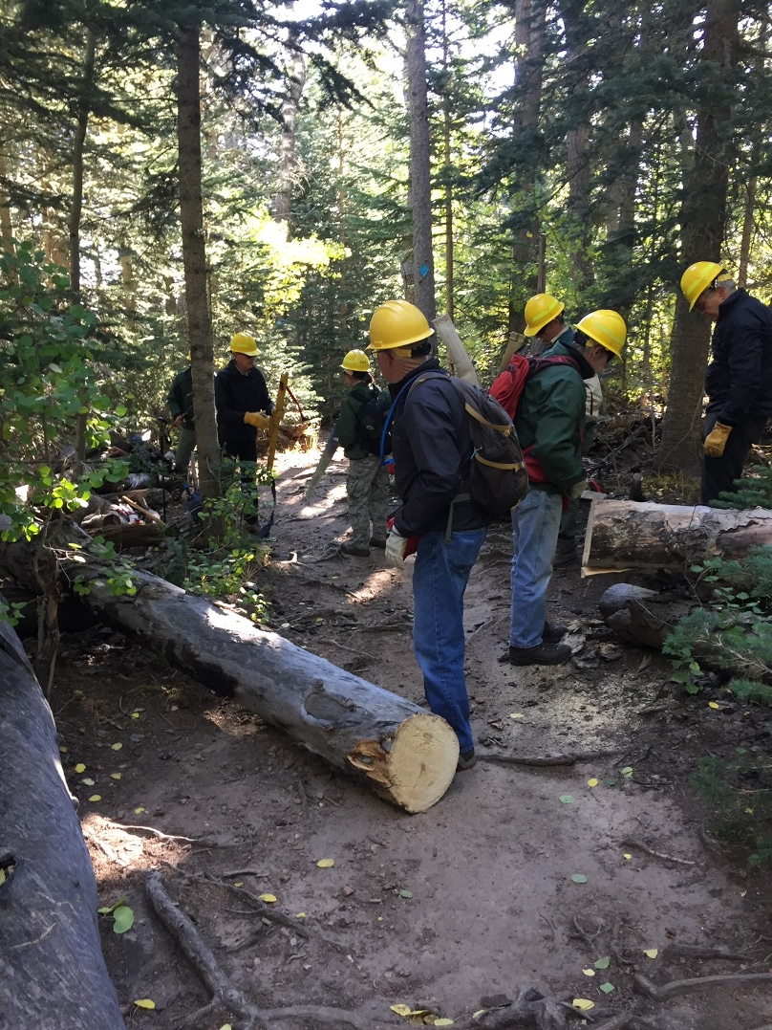
A single cut with a crosscut saw put the tree shown
in previous photo on the ground. It was subsequently
moved well off the trail to the left in the photo.

(Photo by Bill Savage)
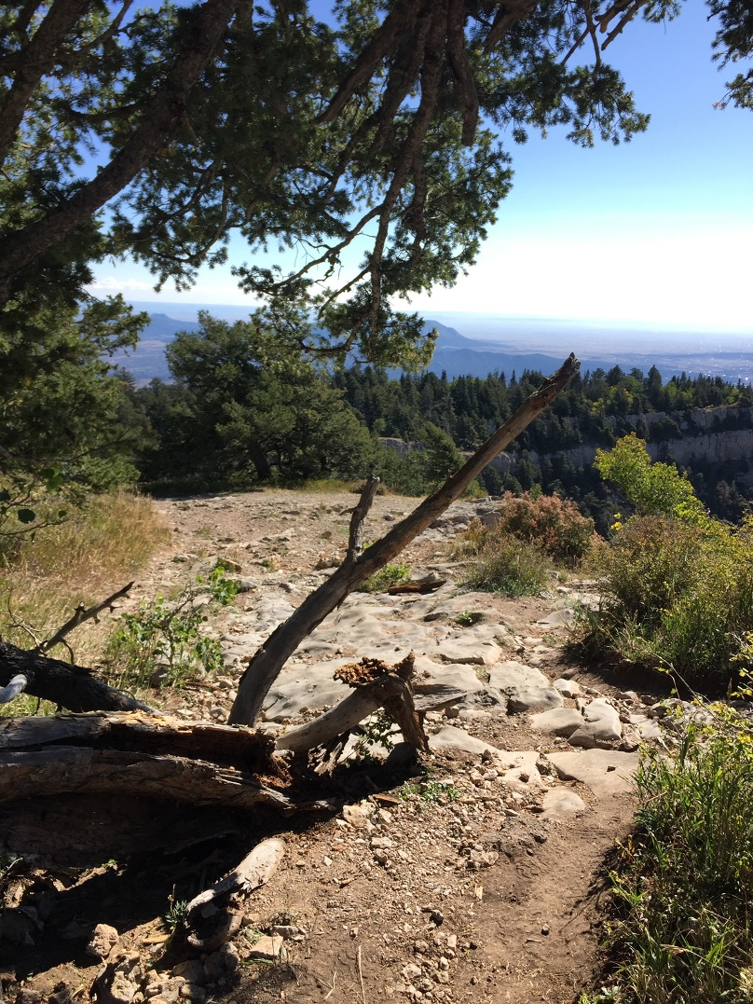
This broken tree was protruding into Trail #93, the Kiwanis
Cabin connector trail that runs between the cabin and Crest
Trail 130.

(Photo by Bill Savage)
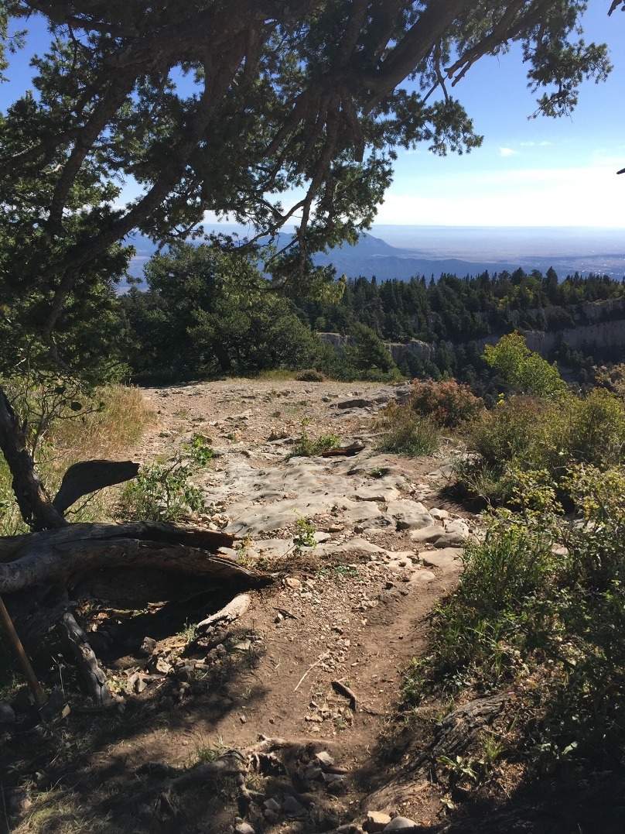
Tree in previous photo has been cut back and the trail cleared.

(Photo by Bill Savage)

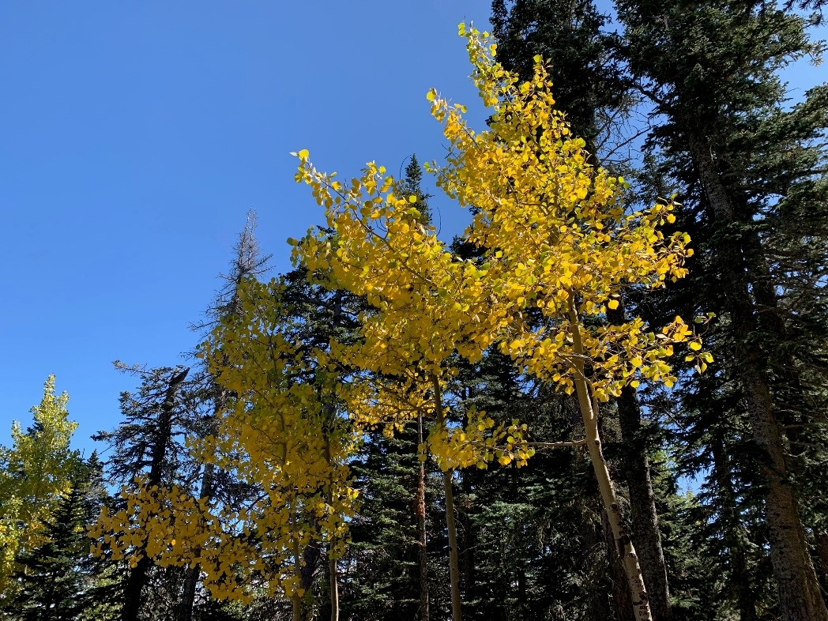
Aspen trees at the higher elevations are at last starting to show their autumn colors. Perhaps by the weekend the display may
improve. This tree was just above Challenge Trail at the Ellis parking lot.

(Photo by Bob Lowder)

