**CATIP Trail Work Report, October 10, 2019**

On Thursday, October 10, ten volunteers worked to extend the Vista Trail southward in the Cienega/Armijo Trails Improvement Project (CATIP).

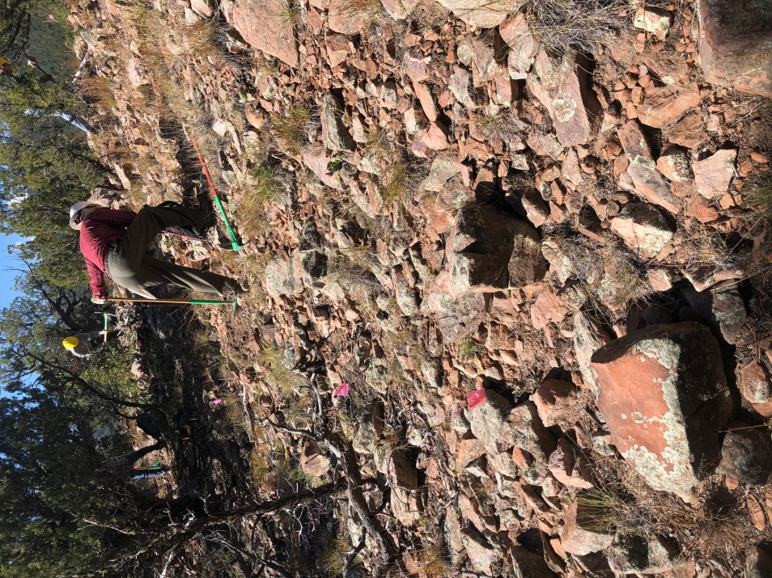This has been a many-session effort as the FOSM crew works through rocky and brushy terrain. Today’s work was along the Vista Trail’s rocky ridge but we still made good progress. The trail is well named since it has great views in all directions.

The volunteer crew consisted of Byron Gardner, Cleve Sharp, Claudia Bergsom, Sim Cook, Pat Madden Bruce Hansche, Mike Madden, Phil Cromer, Don Carnicom, and Eric Russell.

Jim Houle graciously allowed us to park at his house.

The day began really cold in Tijeras. By the time we reached the work area, now a 1.5 mile hike, the weather was sunny and in the 60’s.

A “Before” Section – Cleve Sharp

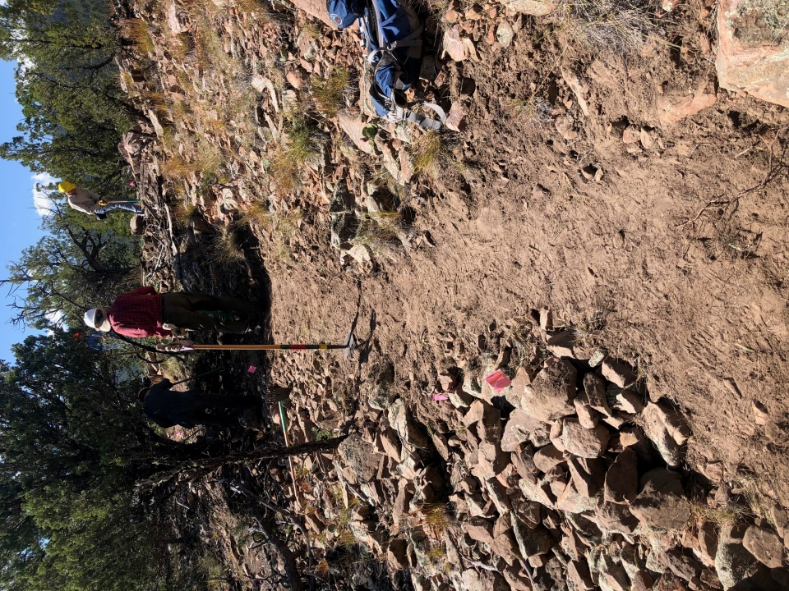It was a productive, hard day but completed the tread south to near the intersection with the user trail. We still need to dig out a few small trees left in the middle of the tread due to the forest-wide halt in timber operations. Also, we need to flag the swithcbacks on the north end. So, there is more to do.

Next session we will probably work on the Deer Bed Trail from the intersection with the Vista Trail east and downhill.

After Photo – Cleve (South End of Segment)

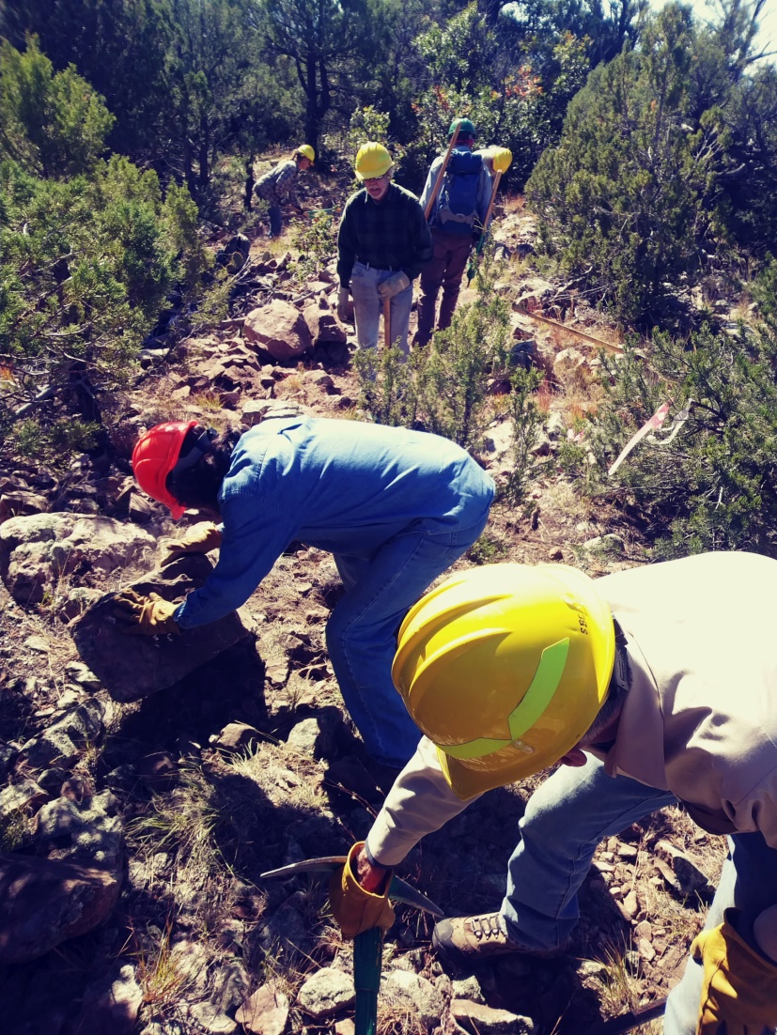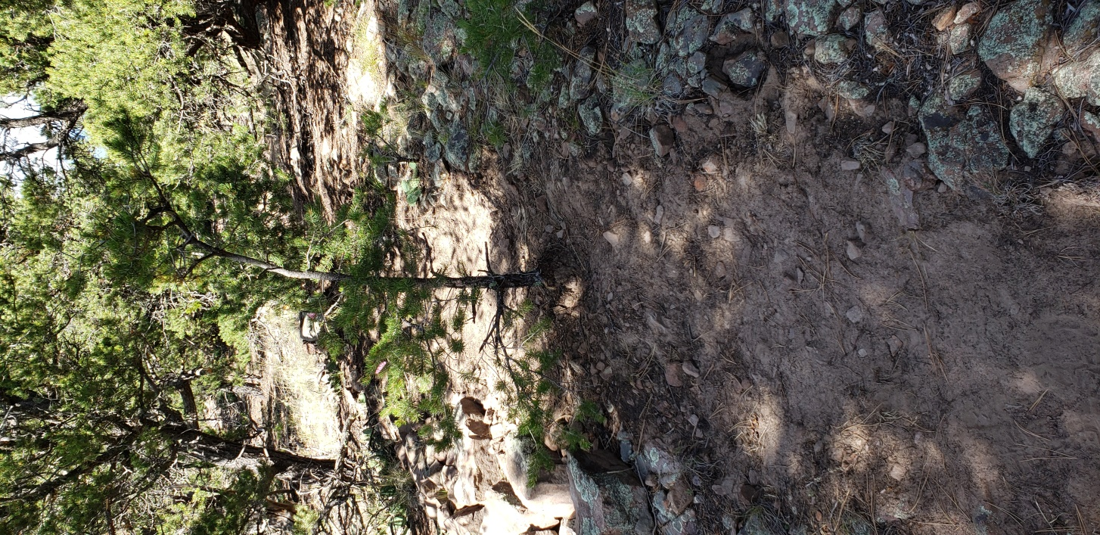

The Ace Rock Removal Team - Bruce

Tree in the Tread Feature (One of Several)

**.**

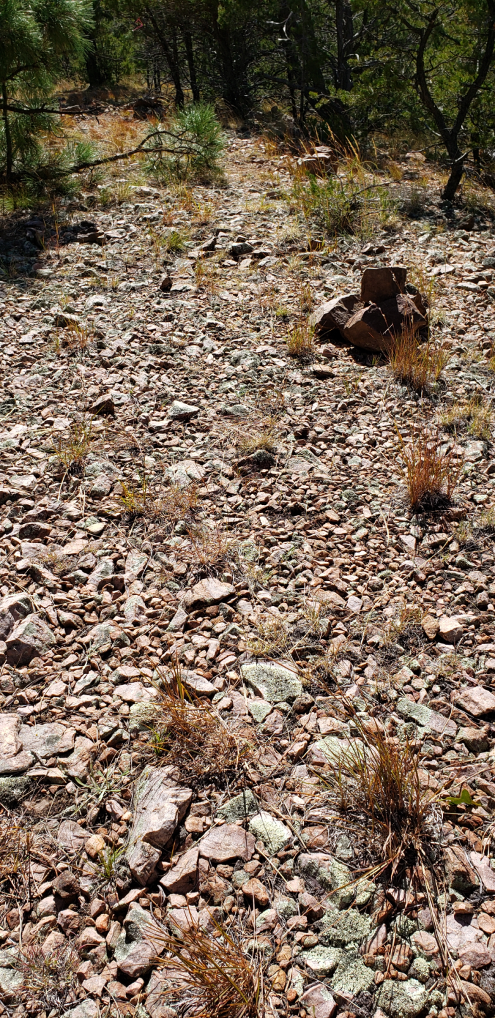

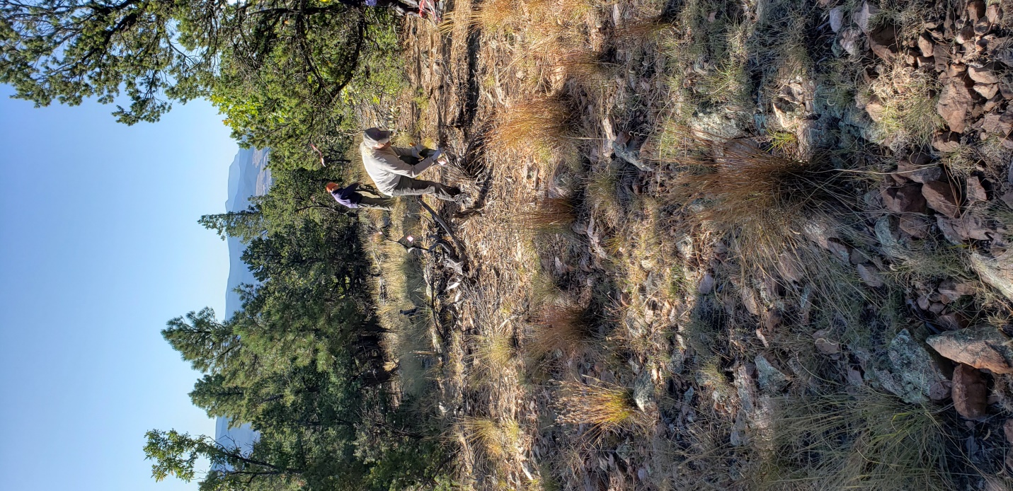

Pebbly Section Left As Is - Eric

Cutting Tread with vista south - Eric