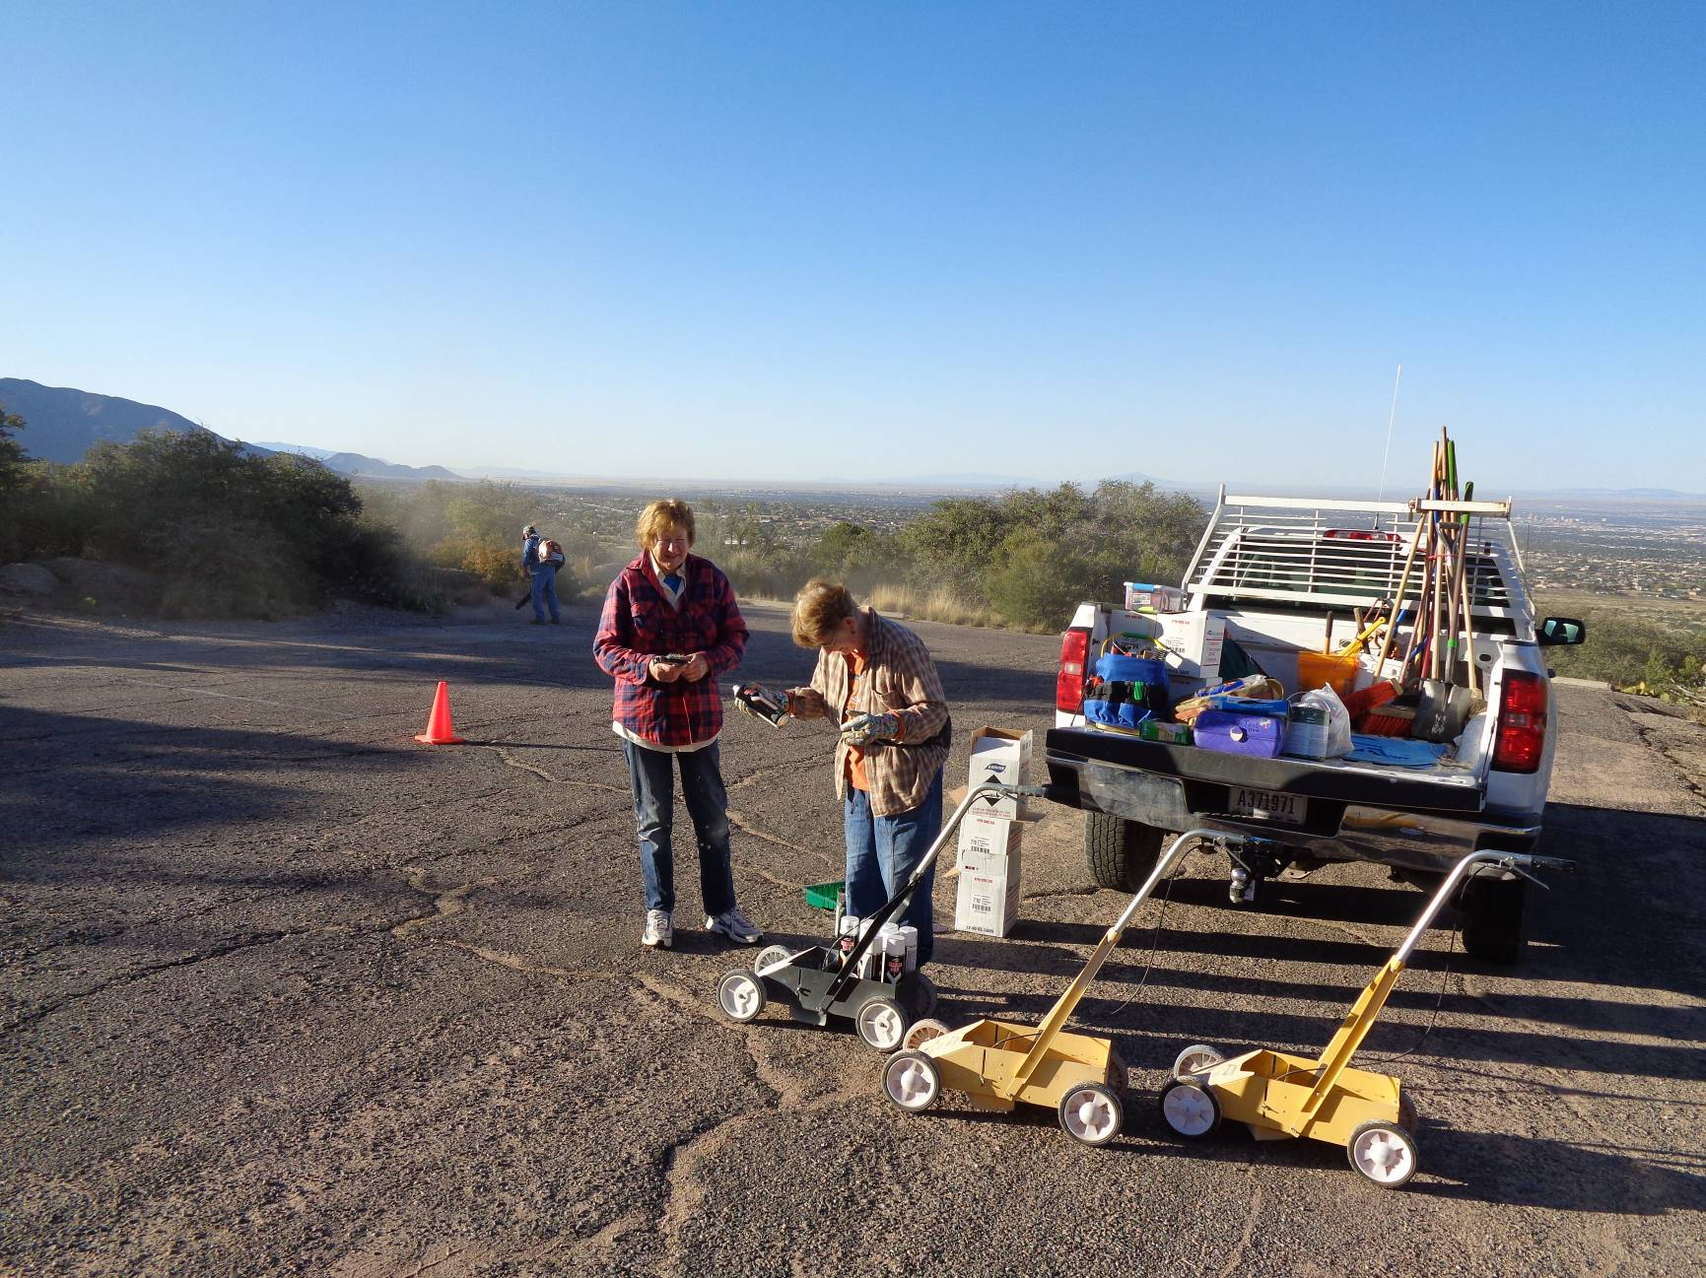
L to R: Anne Hickman and Ellie Parker shaking cans of striping spray paint before putting the cans in the carts in the
first parking lot in La Cueva Picnic Area. All photos by Sam Beard
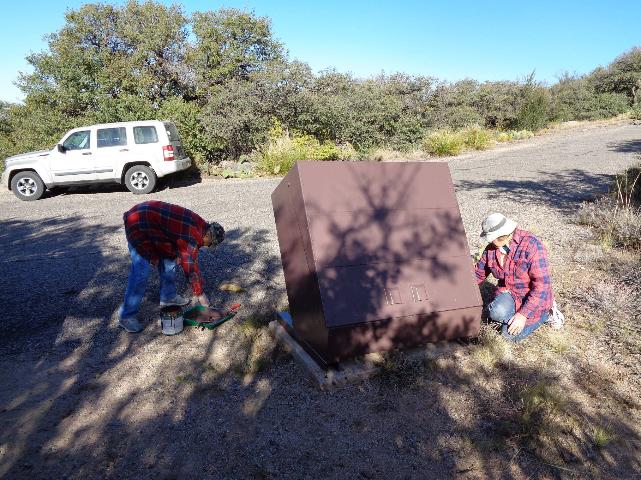
L to R: Rikki Barrett and Anne Hickman painting a trash container..

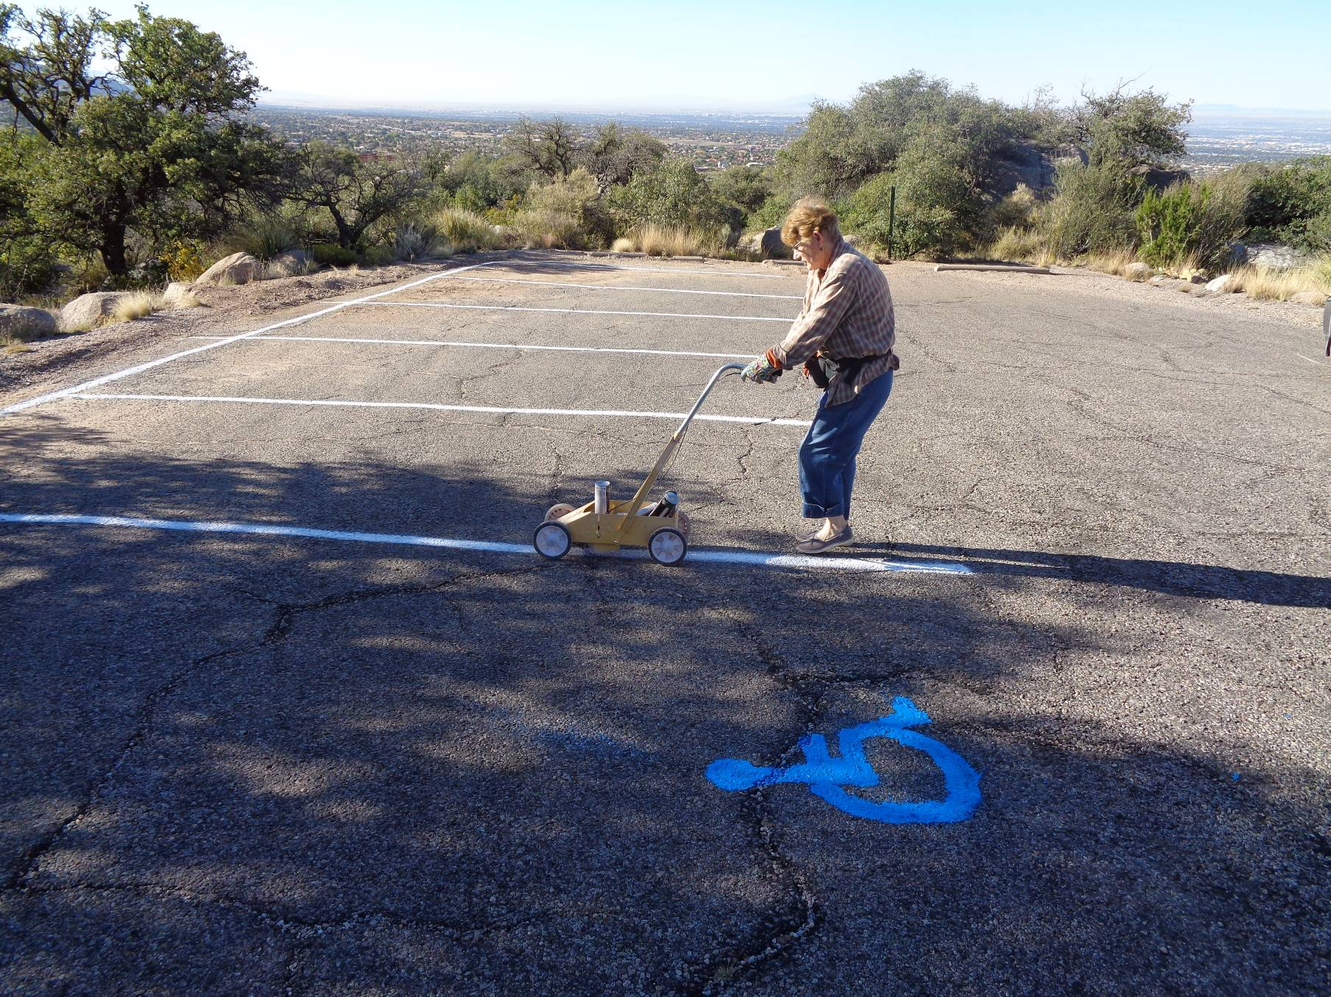
Ellie Parker striping the first parking lot in La Cueva Picnic Area after Jane Harrison painted the wheel chair stencil with blue paint.

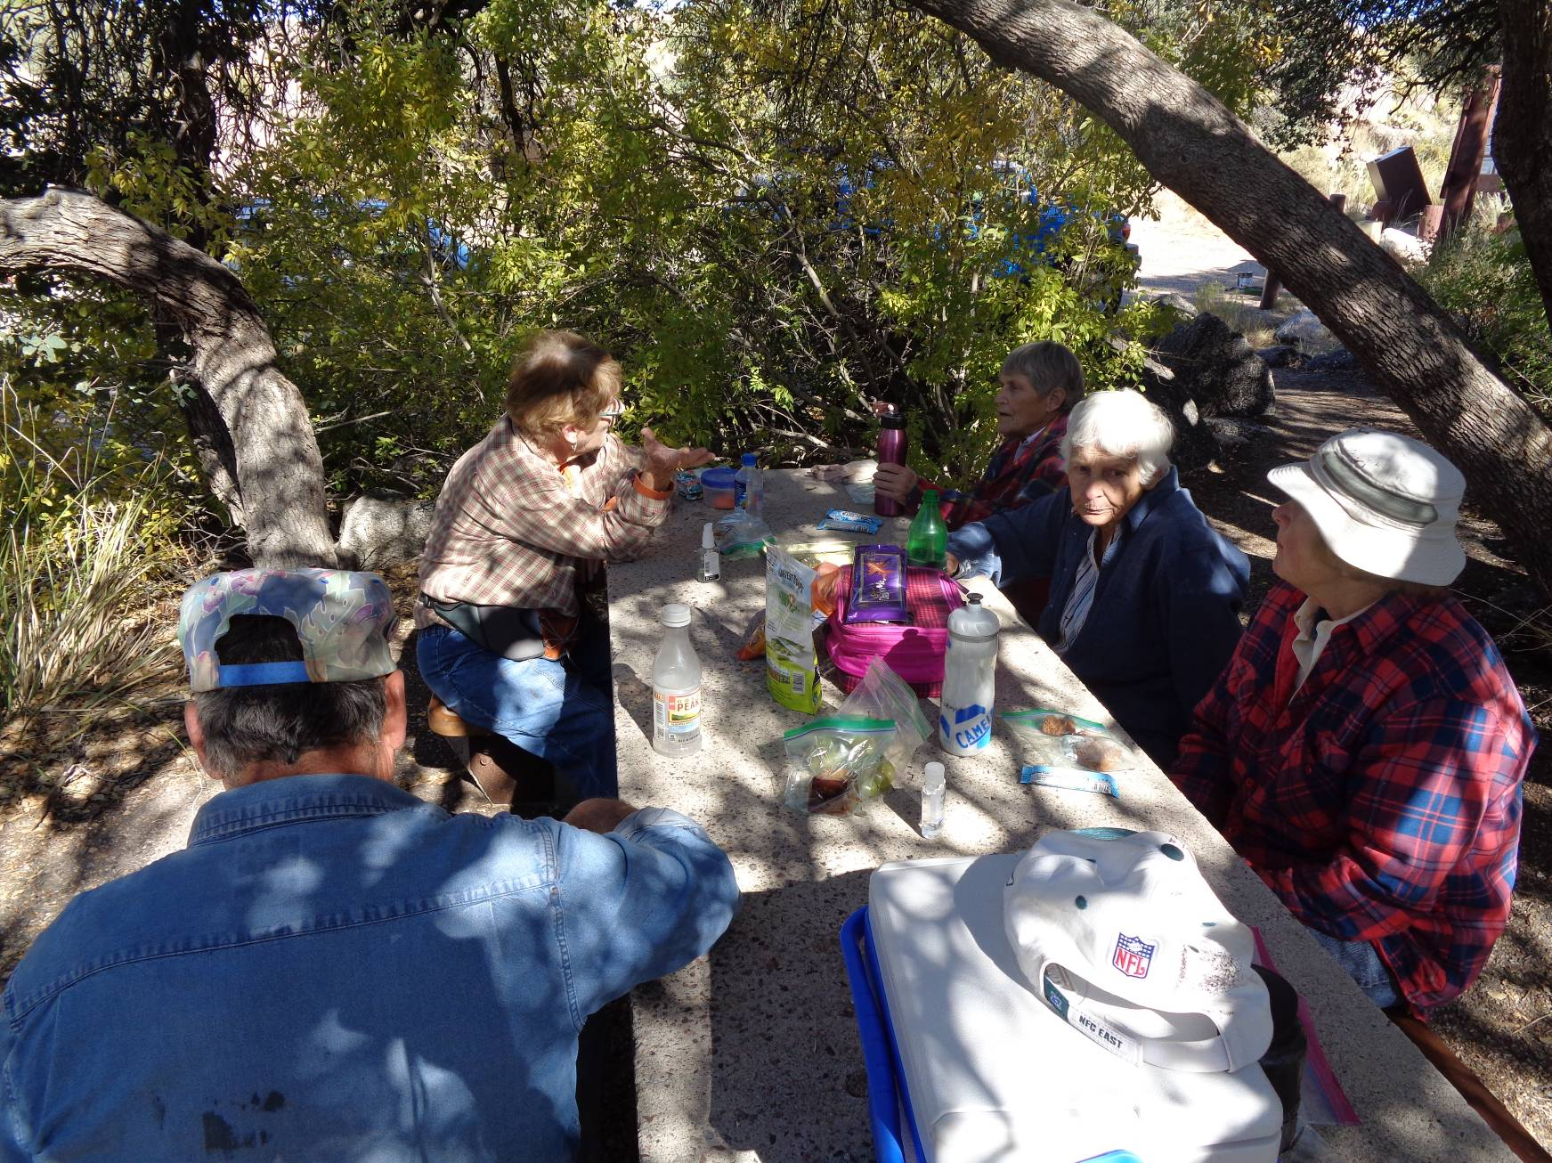
Morning break at one of the modern picnic tables modified so that wheelchair can go under the left side.

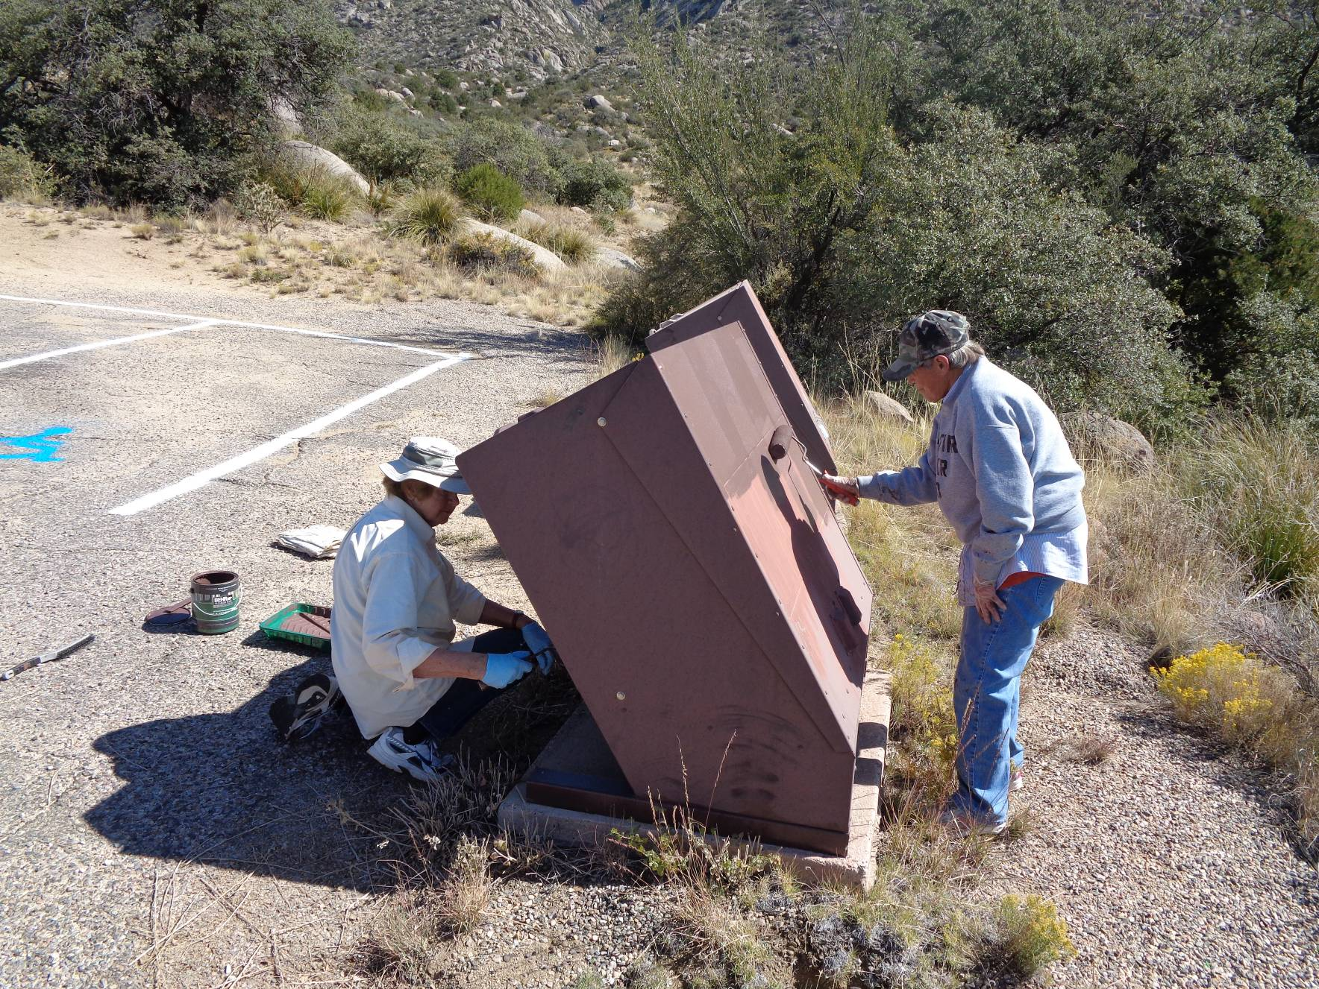
L to R: Anne and Rikki painting a trash container at the last parking lot in La Cueva Picnic Area.

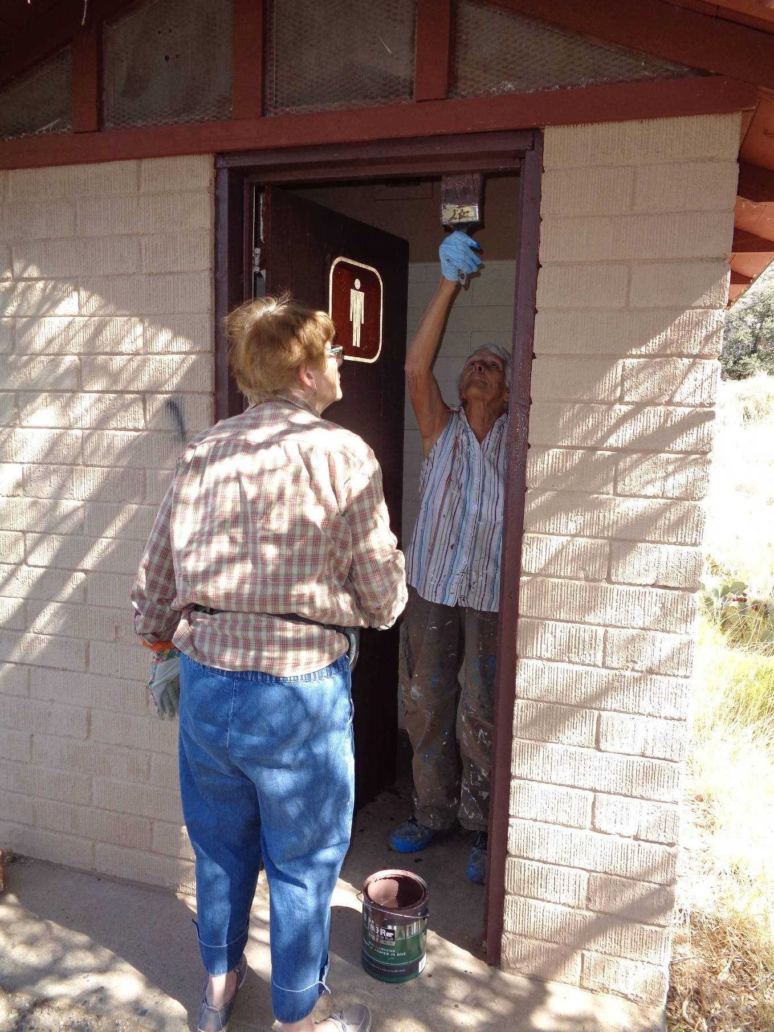
L to R: Ellie Parker and Jane Harrison painting the door of the restroom at the end of the road.

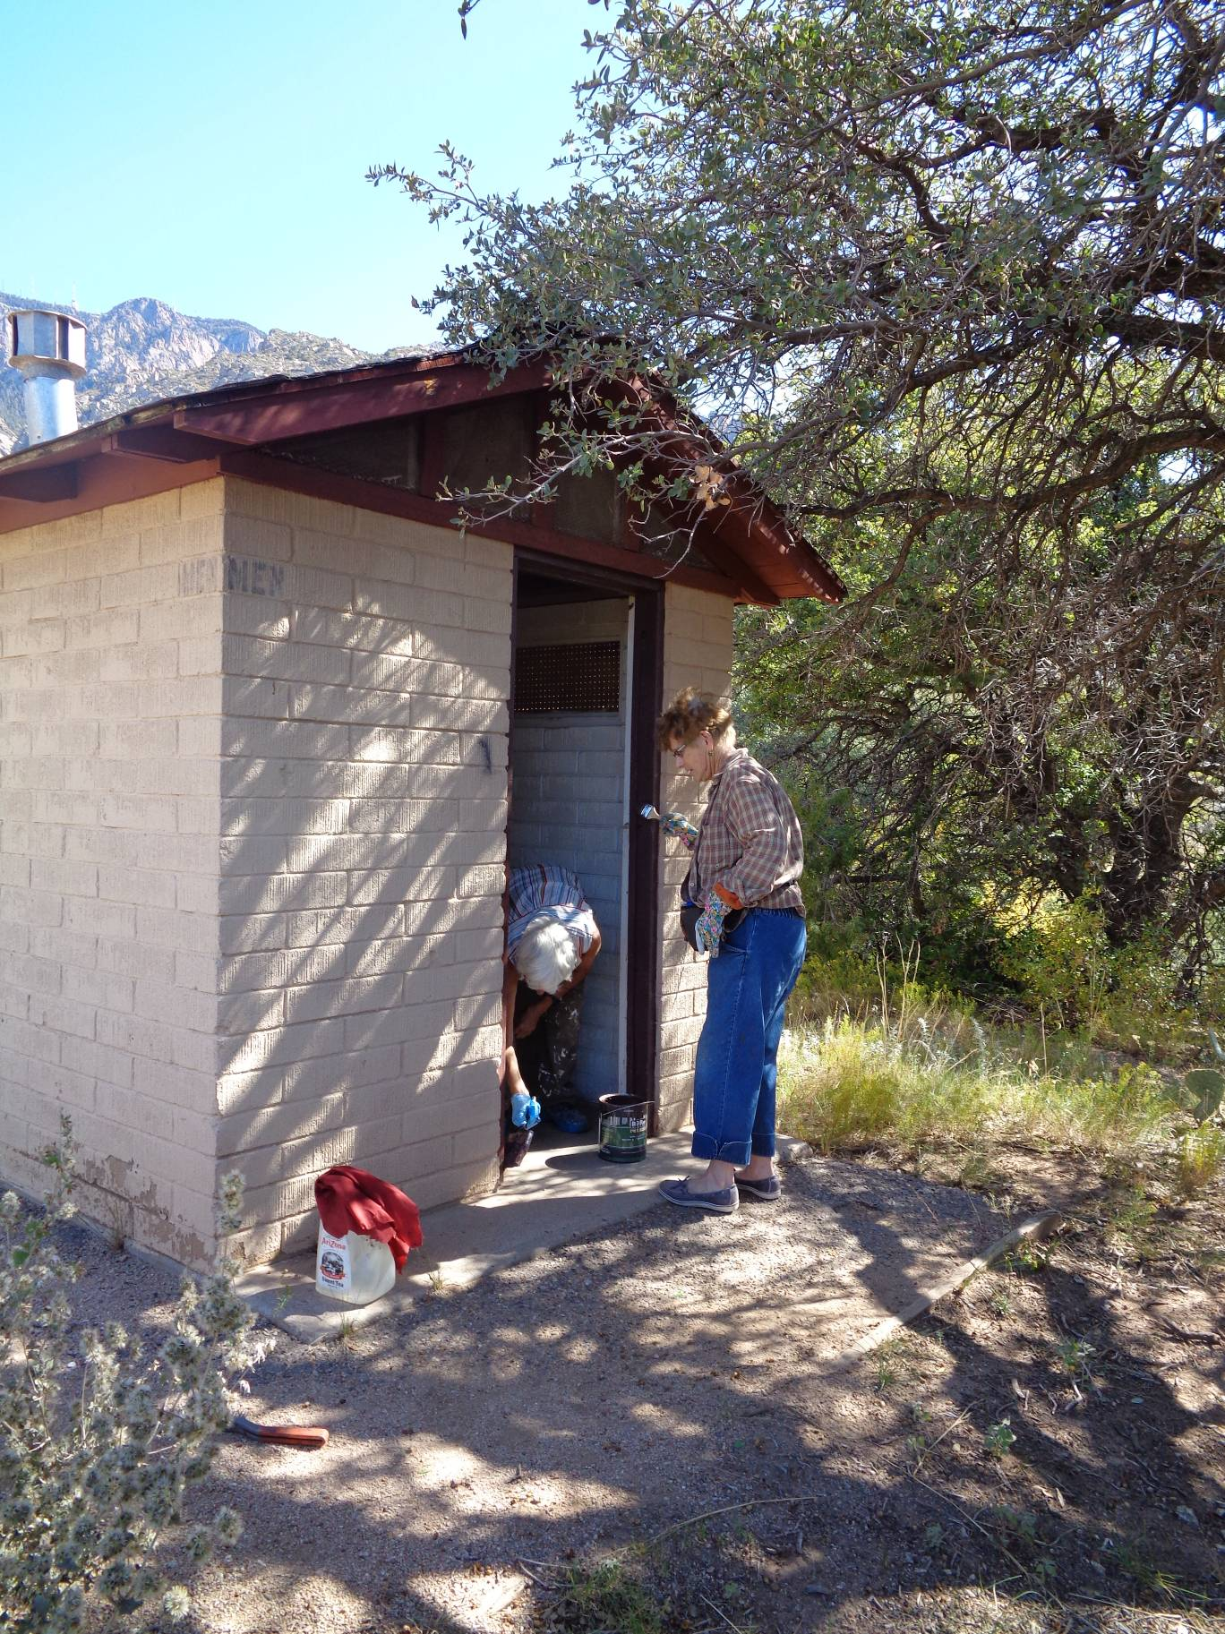
Jane and Ellie completing the painting of the door and door frame of the restroom.

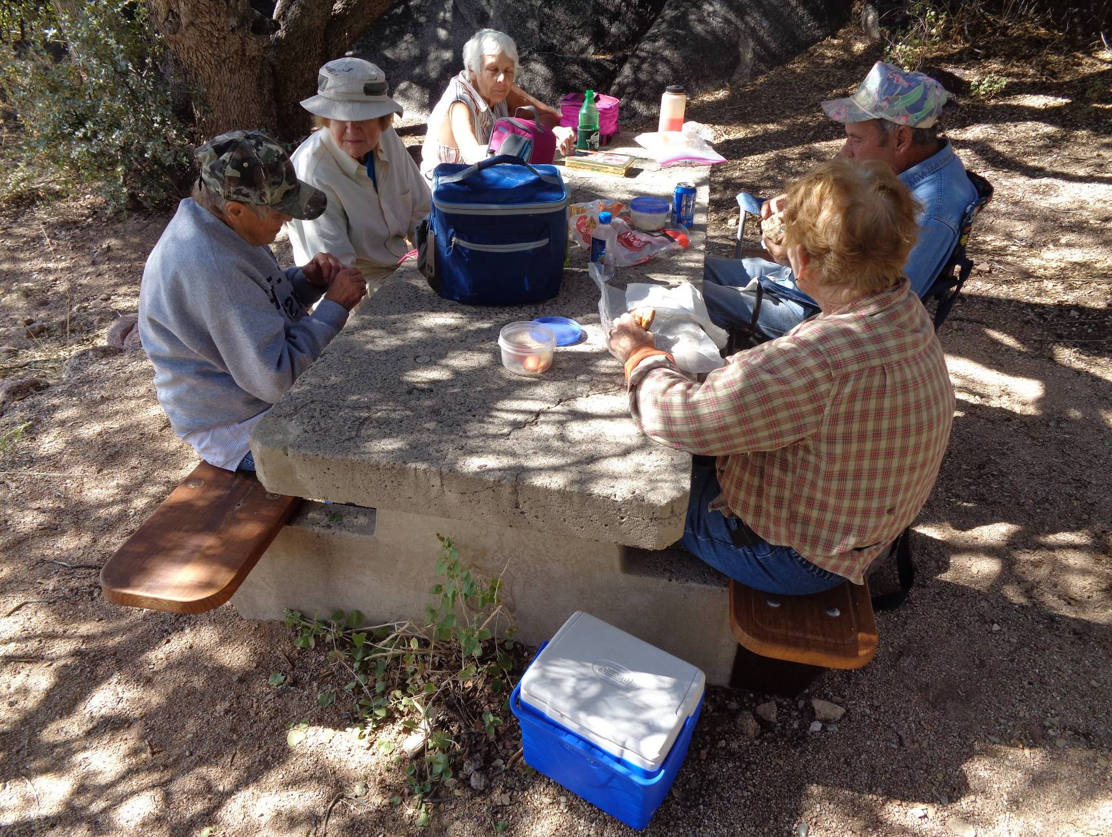
Eating lunch at the table modified to accept a wheel chair at the end of the road. L to R: Rikki Barrett, Anne Hickman,
Jane Harrison, Ellie Parker, and Russ Parker. Ellie is sitting on one of the short benches on the wheel chair side of the table.
Russ is sitting in a folding chair where a wheelchair can get up to the table.

