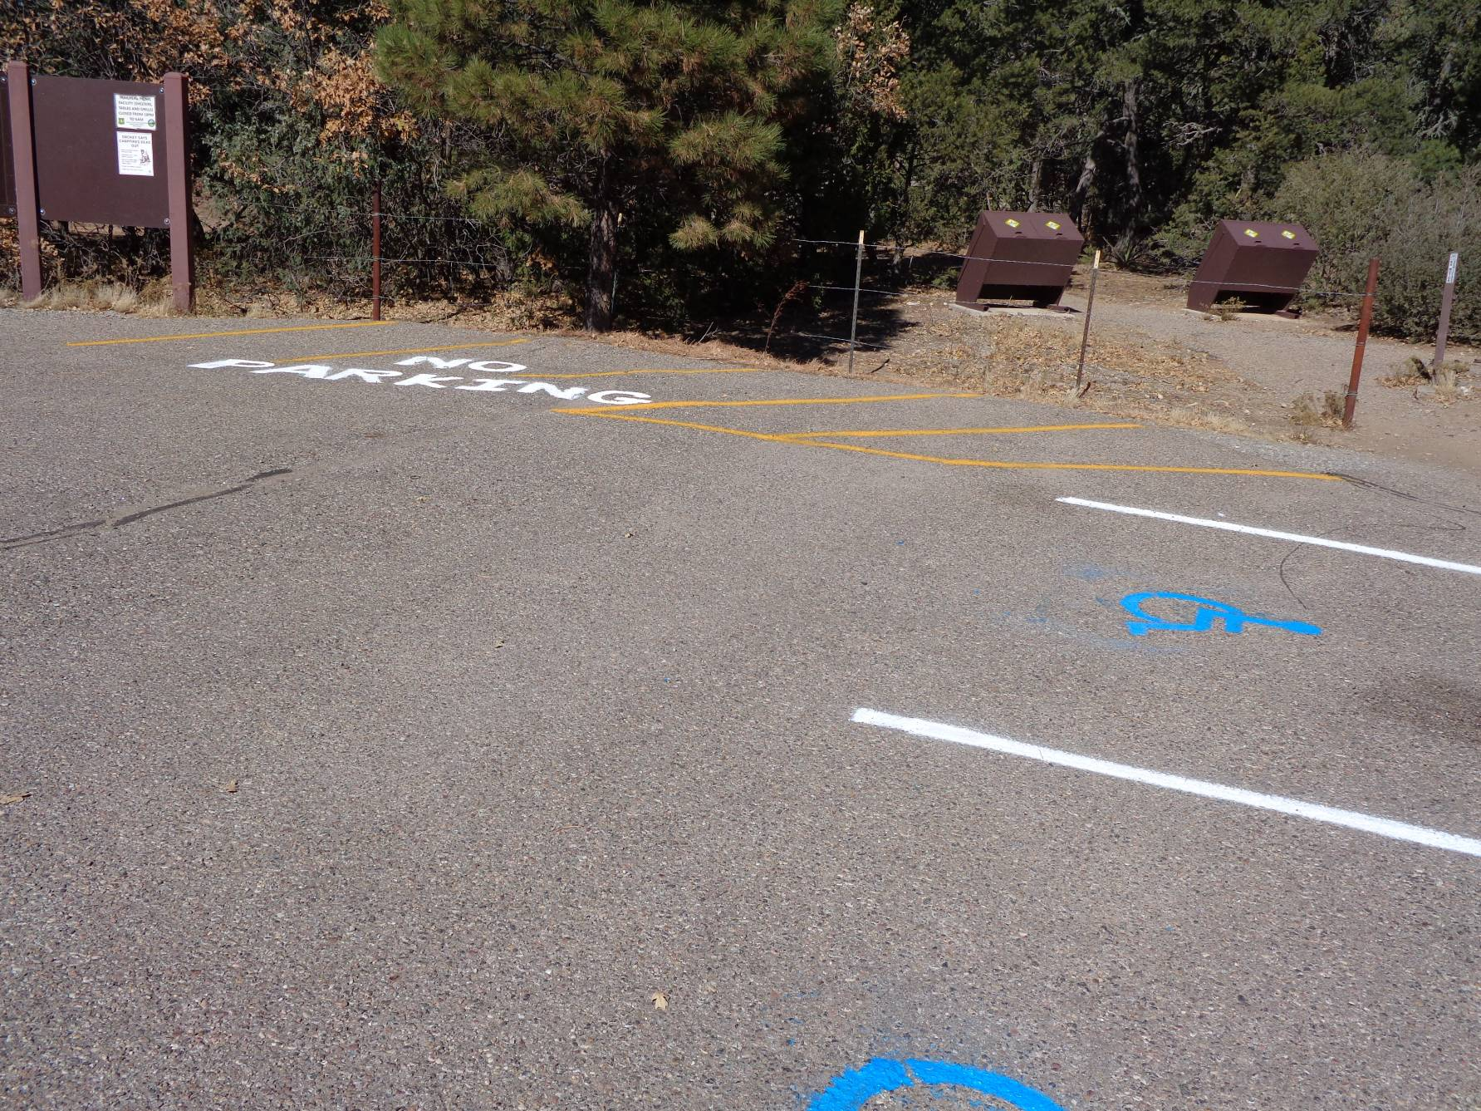
White and yellow stripes, No Parking sign, and handicap blue wheel chair symbols were painted at Oak Trailhead.
Two trash containers were painted with the Forest Service brown paint. Photos by Sam Beard
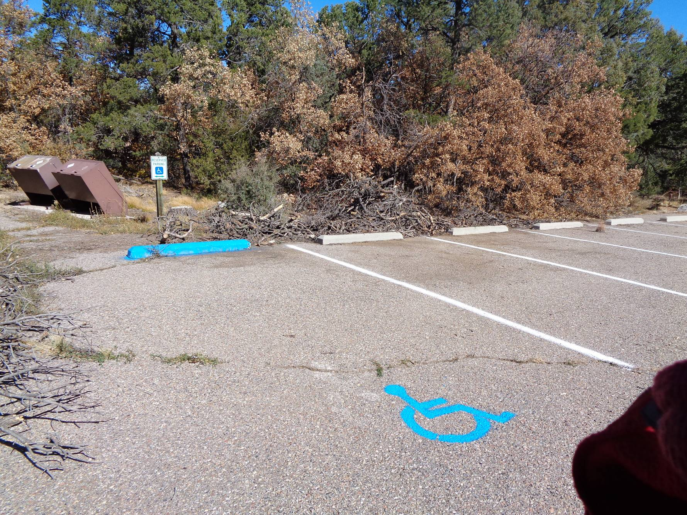
Pinyon Picnic Site parking area. The slash came from our felling a large dead pinyon tree here a few years ago.

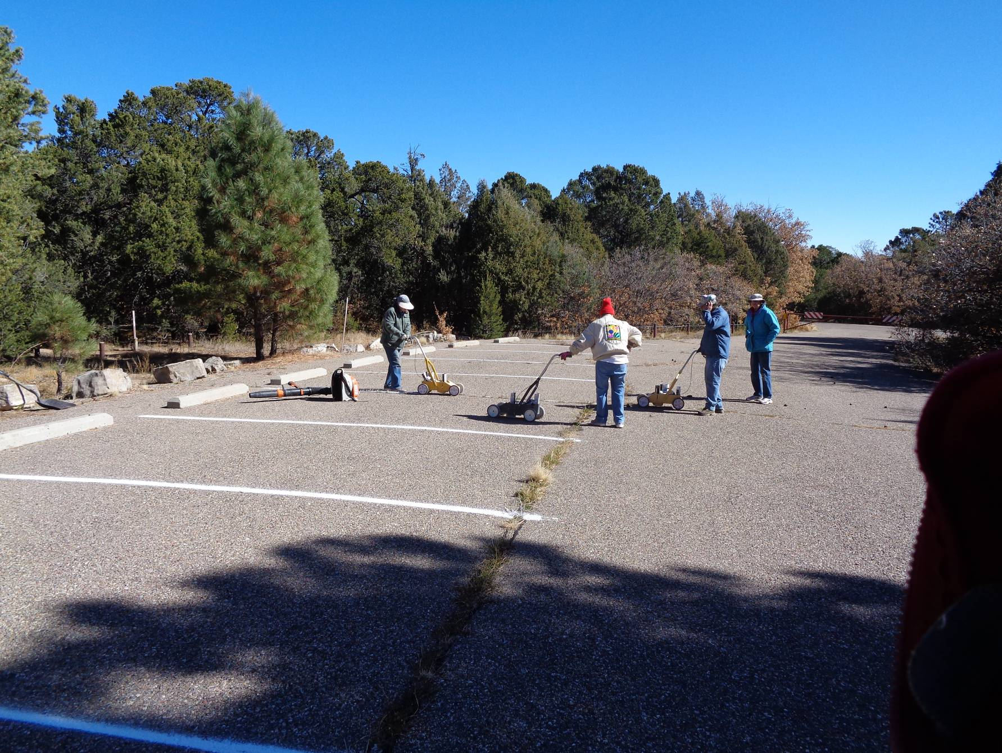
Painting stripes in Pinyon site parking lot.

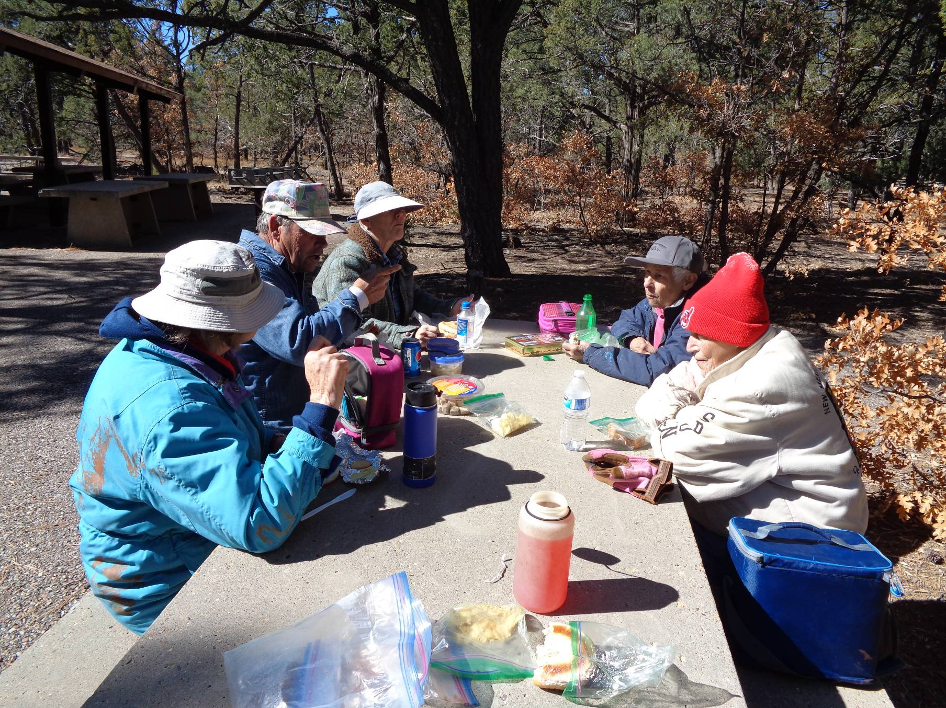
Enjoying lunch in the Yucca picnic area. L to R: Anne Hickman, Russell Parker, Ellie Parker, Jane Harrison, and Rikki Barrett.

