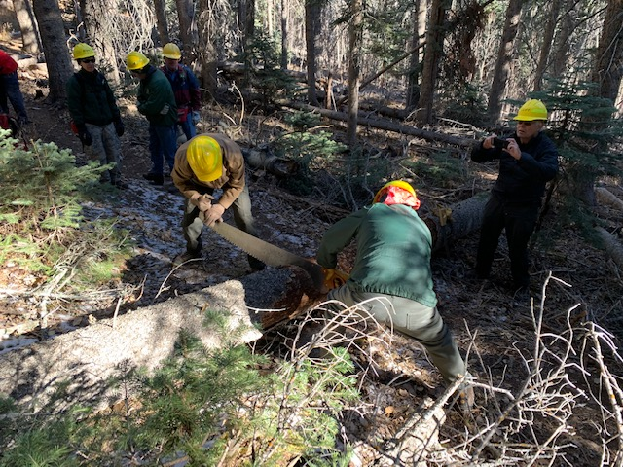
Sim and Jim starting first cut on a 14-inch diameter fallen tree. A smaller 5-inch diameter tree that fell with it has already been removed. These were the first two trees that the crew came to.

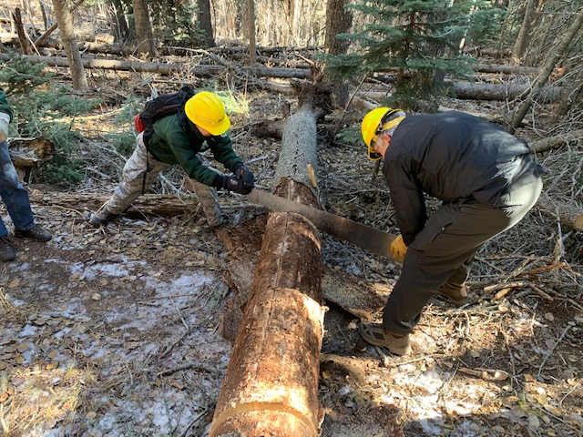
Rav and Cliff start the second cut on the 14-inch diameter tree.

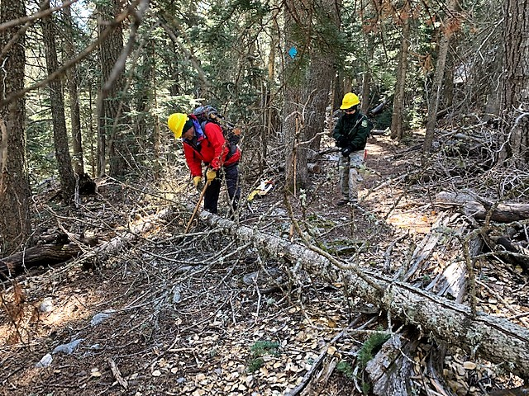
Rav and David begin work on the next tree, which was a 5-inch diameter “porcupine” tree blocking the trail. In was limbed and moved off the trail after being cut with a pruning saw.

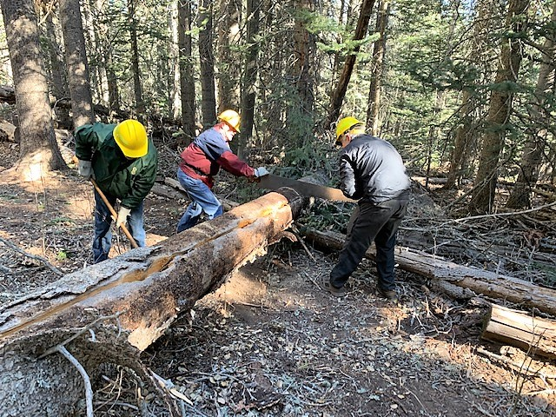
Jerry and Cliff begin the first cut on the second 14-inch diameter fallen tree the crew encountered. It also had taken down a smaller 5-inch diameter tree with it which was removed using a pruning saw. Byron is clearing away debris to provide a safe working area for the second cut.

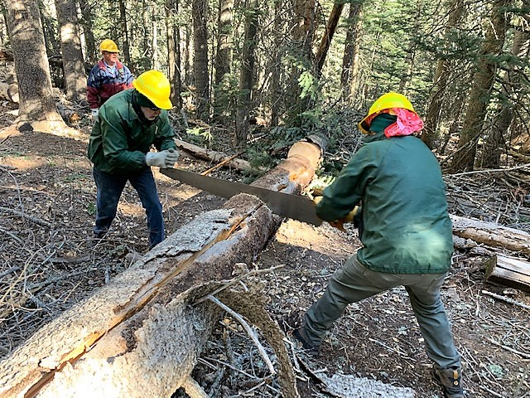
Byron and Jim start the second cut on the 14-inch tree.

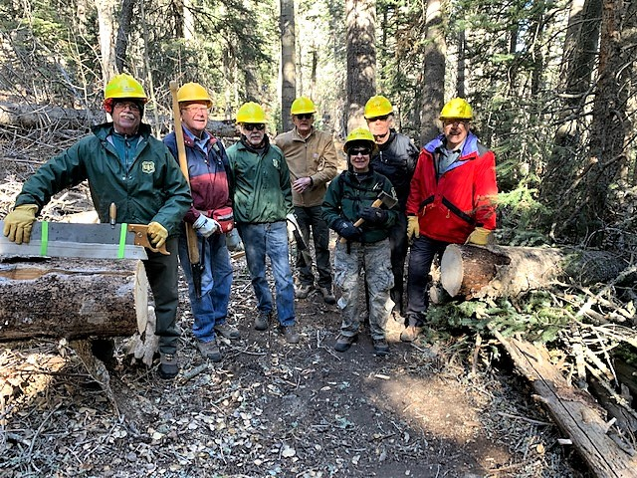
Survey trail is clear. The crew, left to right, consisted of Jim Levesque, Jerry Pekarek, Byron Garner, Sim Cook, Rav Nicholson, Cliff Giles and David McCreery. (Not pictured – Bob Lowder)

