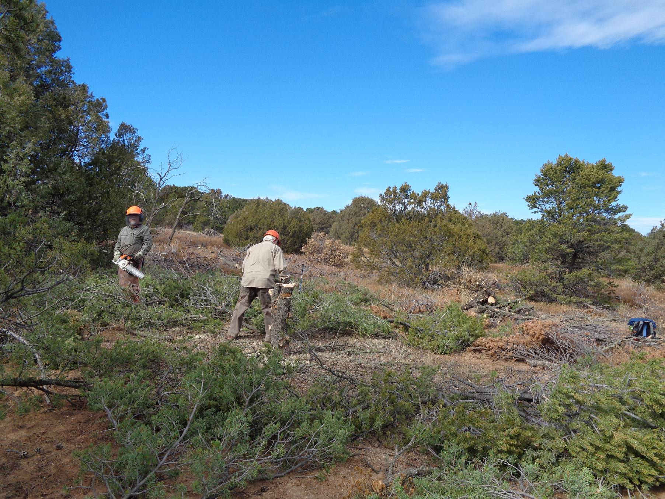
Bill White has just limbed a pinon tree, and Lou Romero is scattering the branches. The three-foot high stump will be cut
near the ground later. Note the pile of fire wood to the right of the photo center. All photos by Sam Beard
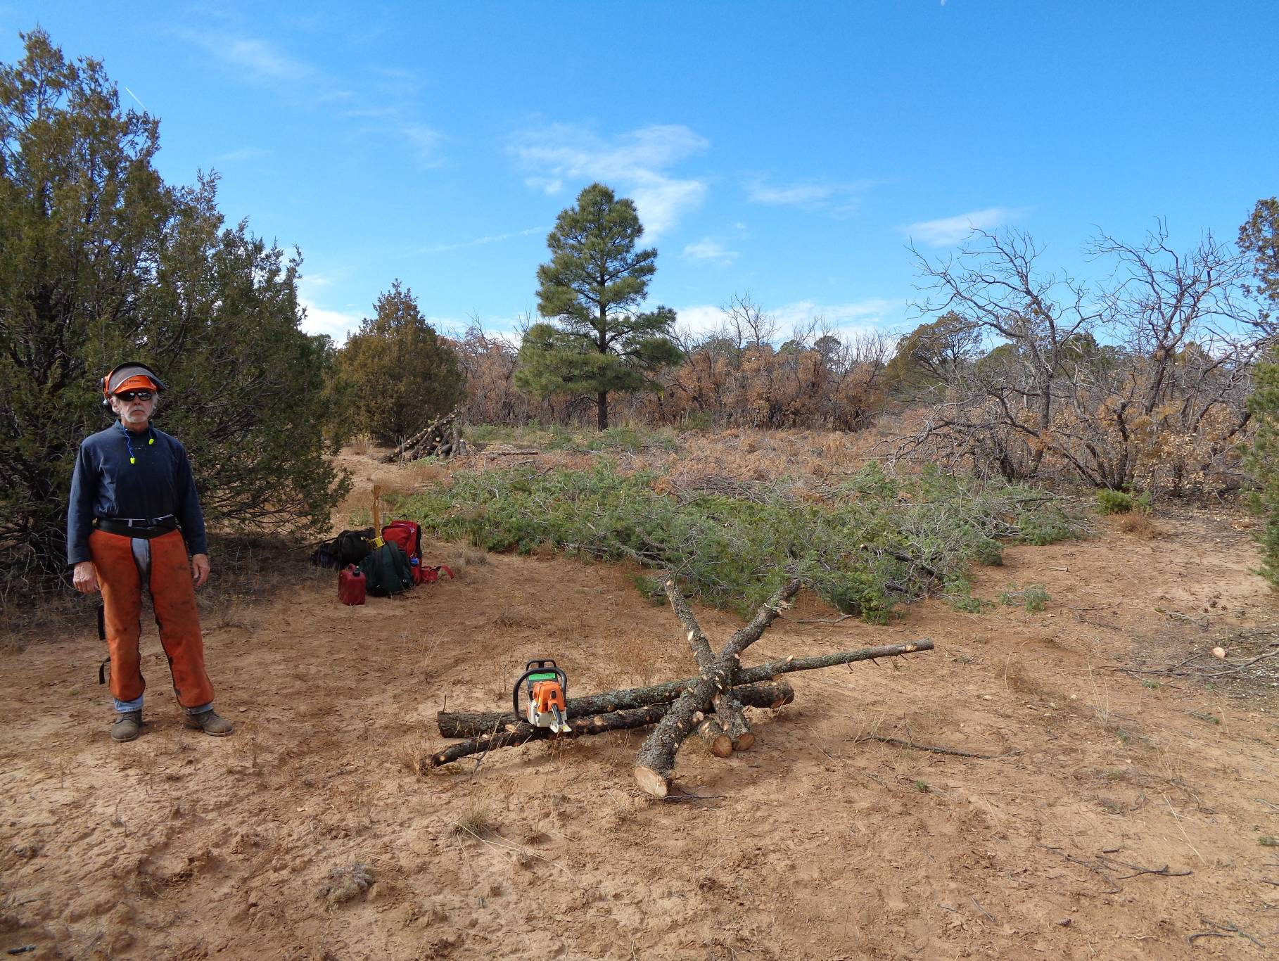
Byron Garner standing near a pile of wood from trees that were felled here. The green branches scattered on the ground will
promote retention of water and the growth of grasses. In the background is one of the few ponderosa pines in the project area.

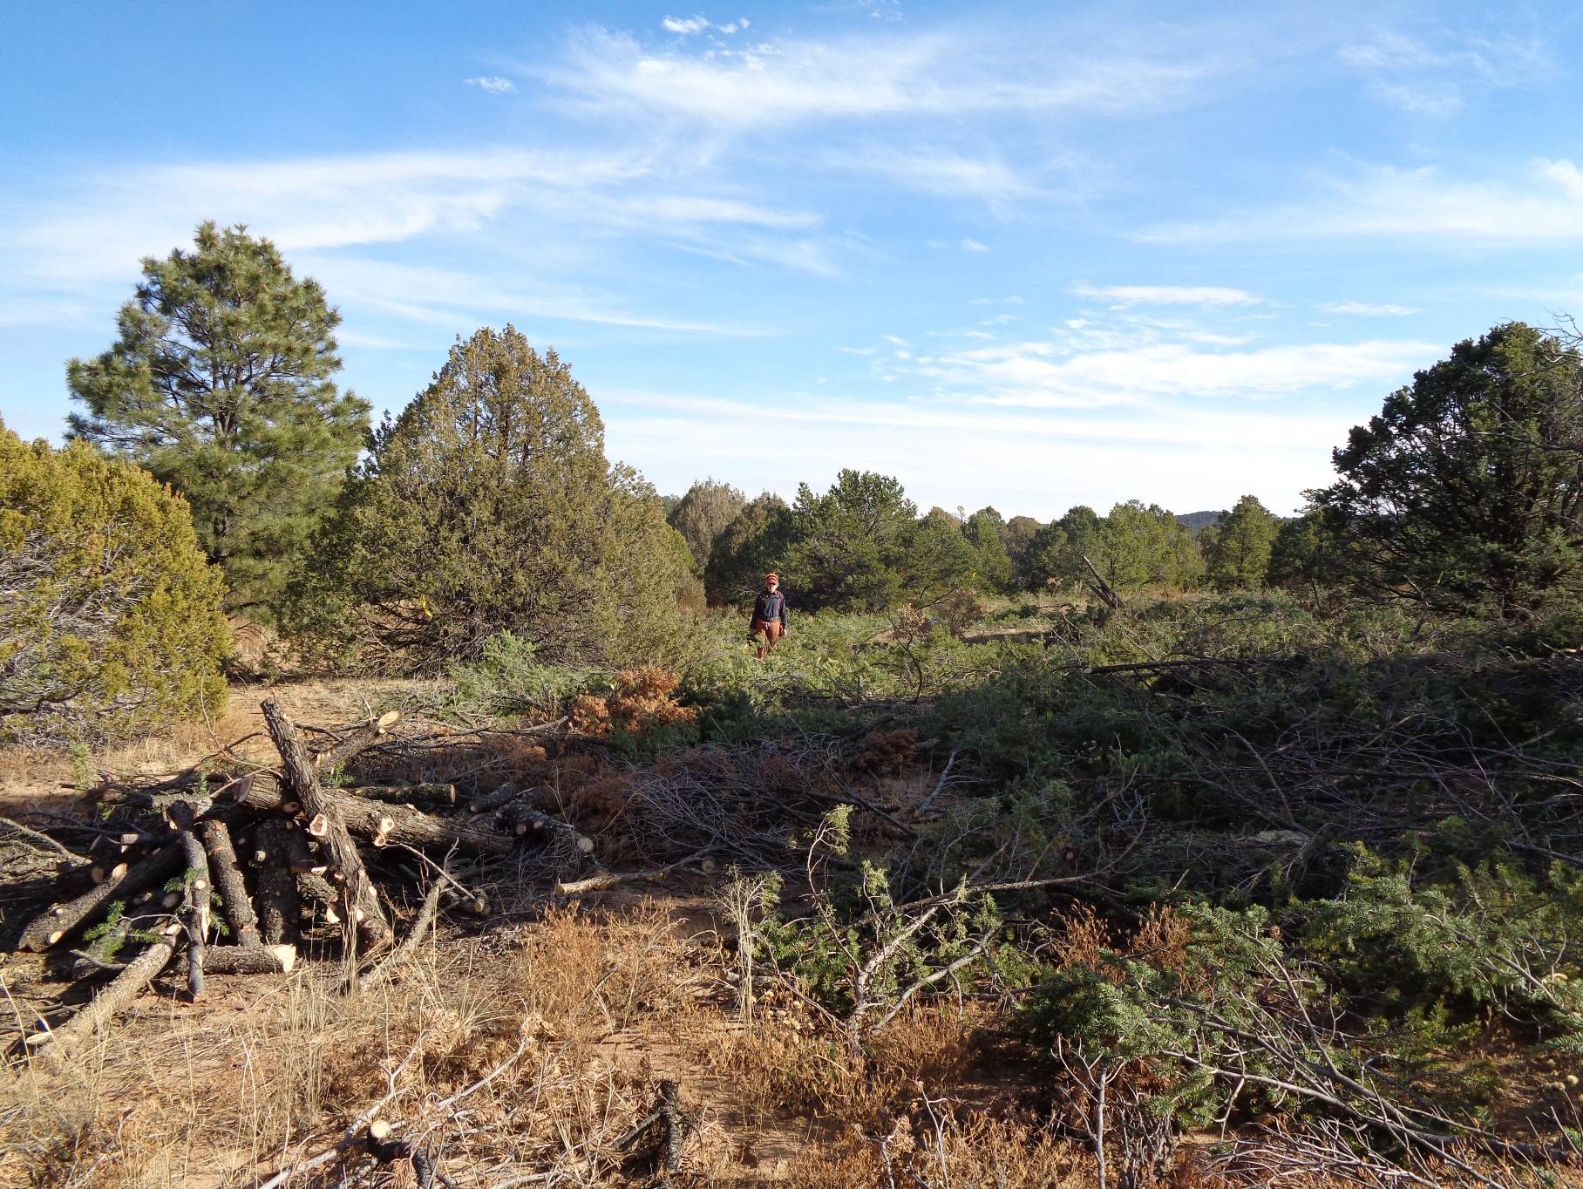
Bryon is standing in a thinned area where trees were felled and the slash was scattered. Next year this area will be covered
by grasses and wild flowers, and a meadow will have been restored. Note the large pile of fire wood on the left and the junipers,
pinons, and pines surrounding this future meadow.

