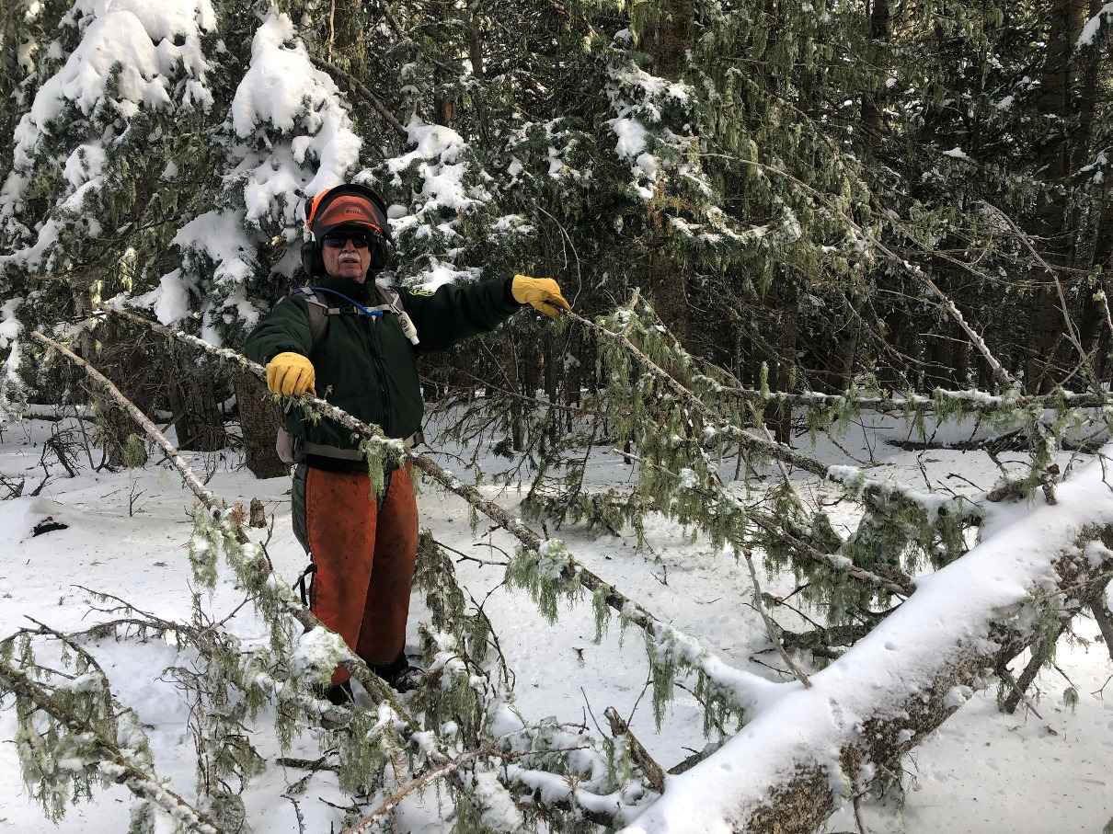
Jim checks out a fallen tree on Kiwanis Meadow Road. It was removed.

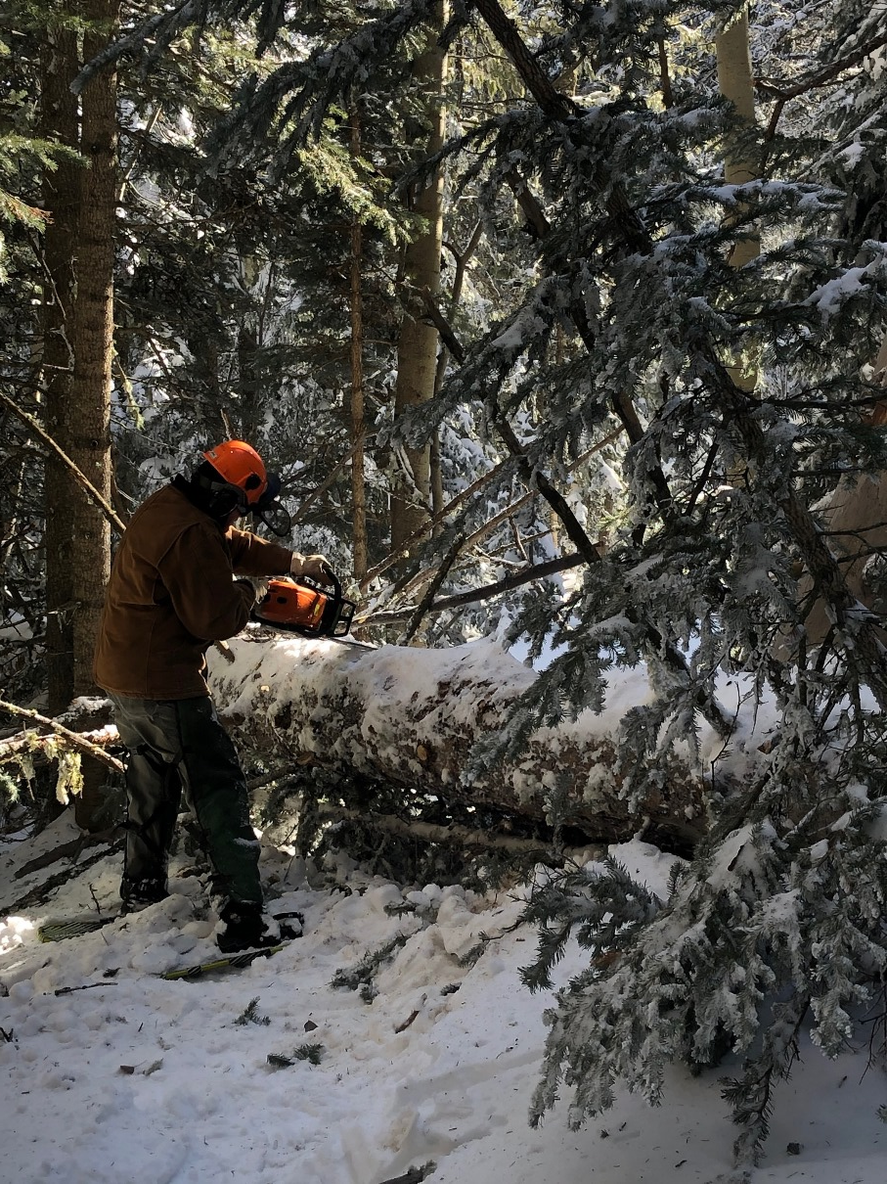
Eric doing some limbing on an 18-inch diameter fallen
spruce tree that was blocking Switchback Trail.

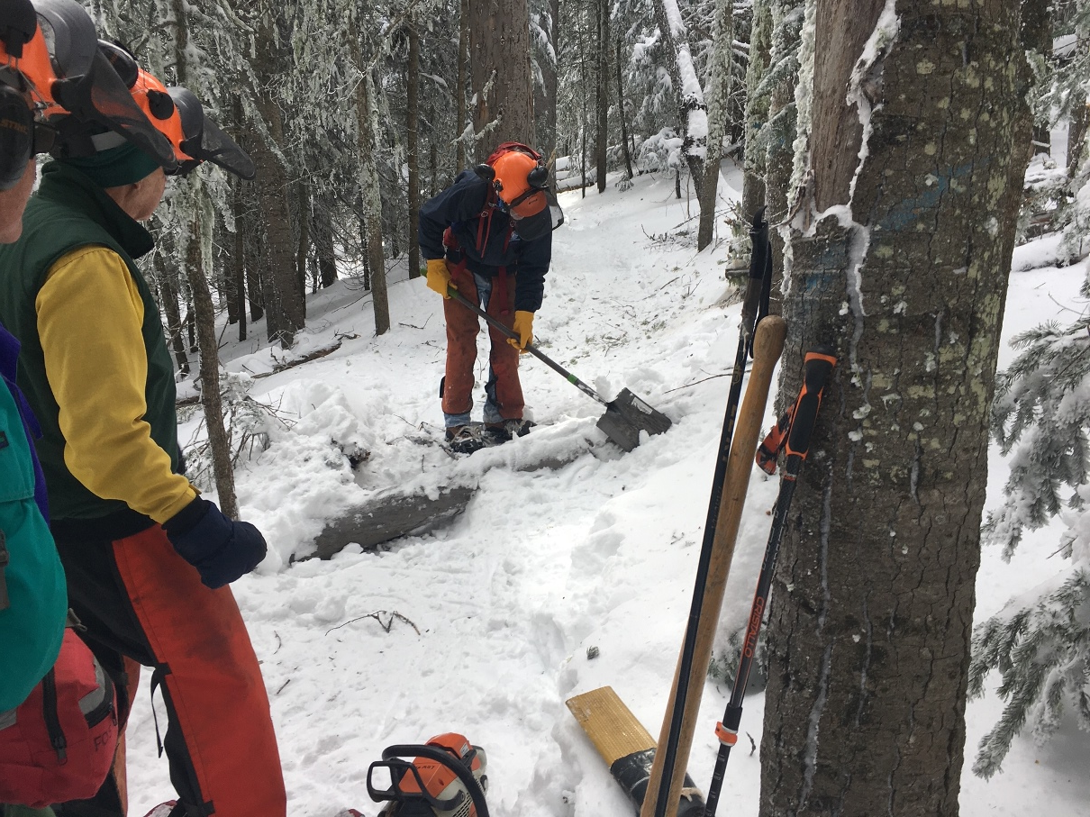
Due to the depth of the snow, it was often necessary to dig around fallen trees to provide access for the saw to cut them for removal. Here Byron demonstrates.
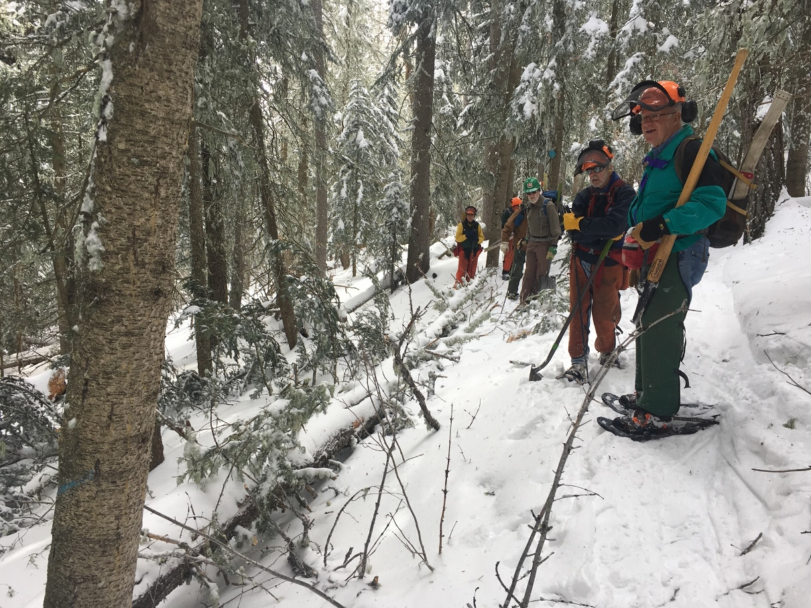
The crew evaluates a large fir tree that had fallen straight along the uphill margin of Switchback Trail. Its lower branches were blocking the trail. It was a very long tree which extended from its top where Bob is standing in the distance to its base and root ball located well to the lower left of the photo. Due to its size and the fact that its uphill side branches were frozen into the snow, the crew decided not to try to cut it completely away. All that was needed to restore the original trail tread was to cut off the lower branches. This was done and the trail was cleared of debris. If it appears that the tree begins to roll downhill on to the trail in the spring, it will be cut away when it is more accessible.
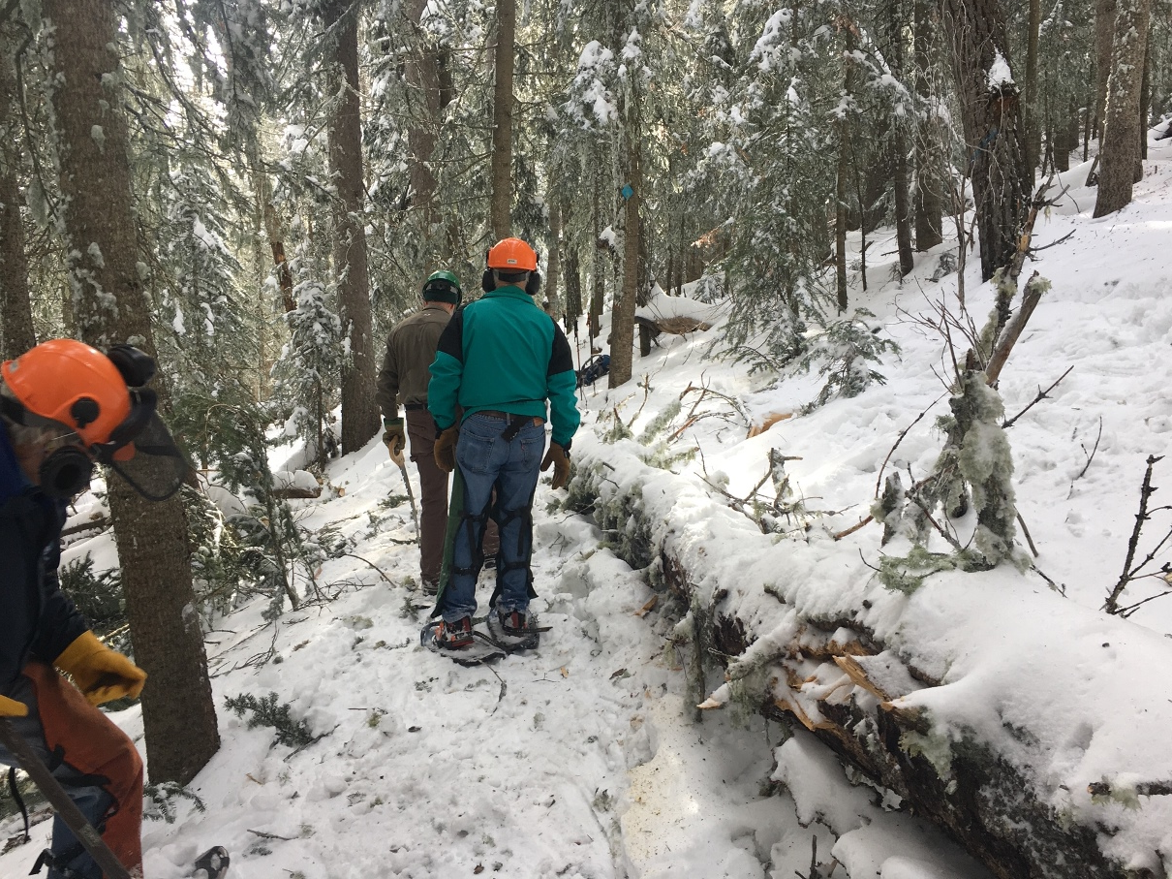
Here is the “after” picture of the tree in the previous photo. The crew is tamping down the tread on the original trail route to smooth its surface.

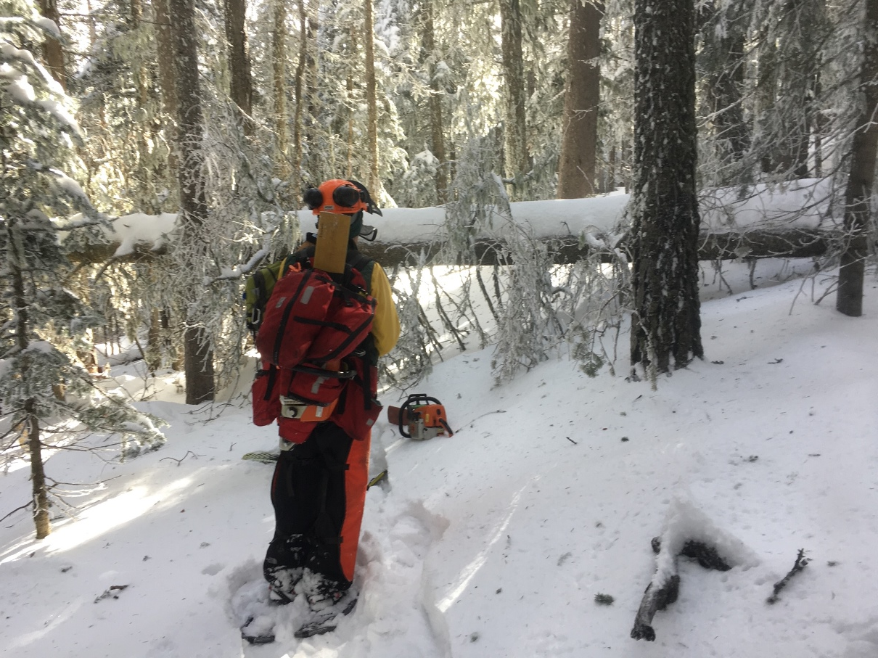
“Oh no, not another big one!”. Bob observes another large fallen tree blocking Switchback Trail at head height. It was removed.
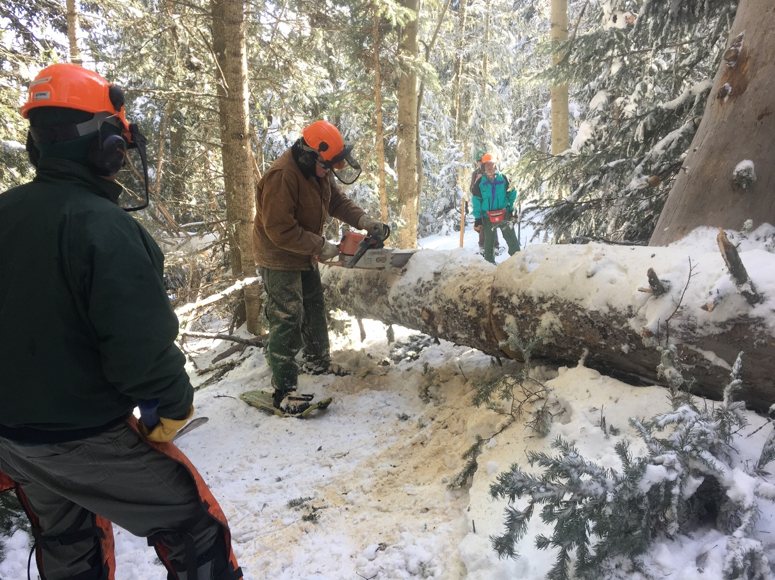
Eric starts the second cut on the large tree shown in the second photo above. It took three cuts to clear the trail. Jim stands by with wedges if needed.
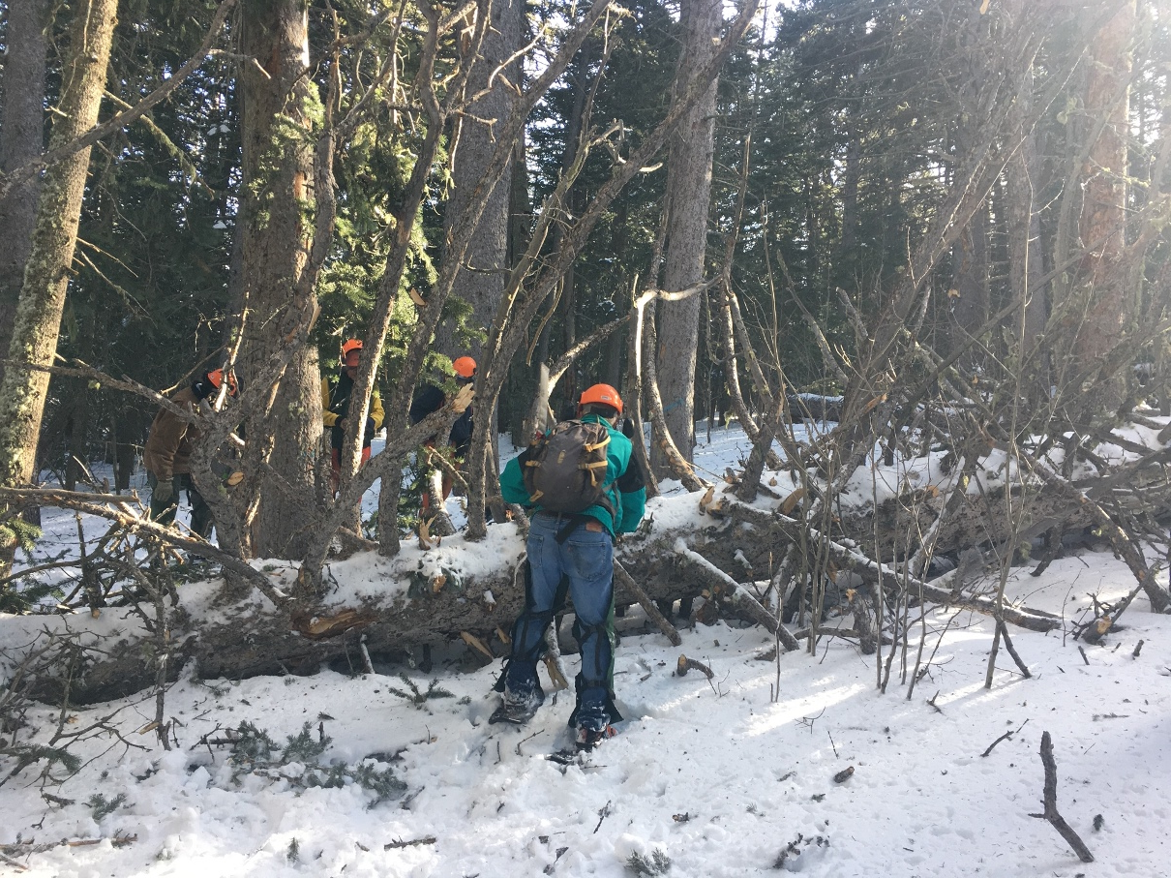
This was the “Grand-Daddy of them all” for this hike. This 24-inch diameter fallen spruce was blocking switchback trail. Some of its branches were as large as small trees.

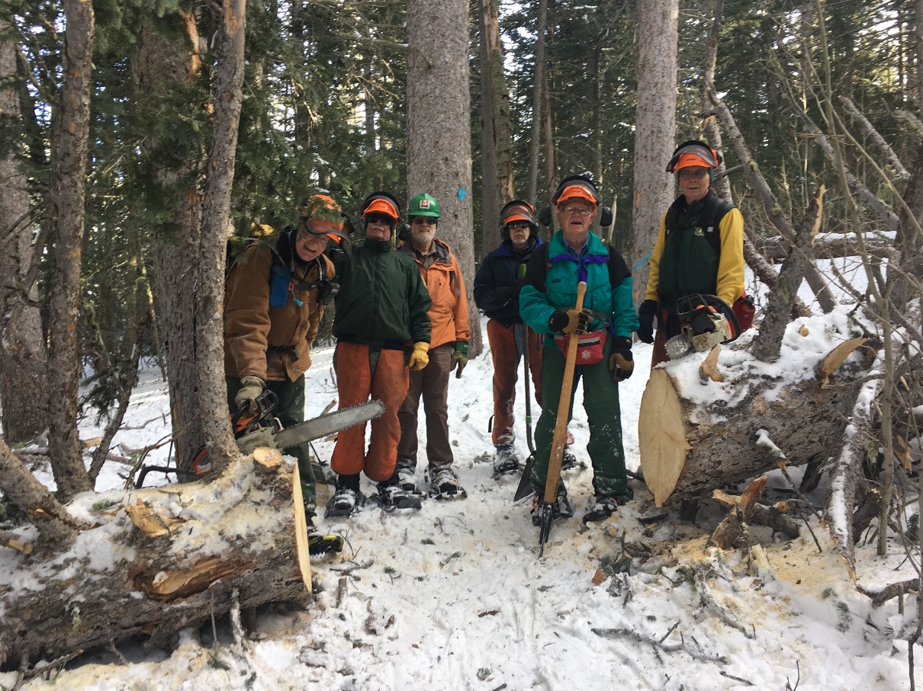
The big tree in the previous photo has been cleared away and Switchback Trail reopened here. The crew (left to right) Eric Russell, Jim Levesque, Cleve Sharp, Byron Garner, Jerry Pekarek and Bob Lowder. (Not pictured – Cliff Giles)
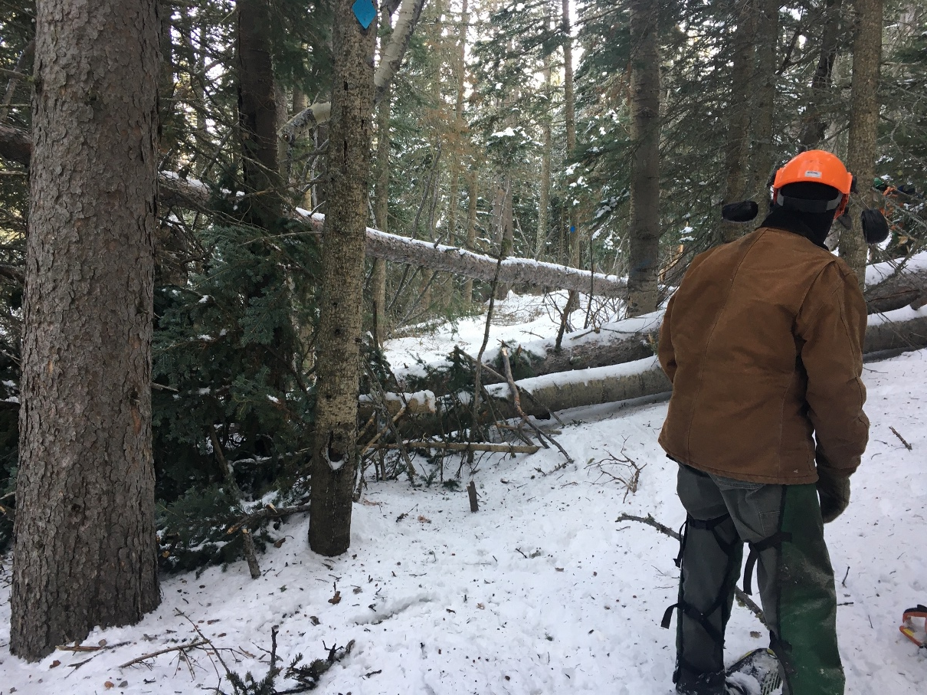
This jumble was located on Switchback trail just below its junction with Survey Trail. It was removed.
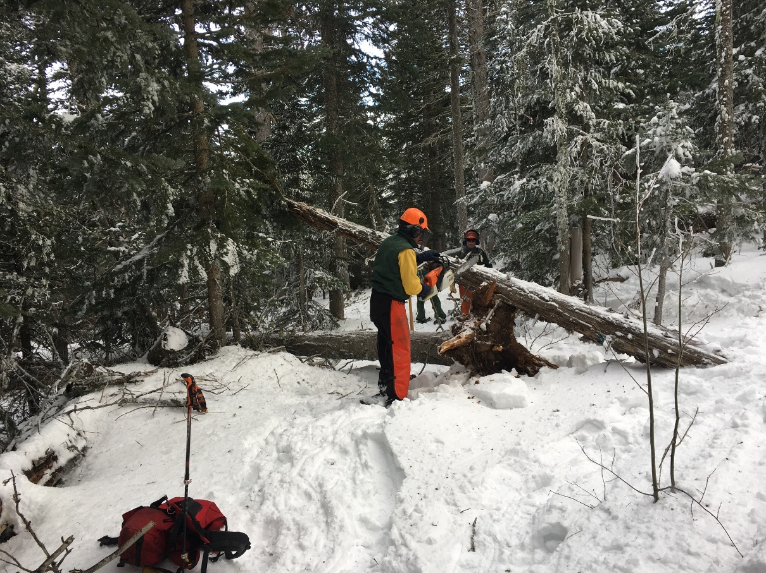
Bob is cutting away this unusual combination which was blocking Switchback near its junction with the Tram Service Road. The higher tree had fallen directly on top of the root ball of the second tree below it.

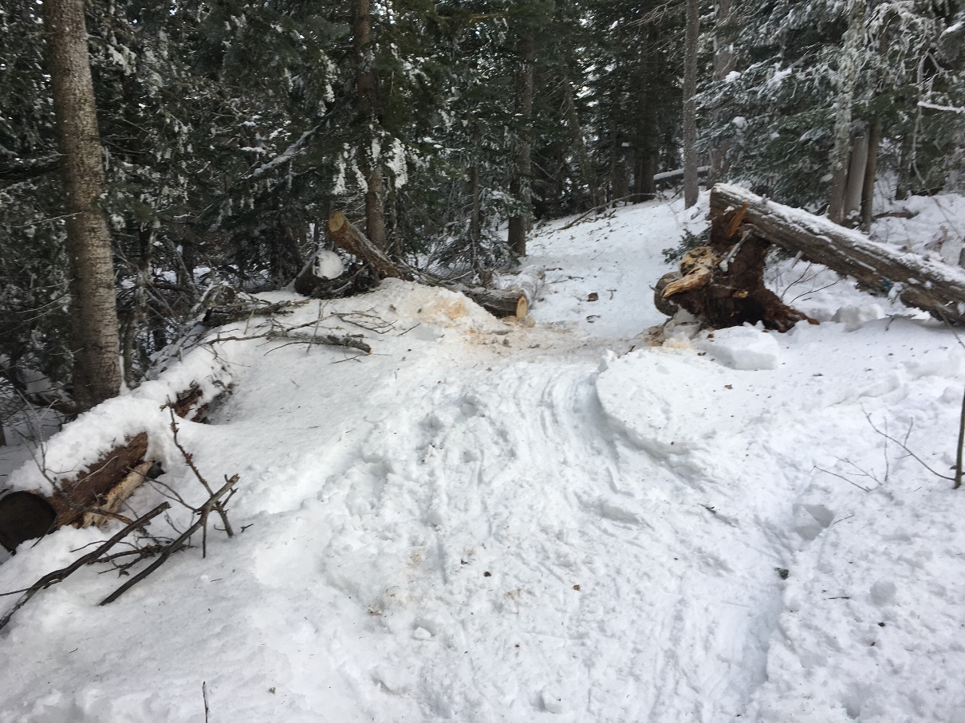
The trail is reopened.
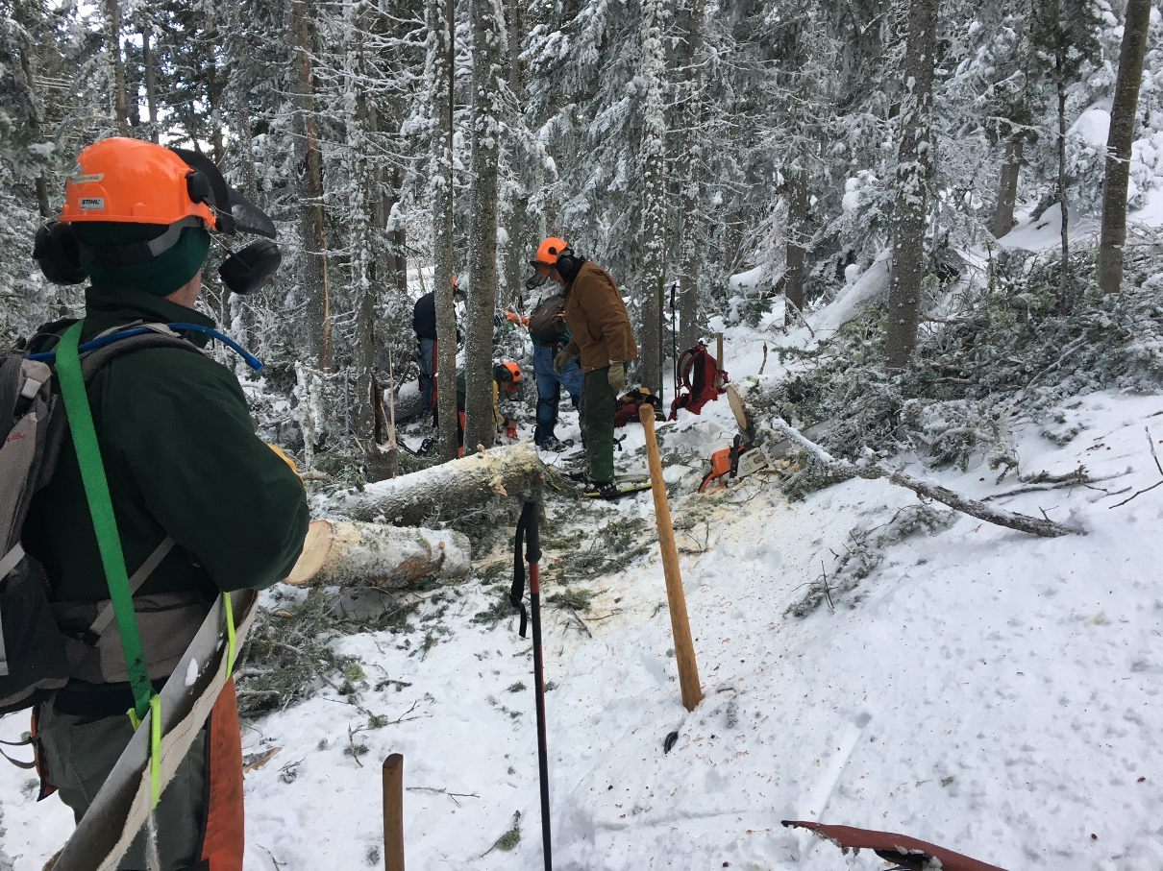
Well, one could hope that the last job would be a simple one. No such luck! This big train wreck was located just above the Switchback/Tram service Road junction. It was cleared. A fitting ending to a long, hard day.

