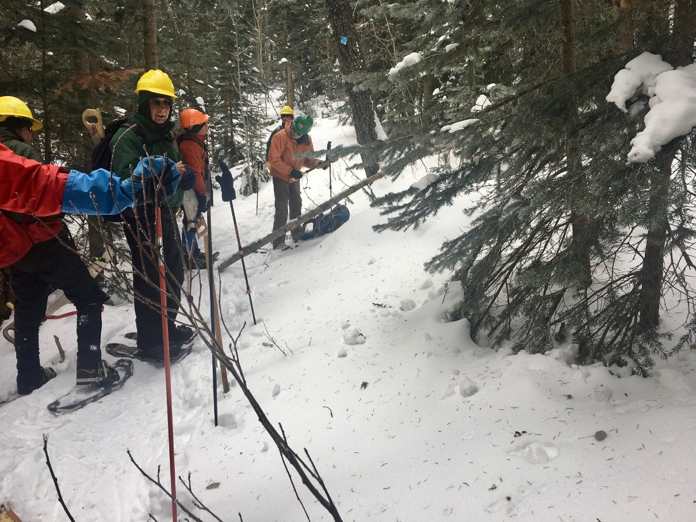
Cleve prepares to remove a small tree from the trail early in the hike. They weren’t all this easy!

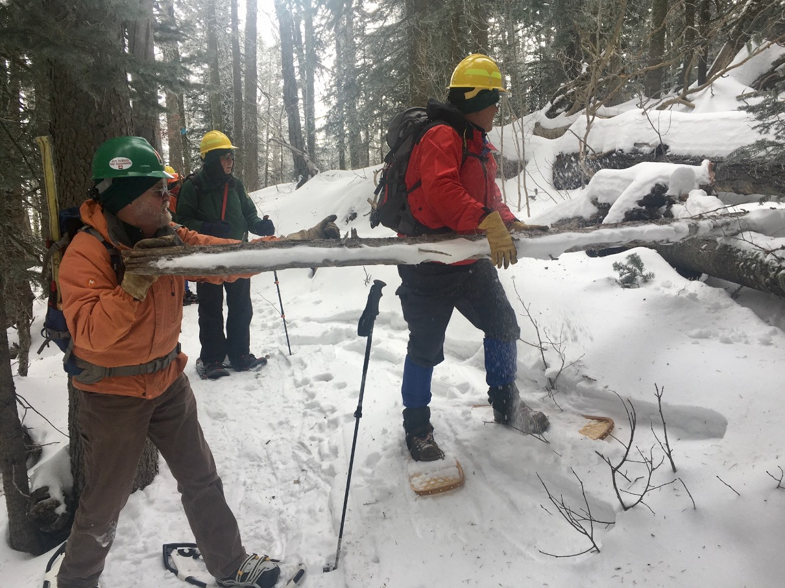
Cleve and David wrestle with a small tree sticking out over the trail in an attempt to simply push it away rather than cutting it. It did not choose to cooperate so it was cut.
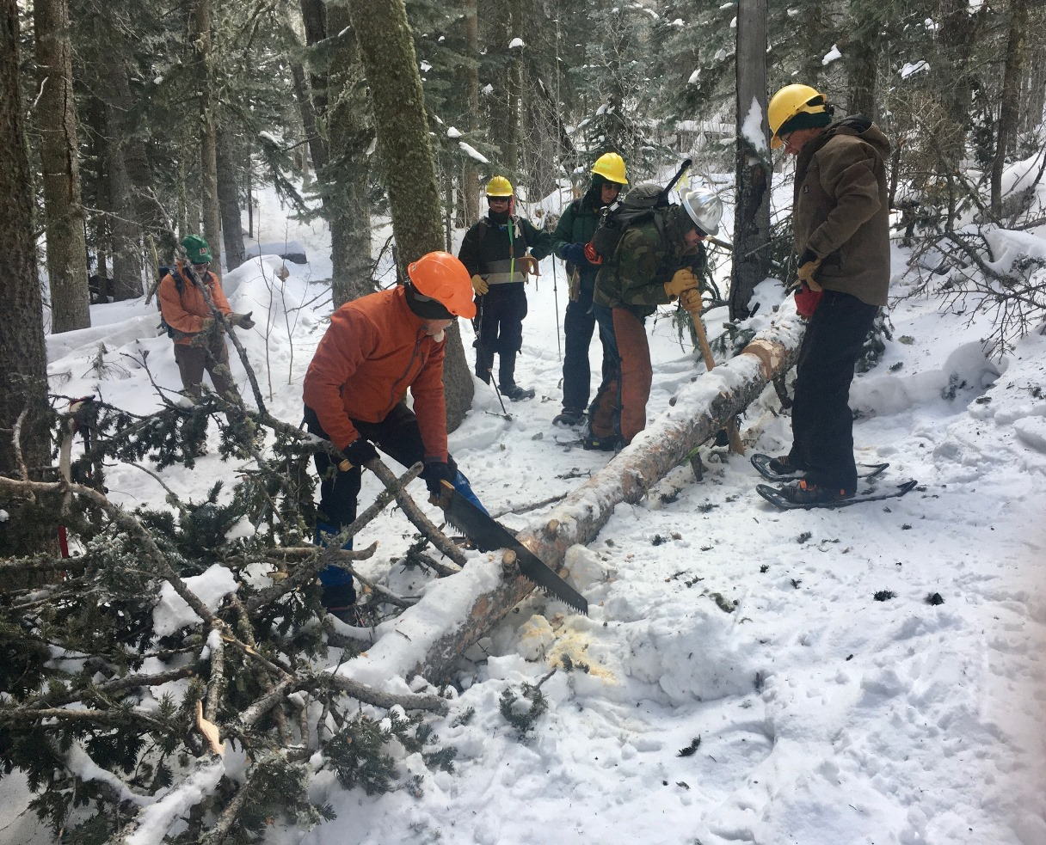
Bill and Michael work together to remove a fallen tree that was blocking the trail.

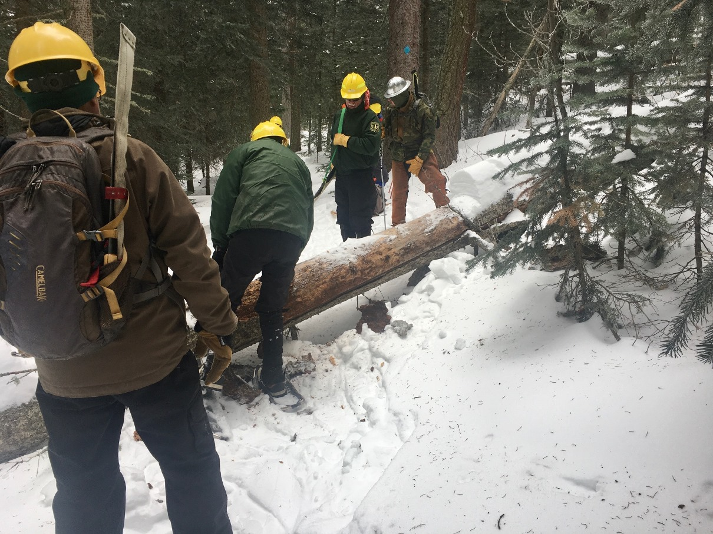
The crew is removing snow and making other preparations prior to removing a 13-inch diameter tree blocking the trail.
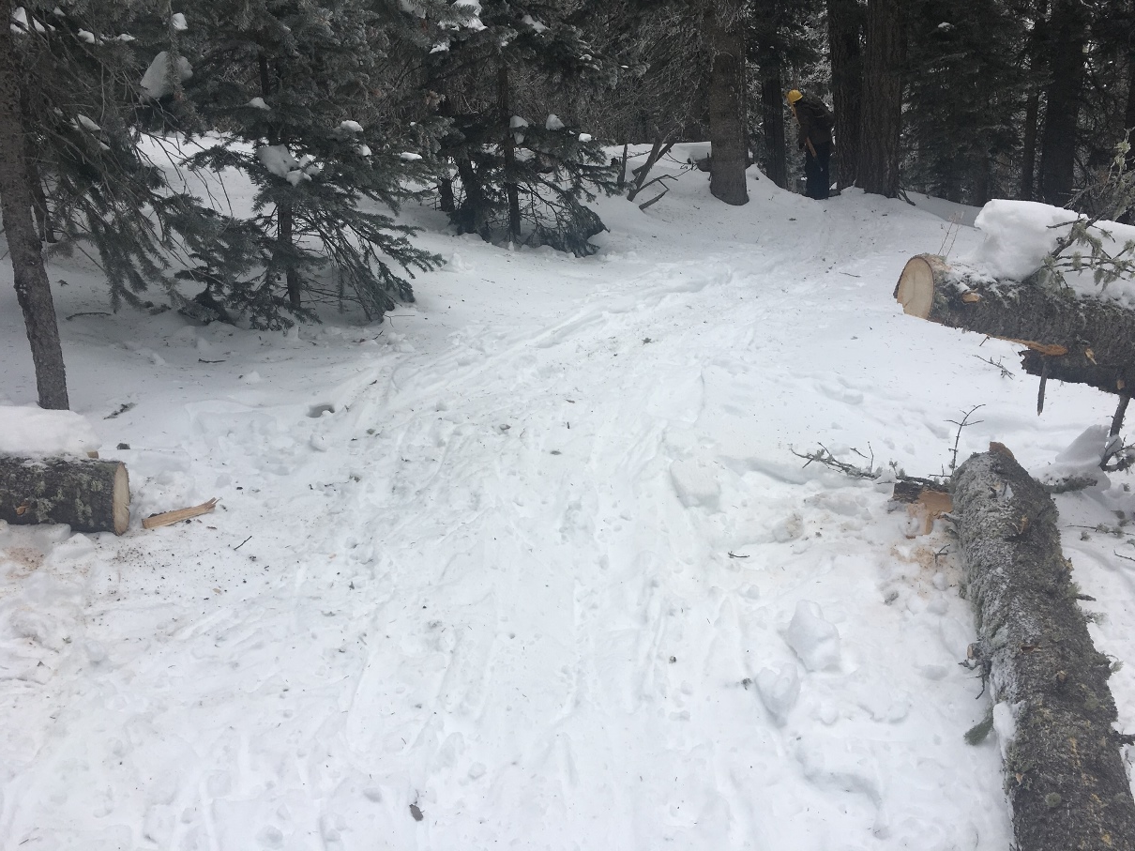
View of a clear Survey trail after a fallen tree has been removed.
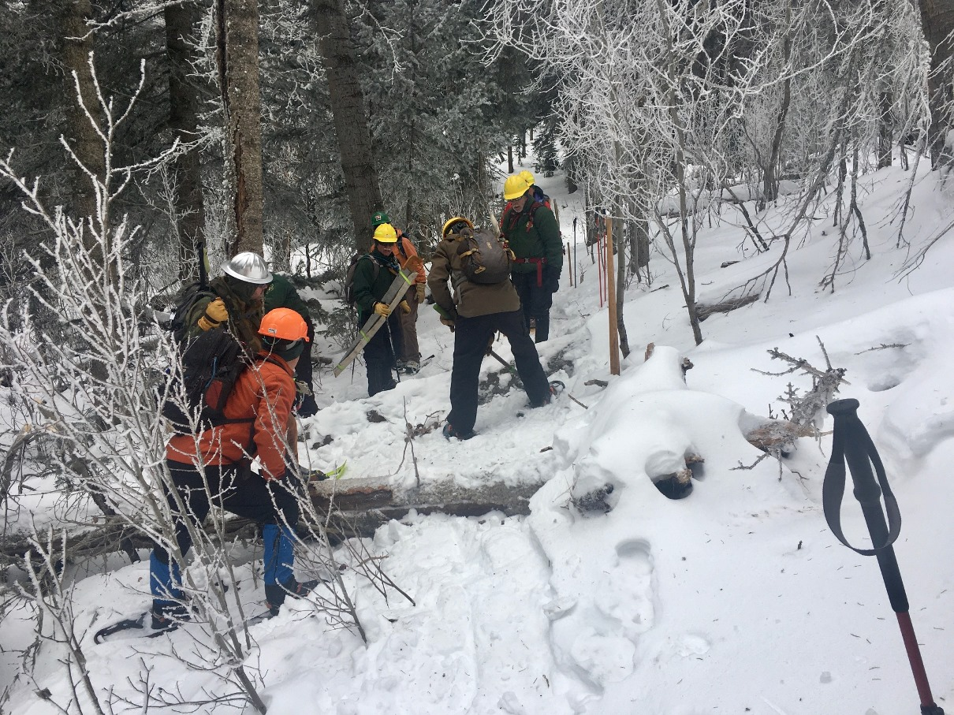
Sometimes it is necessary to dig out the fallen trees from the snow before they can be cut and removed. This is a good example.

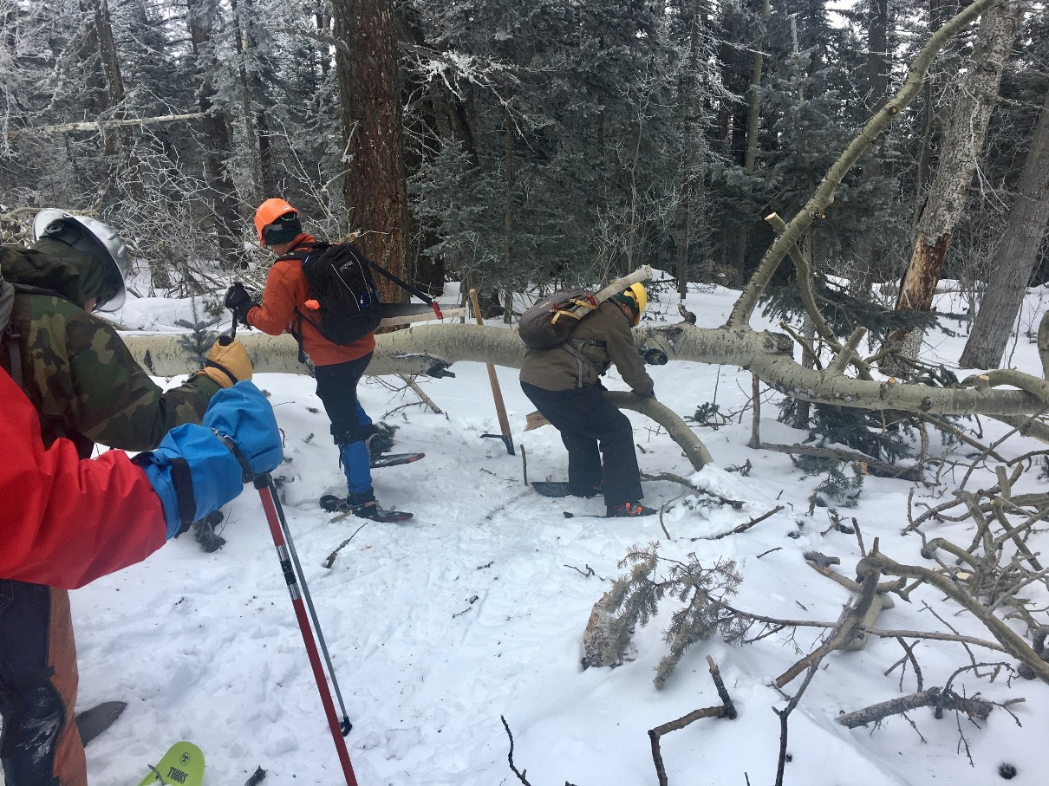
This large aspen had fallen over the trail and was blocking it. The crew has begun the work by first cutting away some branches.
(This is the “before” picture looking north.)
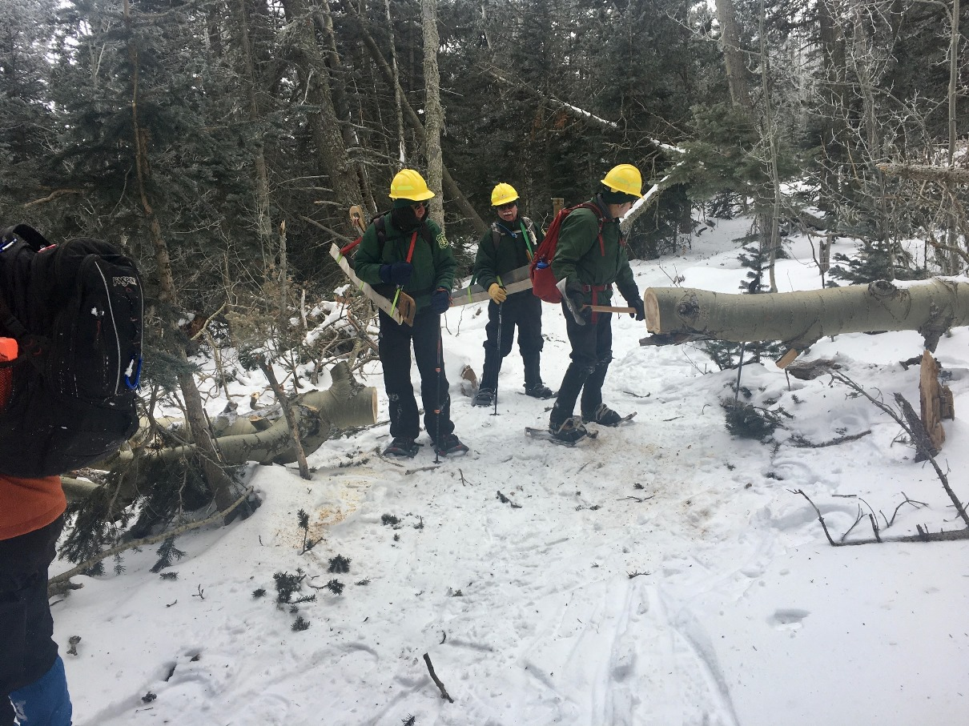
Fallen aspen in previous photo has been removed. This is the “after picture” looking south.)
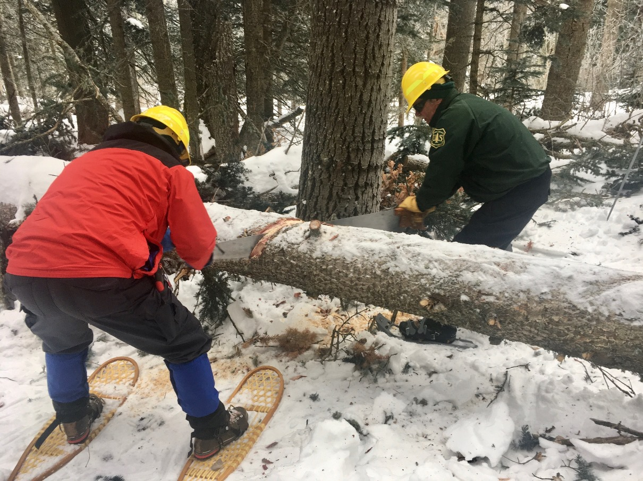
David and Jim making a cut on a large fallen tree.

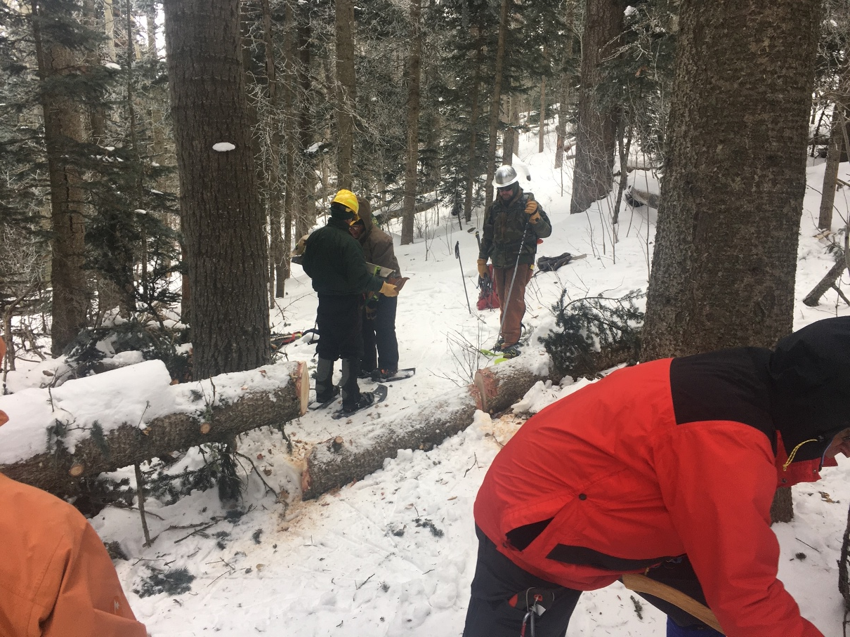
Tree in previous photo has been removed. The crew is placing the sheath back on the crosscut saw and preparing to move the cut section away.
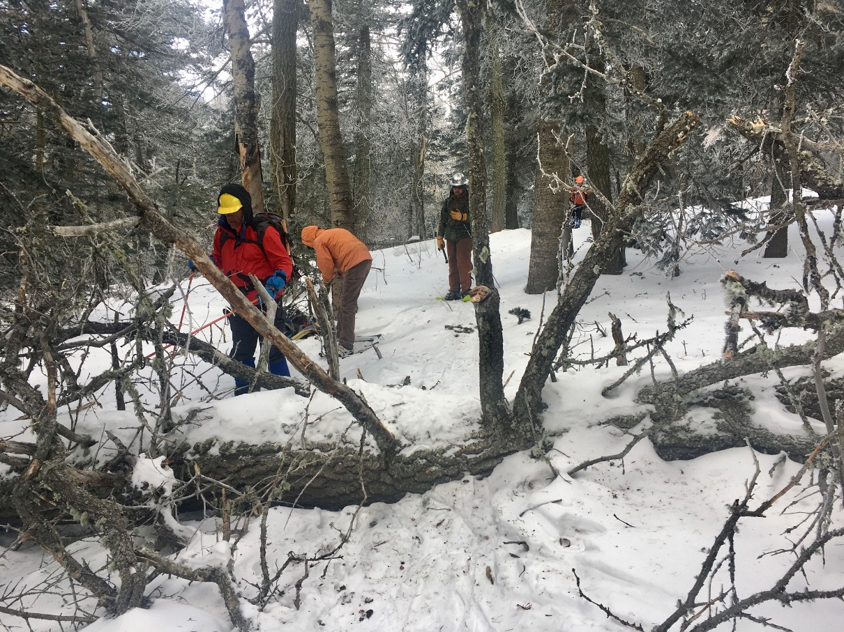
This 23-inch diameter fallen fir was the largest tree removed from Survey trail on Monday. Much limbing and bark removal was required before the sawing of the trunk could begin.
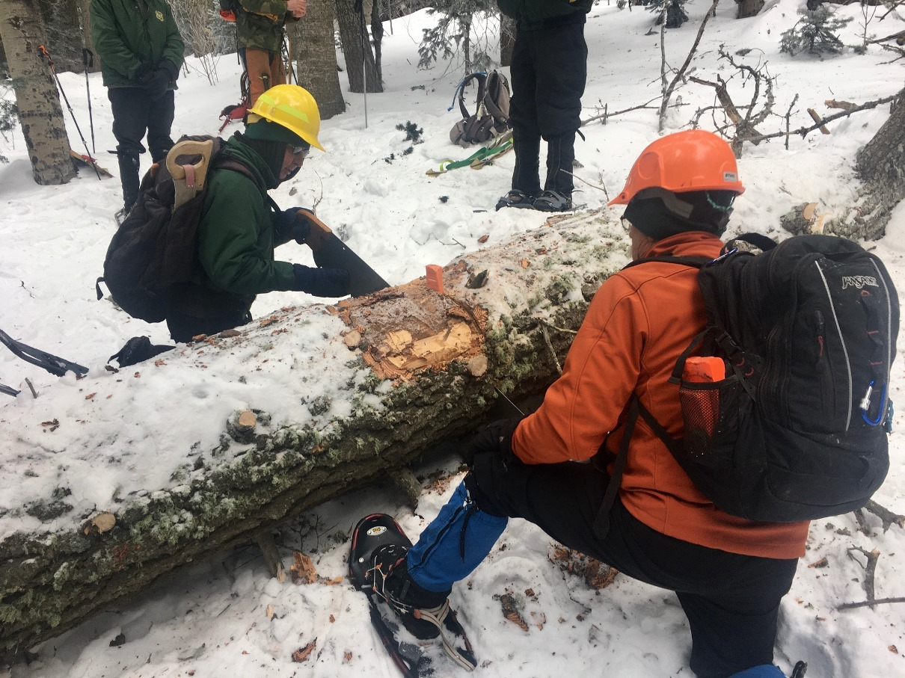
Bob steadies the crosscut saw as the first cut on the large fallen fir is almost complete.

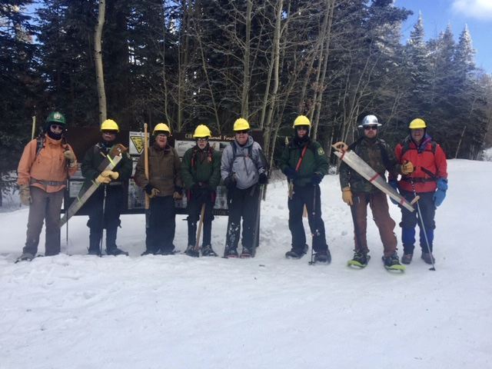
The crew back at Ellis after a long, cold day of work. From left to right, Cleve, Jim, Jerry, Byron, Cliff, Bob, Michael and David. (Not pictured – Bill)

