**FOSM Trail Session Report for 1/30/20**

This week the Friends of the Sandia Mountains (FOSM) trail crew was back working on the Cienega/Armijo Trails Improvement Project (CATIP), extending That Way Trail southwest towards an existing user trail, completing approximately .1mi of new trail during this session. The day started off surprisingly warm in the sun, though the wind picked up before lunch, cooling things down considerably.

The 8 volunteers were Eric Russell, Rav Nicholson, Byron Garner, Mark Grazier, Jim Houle, Phil Cromer, Pat Madden and Jenny Blackmore. The crew were in good hands, led by Russell Berman, SRD Trails Foreman, with Canyon Young, Cibola National Forest & Grasslands Resource Assistant, Trails.

All photos by Jenny Blackmore.

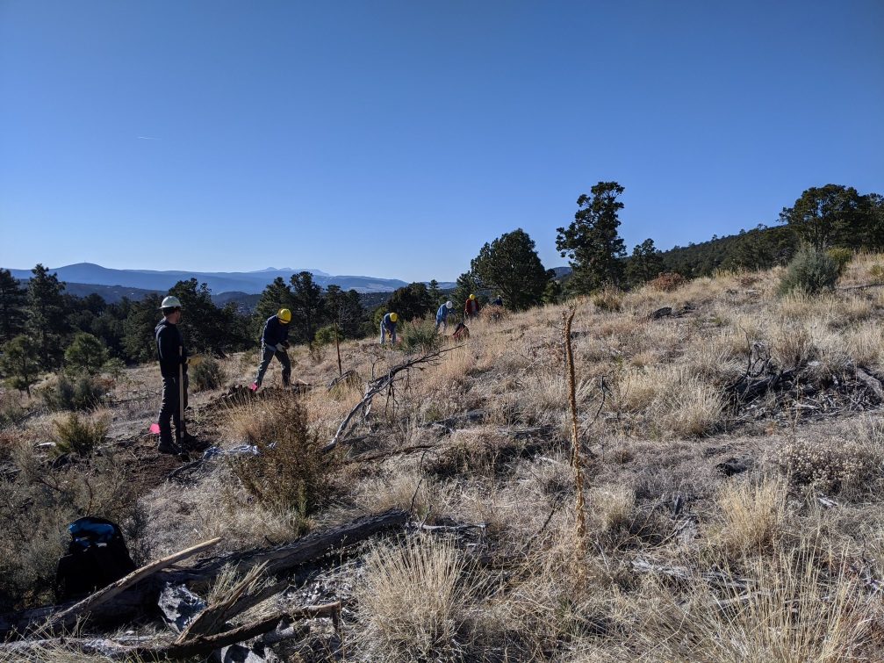

A beautiful sunny morning!

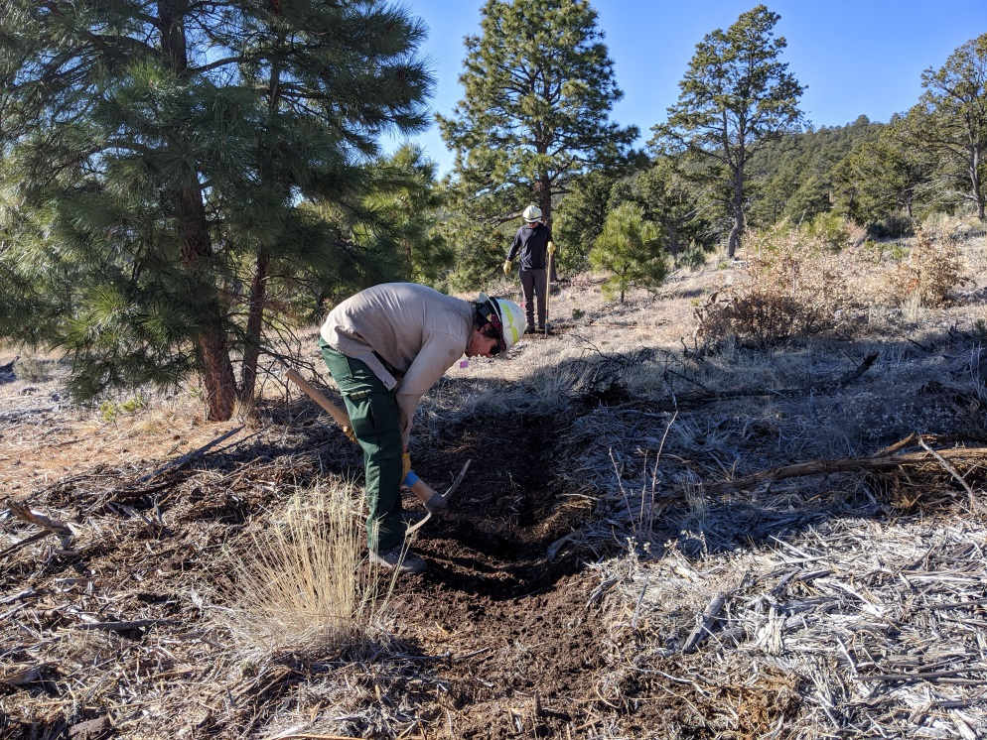

The ground was thawed, though still plenty rocky.

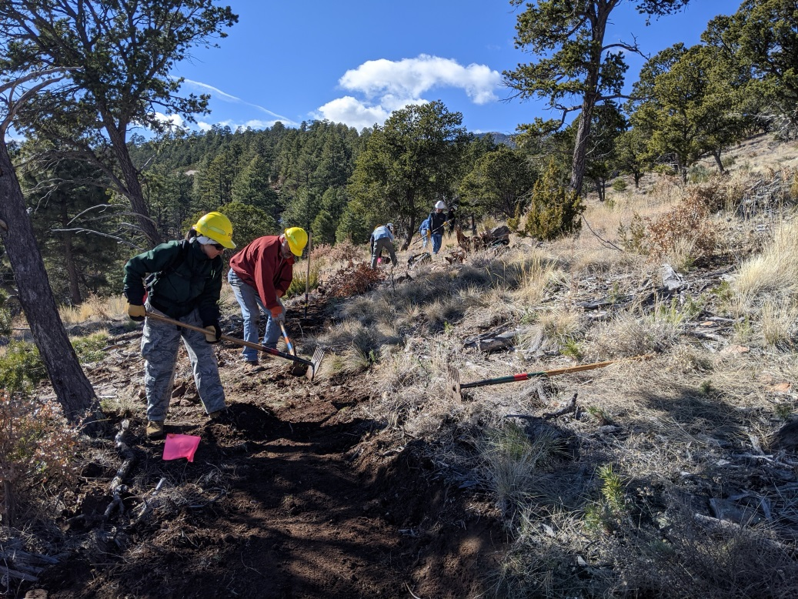

Many hands, and the trail begins to take shape.

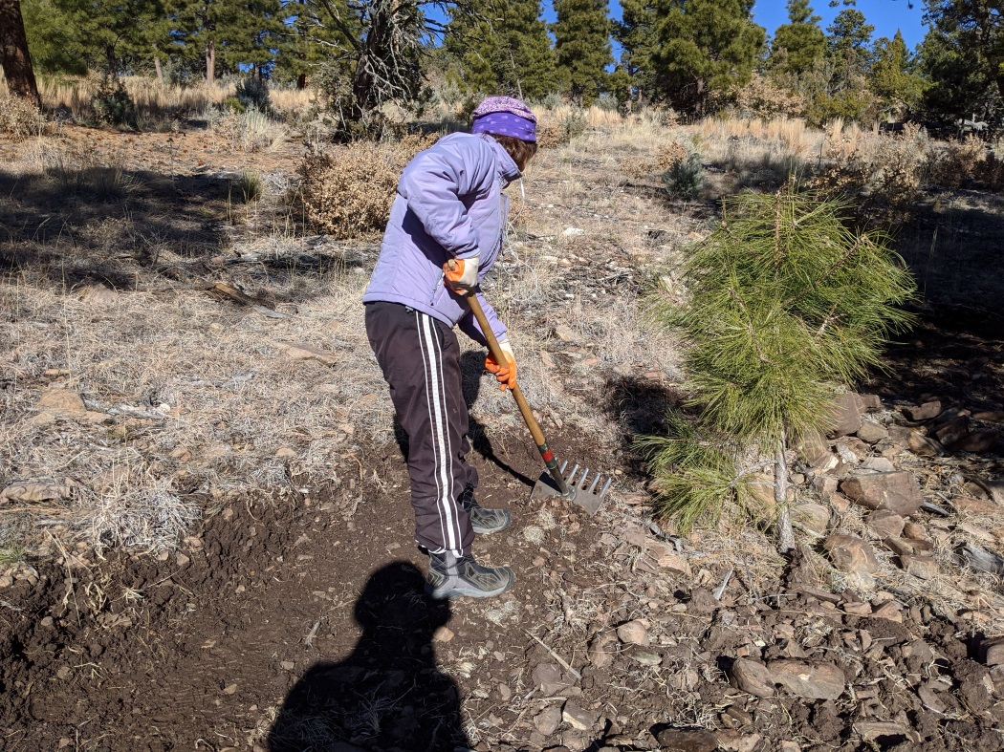

This worker said, “No photos!” but got stalked by a shadow.

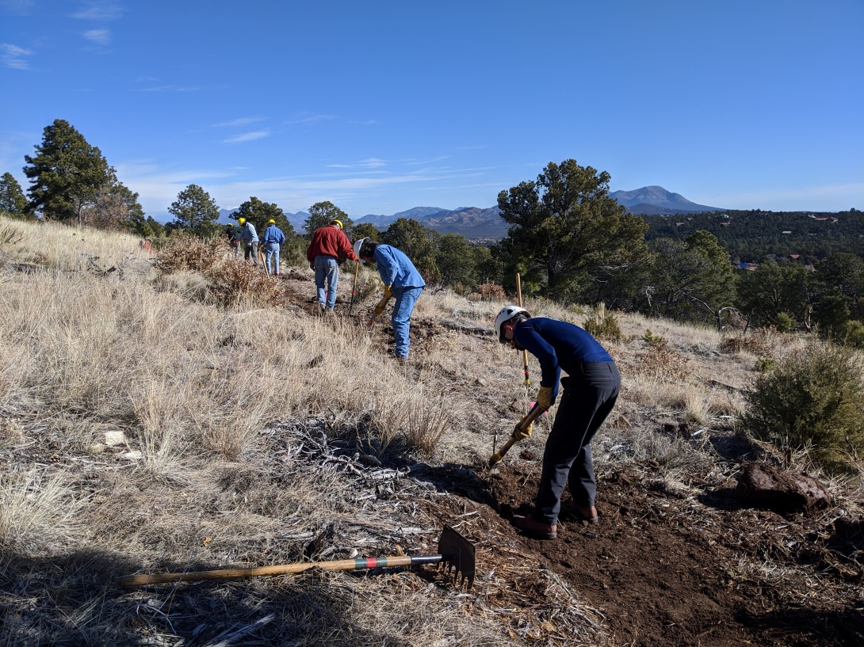

As always, the crew is treated to impressive views… when they take time to look up!

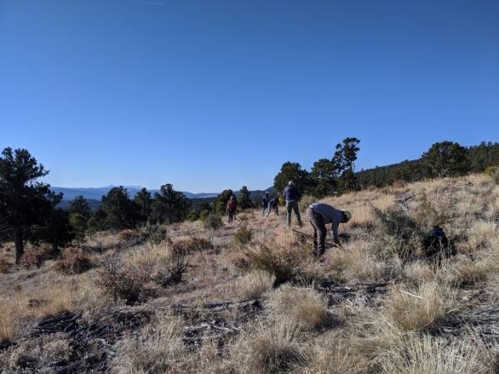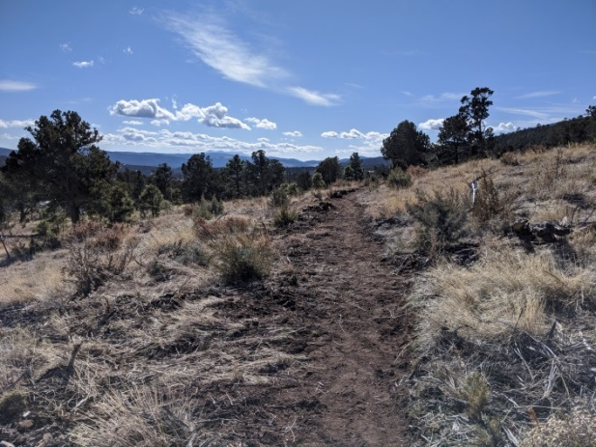

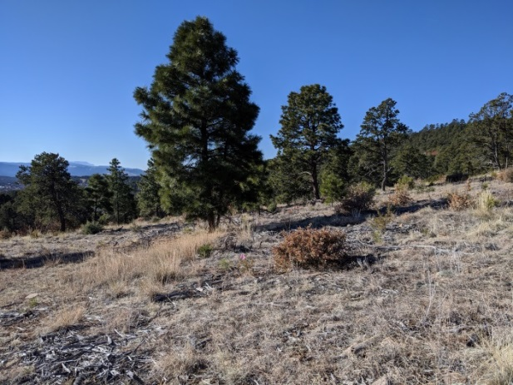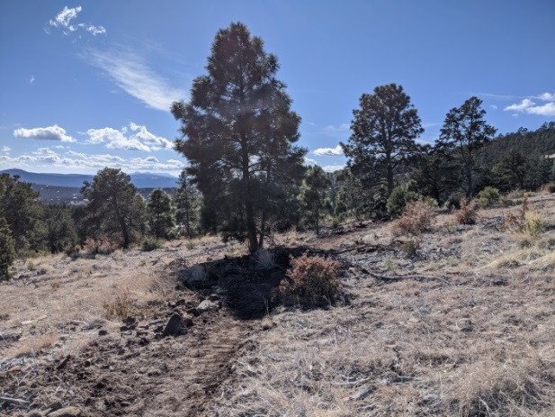

A couple of before/after’s

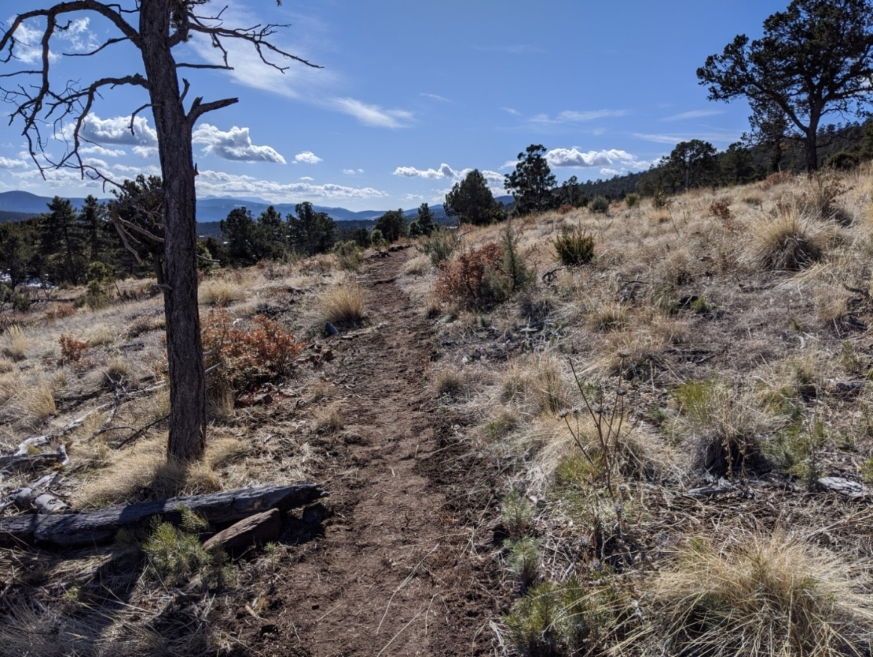

The new trail wends its way southwards.