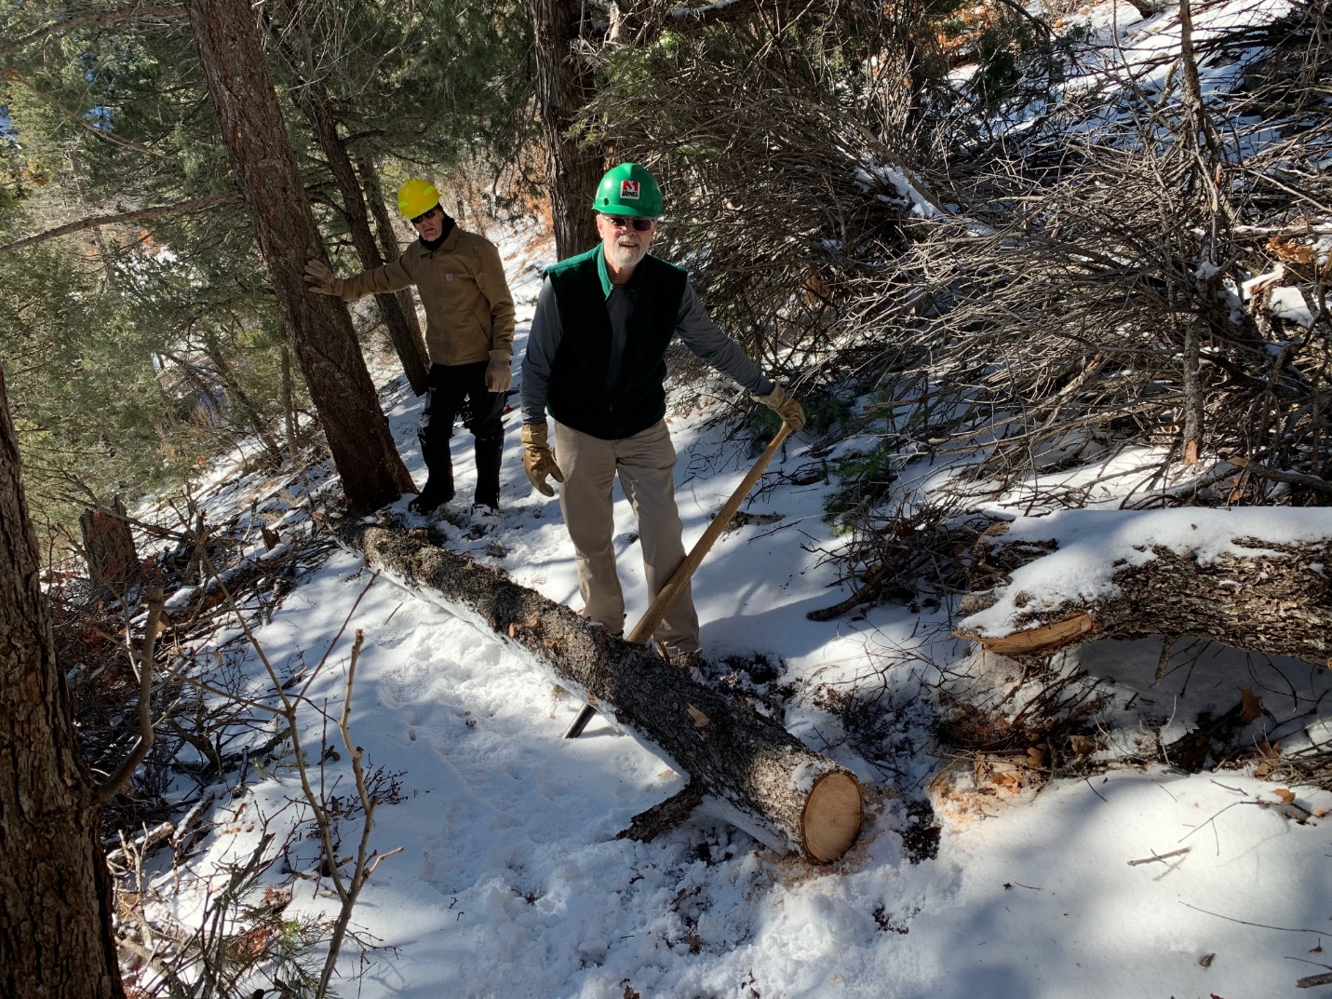
This tree had fallen over Faulty trail a short distance north of the Sulphur Spring trail junction. David McCreery cut away all its protruding branches during a hike last week. Our crew made the cut that put the tree on the ground. Cleve is using the cant hook to move the tree off the trail to the downhill side.
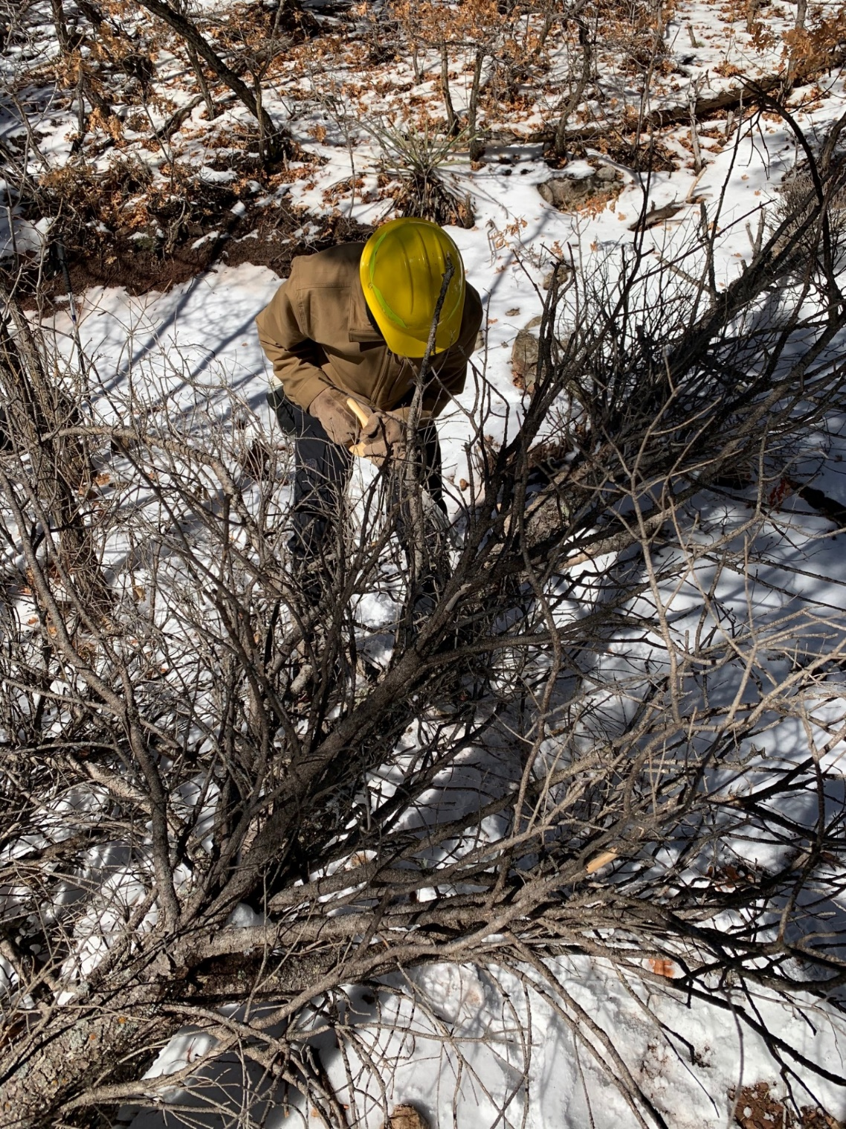
This tree was hung up over Faulty trail a short distance
north of the tree in the previous photo. After the tree
was removed from its supporting branches and onto the ground,
Sim is using a pruning saw to cut it in half to ease
its removal from the trail.
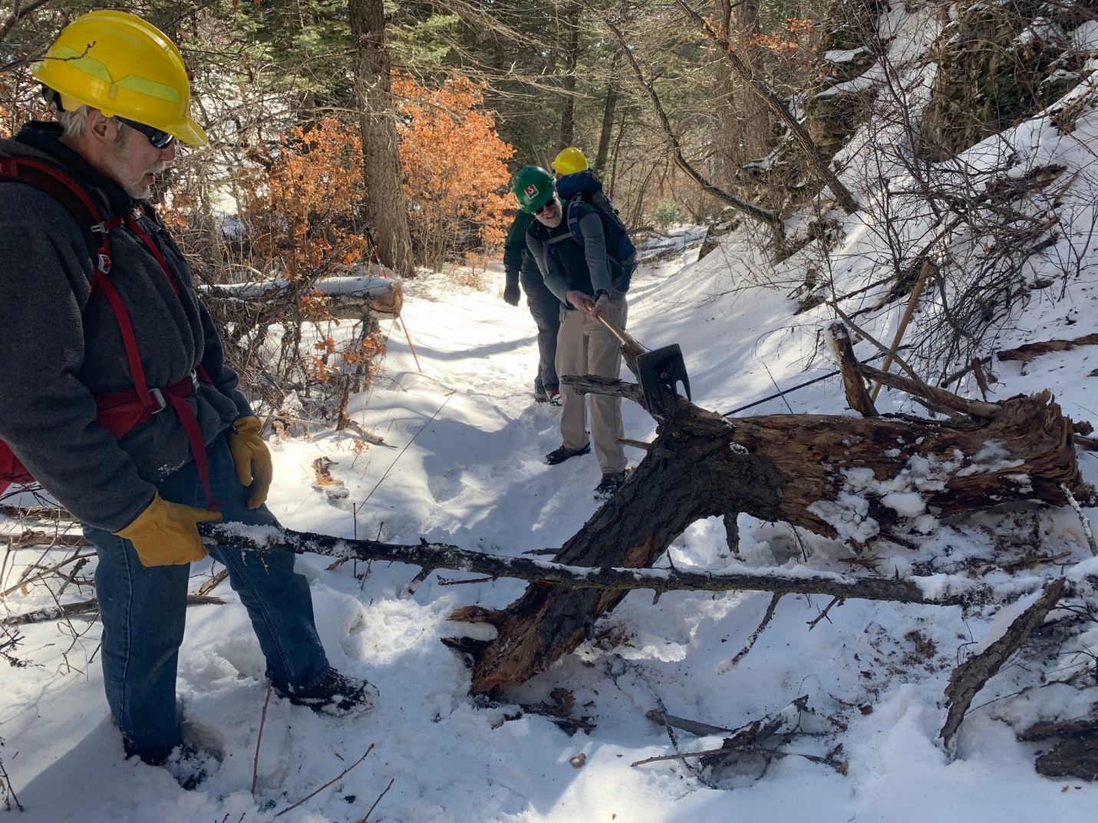
This broken section of tree trunk was partially blocking Bill Spring trail. Cleve is using a McLeod to safely turn it over so it could be moved away.
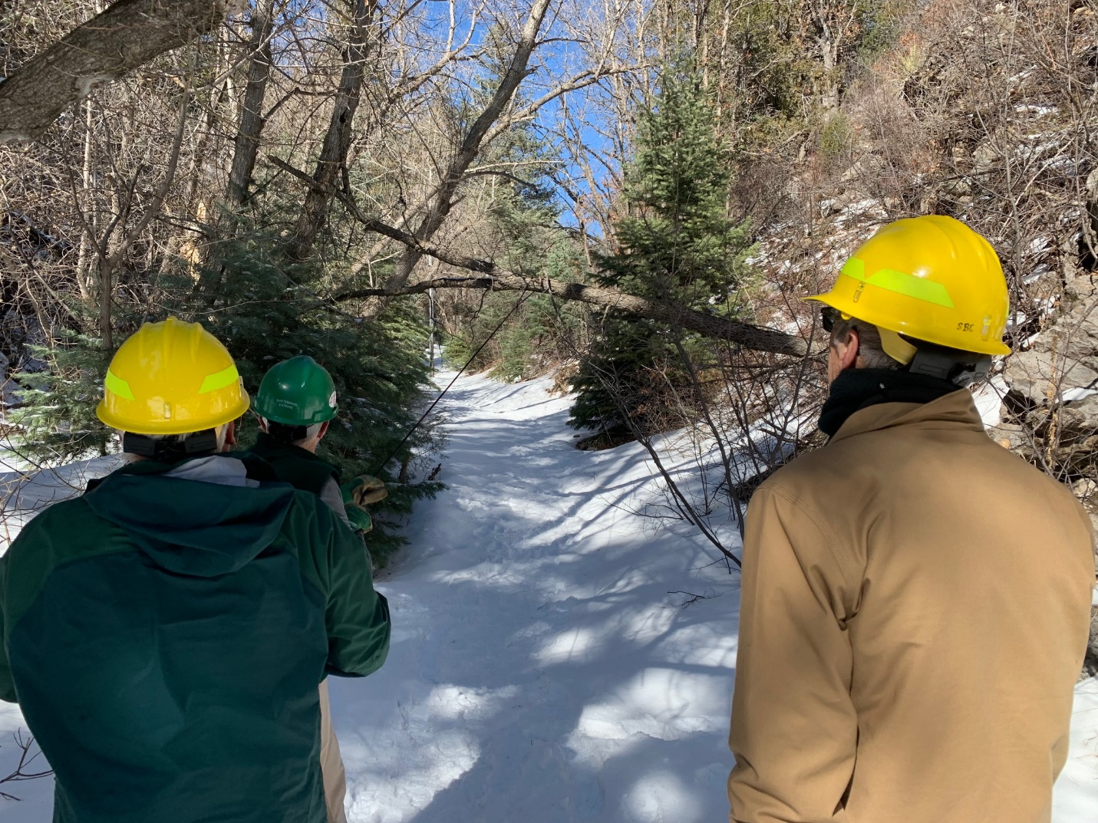
This fallen tree was suspended over Bill Spring trail could be walked under, but anyone on horseback could be hit on the head when trying to go through. The first attempt to remove it involved attaching a long rope to it to pull it off its upper supports. Although the base was only being held by a small section of root it proved to be strong enough to keep the base in place. Time for “Plan B”.
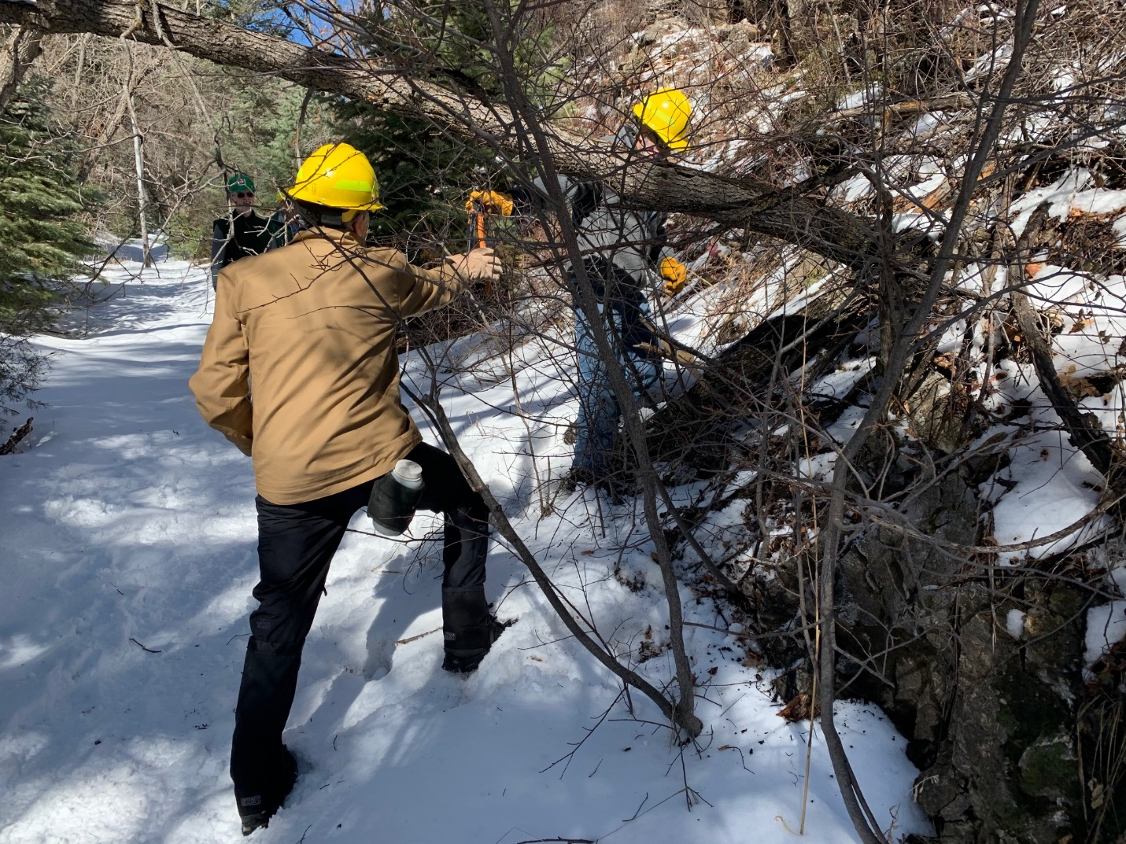
Byron is preparing to make a cut at the tree base so that when the top part is pulled, the tree would no longer be supported there. Sim is starting to remove any shrub branches that might be in the way. The tree was subsequently pulled down with a rope and removed from the trail.

