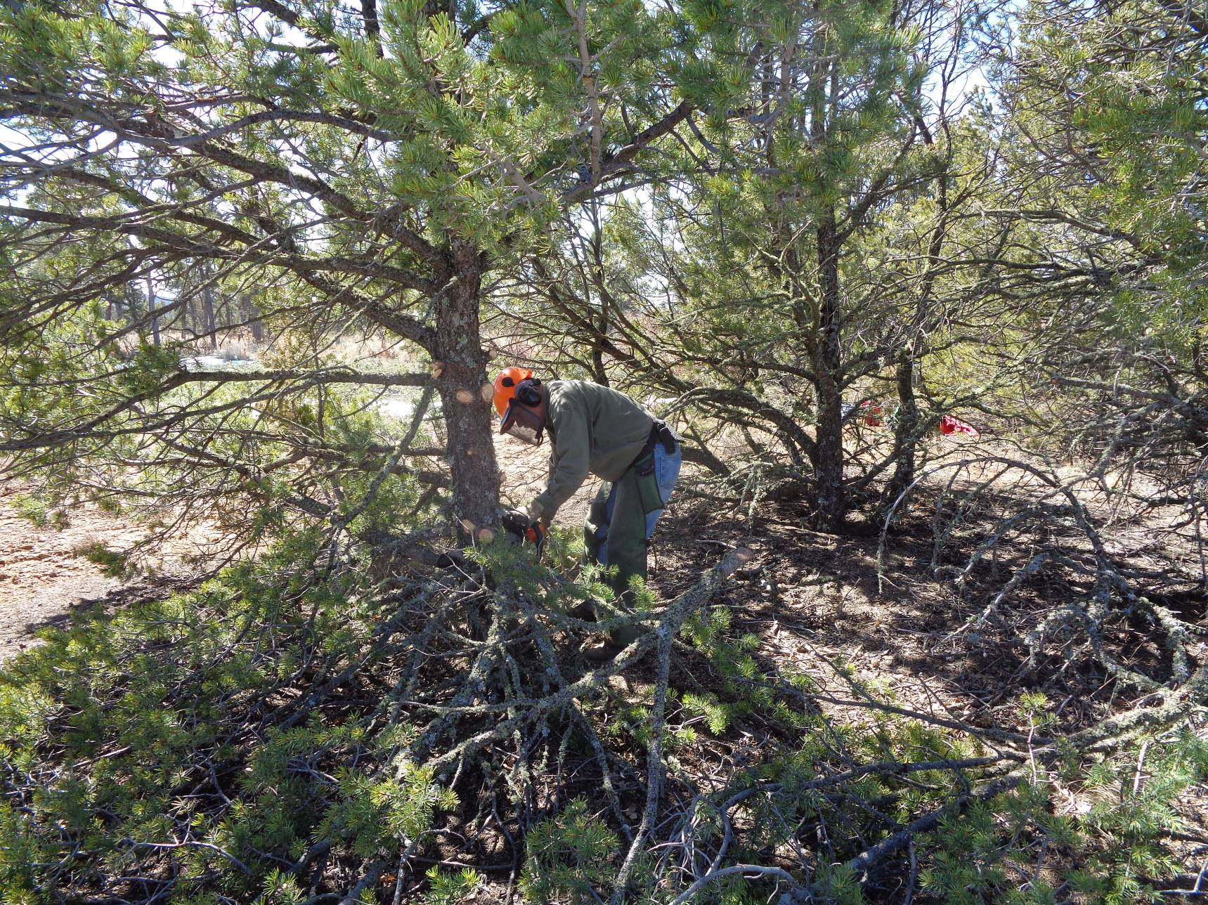
Jerry Carroll limbing a pinon tree before felling it as part of the FOSM project to thin 12 acres this year in the
Cedro CFRP south of the ranger station. All photos by Sam Beard
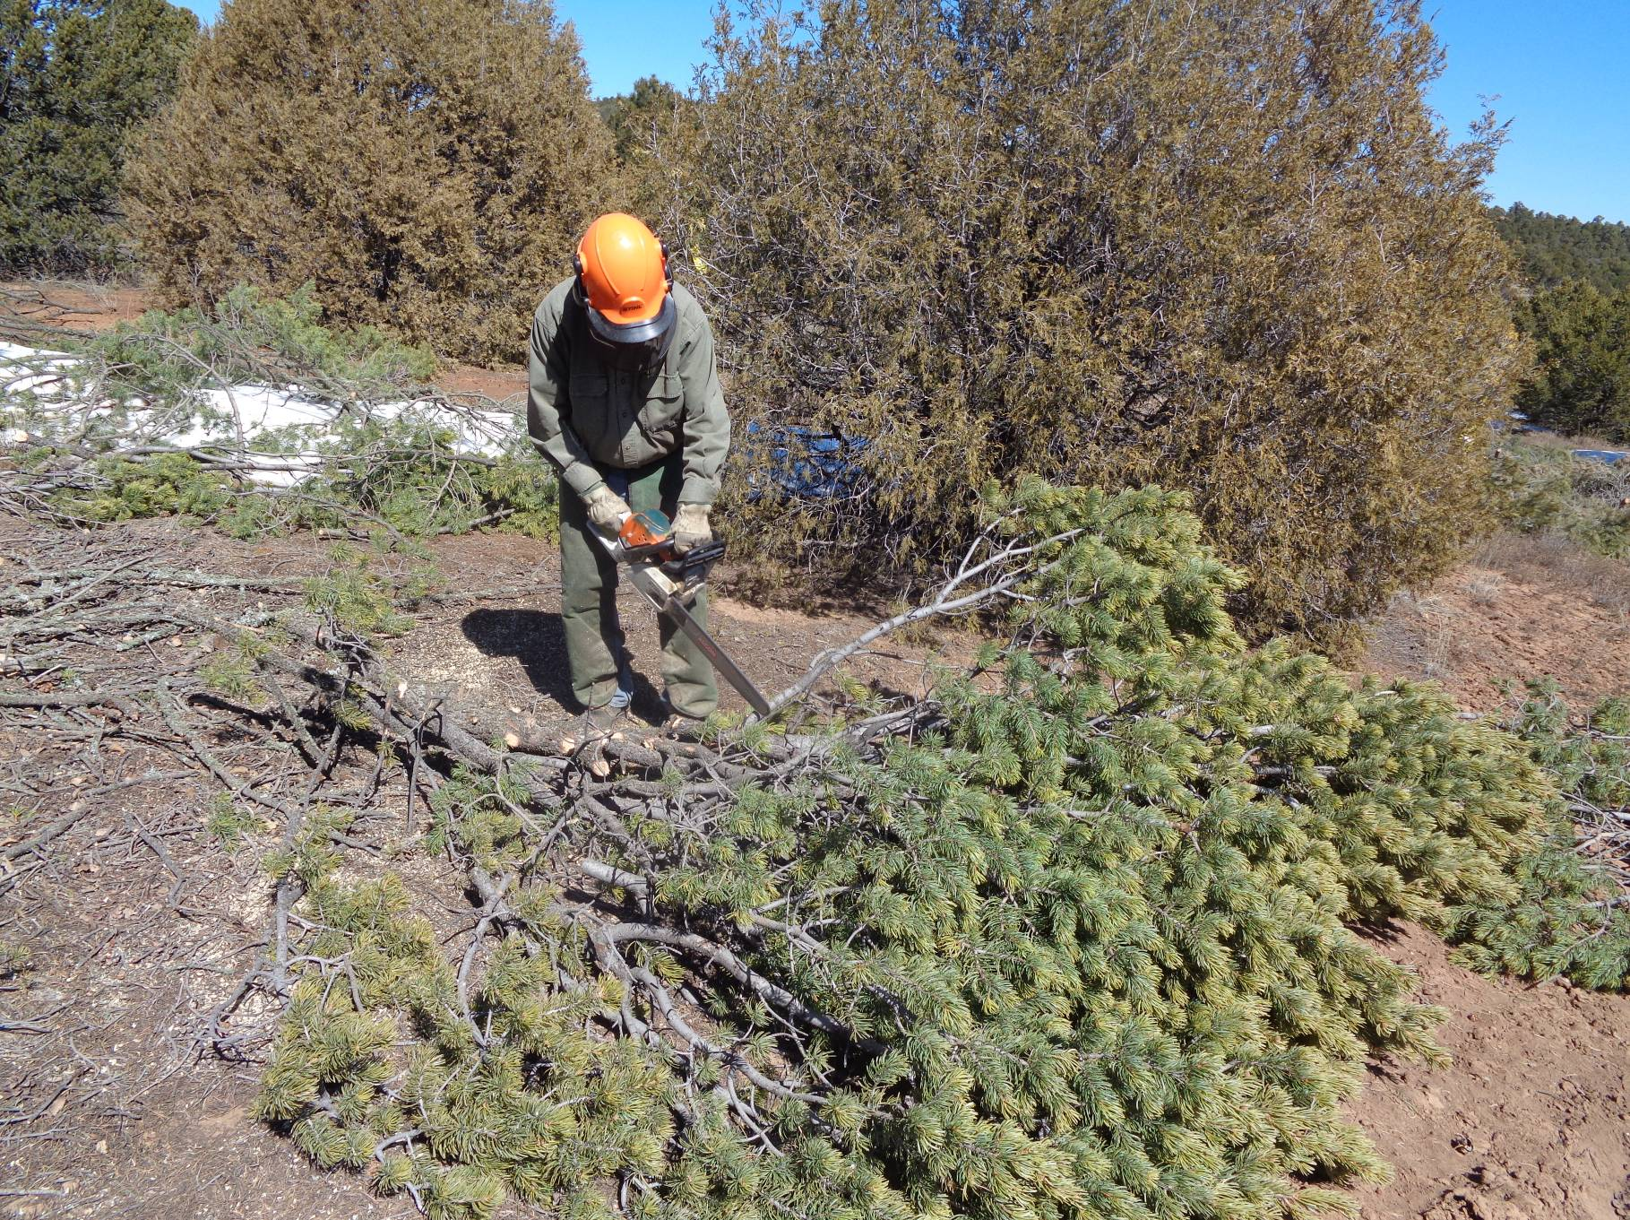
On this tree, Jerry is doing the limbing after he felled it.

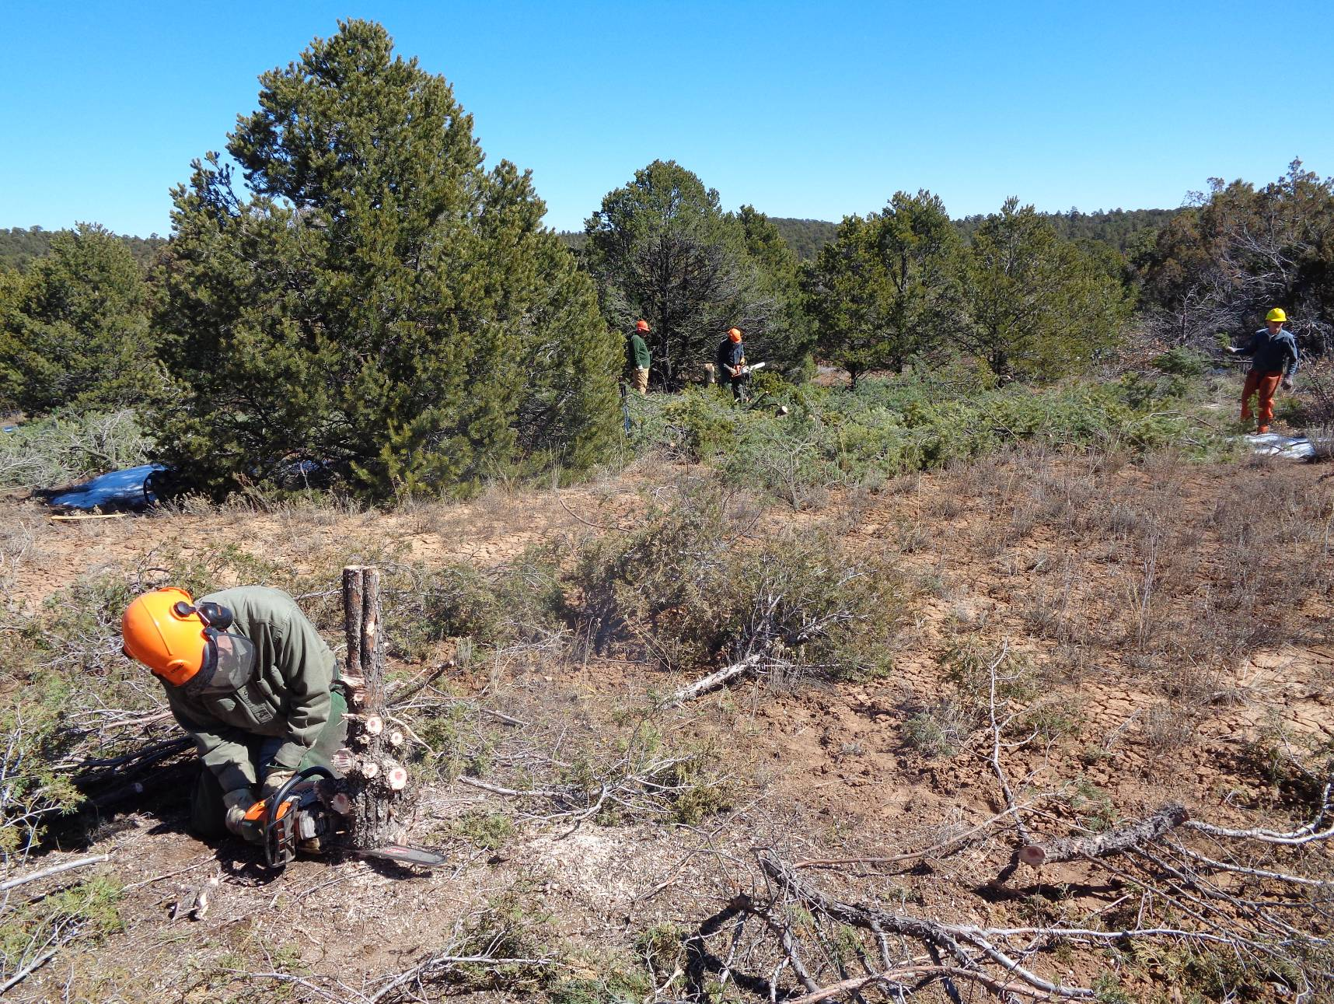
Jerry is felling the trunk after he limbed this tree. L to R in the background: Lou Romero, Dan Benton, and Sim Cook.
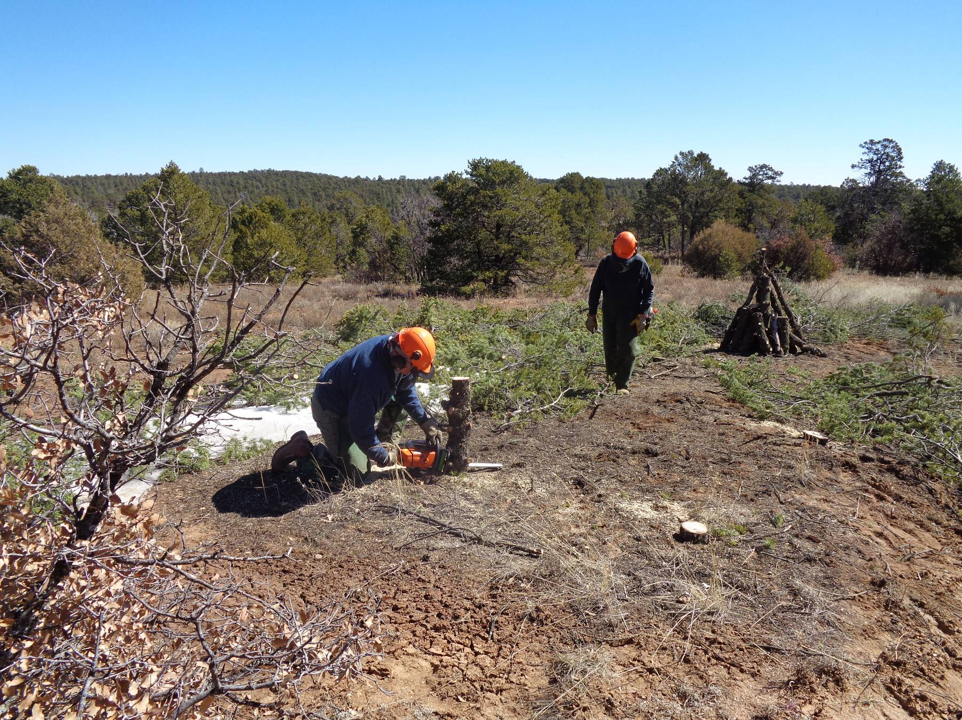
Eric Russell is felling the trunk of this tree after it had been limbed and the slash had been scattered. Note the large pile of wood
that will probably be collected as part of an Eagle Scout Project and donated to needy East Mountain families.

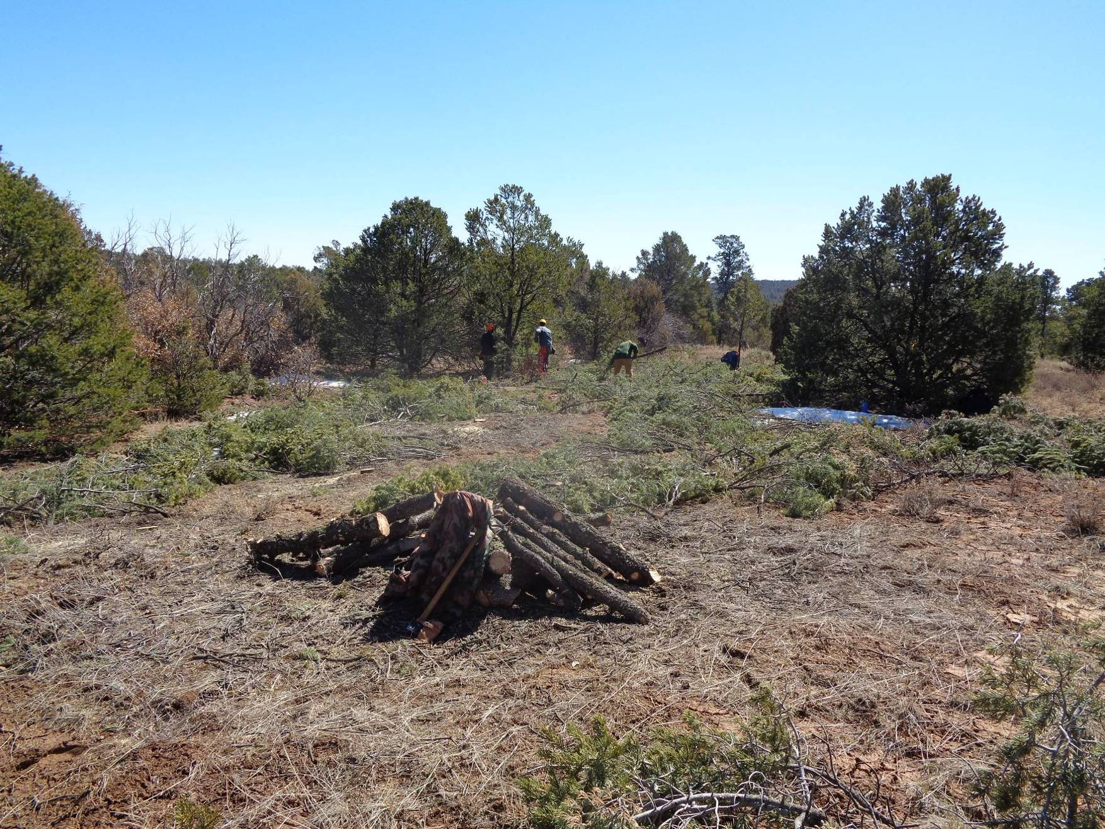
Another pile of fuel wood. Note the slash (limbs) that have been scattered in the thinned area between the large trees
that have not been felled in accordance with the thinning prescription to remove trees with diameters less than 13 inches.

